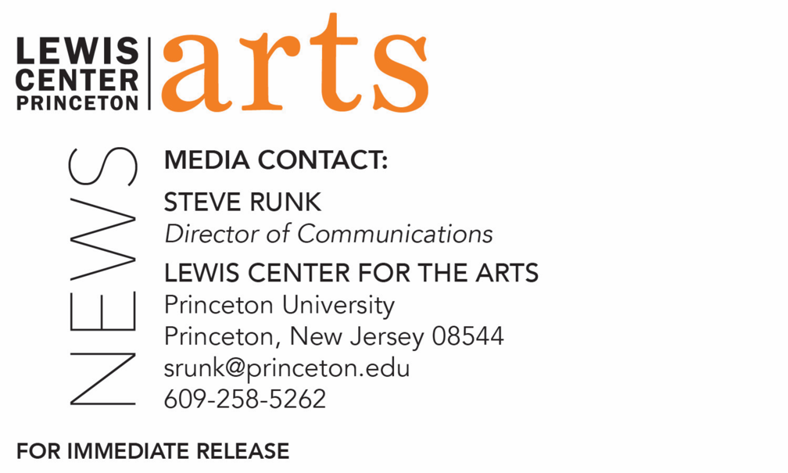

November 13, 2019

Fund for Irish Studies at Princeton University presents
“Dronehenge”
Journalist and Photographer Anthony Murphy delivers
a lecture at Princeton University on this recent Neolithic discovery at Newgrange

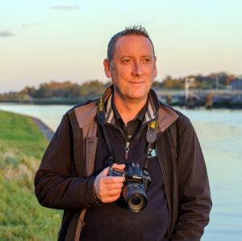

Photo caption: Journalist and photographer Anthony Murphy
Photo credit: Courtesy of Anthony Murphy

What/Who: Journalist and photographer Anthony Murphy lectures on “Dronehenge” as part of the fall 2019 Fund for Irish Studies event series. Murphy’s upcoming book, Dronehenge: The Story Behind the Remarkable Discovery at Newgrange, will be available in January 2020. Presented by Princeton’s Fund for Irish Studies
When: Friday, November 22, 2019 at 4:30 p.m.
Where: James Stewart Film Theater at 185 Nassau Street on the Princeton University campus
Free and open to the public

(Princeton, NJ) Journalist and photographer Anthony Murphy will present a lecture, entitled “Dronehenge,” on Friday, November 22 at 4:30 p.m. in the James Stewart Film Theater at 185 Nassau Street on the Princeton University campus. Part of the 2019-2020 Fund for Irish Studies series at Princeton University, this event is free and open to the public.

Murphy’s upcoming book, Dronehenge: The Story Behind the Remarkable Discovery at Newgrange, is set to release in January 2020. This book details the discovery made in July 2018 by Murphy and a colleague, Ken Williams, of a giant Late Neolithic henge monument while flying their drones over the Boyne Valley. During the course of the book, he sets out to unravel some of the mysteries that the henge, and some of its features, revealed. This discovery gained global attention, spawning a media frenzy and internet sensation. Murphy further discusses the construction of the henge and what it might have been used for, in addition to how this might completely alter perspectives on the Brú na Bóinne landscape. Essentially, he has discovered something that will be studied for many years to come.

Anthony Murphy is a journalist, author, photographer, astronomer and tour guide who lives in Drogheda, at the gateway to Ireland’s historic Boyne Valley. He has been researching, photographing and writing about the ancient megalithic monuments of the Boyne Valley and their associated mythology, cosmology and alignments for the past 20 years. He is the author of five books, including Island of the Setting Sun: In Search of Ireland’s Ancient Astronomers and Mythical Ireland: New Light on the Ancient Past.

Copies of Dronehenge: The Story Behind the Remarkable Discovery at Newgrange will be available for purchase at the event by Labyrinth Books.

The Fund for Irish Studies affords all Princeton students, and the community at large, a wider and deeper sense of the languages, literatures, drama, visual arts, history, politics, and economics not only of Ireland but of “Ireland in the world.” The series is co-produced by the Lewis Center for the Arts and the fall 2019 edition of the series is organized by Paul Muldoon, Princeton’s Howard G.B. Clark ’21 University Professor in the Humanities, Professor of Creative Writing, Director of the Princeton Atelier, and Acting Chair of the Fund for Irish Studies.

Information about the Fund for Irish Studies series events can be found at fis.princeton.edu. Other upcoming events in the current series include:
- Award-winning tech executive Domhnaill Hernon, presents a lecture, “Fiddle Strings, Airplane Wings and Humanizing Technology” on December 6
- A reading by award-winning poet Hannah Sullivan on March 6
- A reading by award-winning fiction writer Kevin Barry on April 2, cosponsored with Special Collections at Princeton University Library
- Lecture by Laurence Cox on his new book, The Irish Buddhist: the Forgotten Monk who Faced Down the British Empire, written with Alicia Turner and Brian Bocking, on April 17.

The Fund for Irish Studies is generously sponsored by the Durkin Family Trust and the James J. Kerrigan, Jr. ’45 and Margaret M. Kerrigan Fund for Irish Studies.

To learn more about the more than 100 public performances, exhibitions, readings, screenings, concerts, lectures and special events, most of them free, presented each year by the Lewis Center for the Arts, visit arts.princeton.edu.

###

