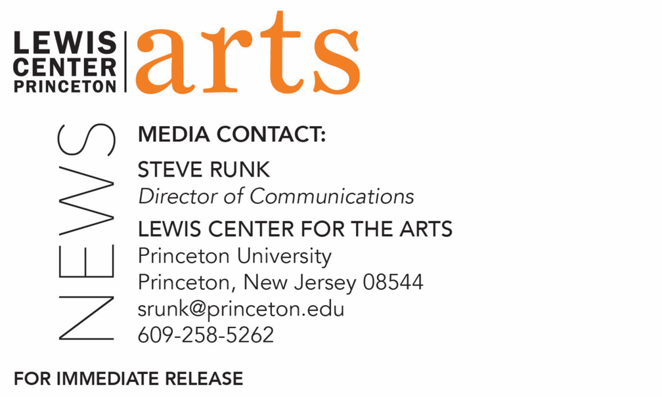
November 25, 2019

Screening of Me, My Selfie and I followed by talk with artist Ryan Gander, presented by Lewis Center for the Arts’ Program in Visual Arts

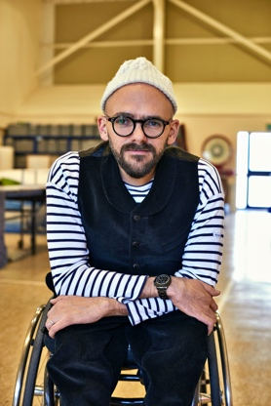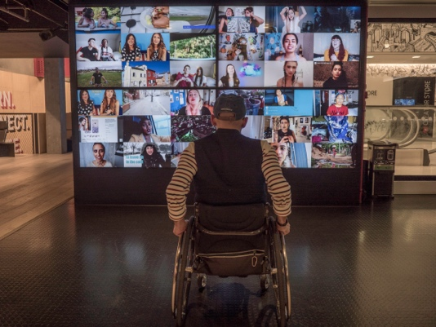
Photo caption 1: Artist and 2019-20 Hodder Fellow at Princeton Ryan Gander
Photo caption 2: Still from Me, My Selfie and I
Photo credit 1&2: Photo by Tom Mannion; Photo courtesy Swan Films

What/Who: Screening of Me, My Selfie and I followed by a talk with artist Ryan Gander moderated by faculty member David Reinfurt, presented by Lewis Center for the Arts’ Program in Visual Arts
When: Friday, December 6 at 7:00 p.m.
Where: James Stewart Film Theater at 185 Nassau St. on the Princeton University campus
Free and open to the public

(Princeton, N.J.) On Friday, December 6, the Lewis Center for the Arts’ Program in Visual Arts at Princeton University will present a screening of the documentary film, Me, My Selfie and I, at 7:00 p.m. at the James Stewart Theater at 185 Nassau Street on the Princeton University campus. The film, directed and produced by Sam Anthony, focuses on celebrated conceptual artist and 2019-20 Hodder Fellow at Princeton Ryan Gander, who reckons that nothing symbolizes the times we live in better than the selfie, the roots of which surprisingly go back hundreds of years before smartphones. A talk with the artist, moderated by faculty member David Reinfurt, will follow the screening. The event is free and open to the public.

Gander explains that the selfie, the icon of a new kind of self-regard that hardly existed just ten years ago and a uniquely 21st century phenomenon, is just the visible tip of a much bigger iceberg – a radical reinvention of who we are powered by the very latest digital technology. The selfie has not just changed how much we look at ourselves but also transformed what we see in the screen when we do. He asks the question: In the age of social media, when we are told to be our best selves and live our best lives, what does that really mean, and what is it doing to our sense of self? To find out, Gander set off to meet a selection of “modern selves” living in the U.K., Silicon Valley, and Arizona, who are redefining what it means to be “us” now, and in the future: from one of YouTube’s brightest stars to a would-be android, and from a virtual hermit hiding out in the Welsh woodlands to a wannabe influencer dancer longing for likes, via a celebrity in love with Twitter and dealing with hate, and a real-life company that promises to cheat death. The film, produced by Swan Films and directed by Sam Anthony, was commissioned for BBC Arts and BBC Four by Mark Bell.

Gander currently lives and creates in London and Suffolk, visiting Princeton periodically during his fellowship year. His work encompasses graphic design, installation, performance, and more, and he has garnered international attention as he challenges notions of knowledge, language, and understanding. He is drawn to the contradictions in paradoxes and the ambiguity of life. His work often unites the mundane and commonplace with the aberrant and extraordinary. His recent solo shows include exhibitions at Esther Schipper in Berlin, The National Museum of Art in Osaka, Hyundai Gallery in Seoul, Contemporary Art Gallery in Vancouver, and Manchester Art Gallery in Manchester. His most recent publications include The Boy That Always Looked Up, Picasso and I, and the monograph Culturefield. He has been presented with the 2007 Paul Hamlyn Award for Visual Arts, the 2006 ABN AMRO prize of the Netherlands and the 2009 Zürich Art Prize. Gander studied at Manchester Metropolitan in the U.K., Rijksakademie van Beeldende Kunsten and the Jan van Eyck Akademie, both in the Netherlands. He has been a visiting lecturer at a number of European art schools throughout the continent. He was also awarded Doctor of Arts of the Manchester Metropolitan University and Honoris Causa for his efforts in academia.

David Reinfurt is a lecturer in the Program in Visual Arts and an independent graphic designer and writer based in New York City. He was the lead designer for the New York City MTA Metrocard vending machine interface, founder of a flexible graphic design practice composed of a constantly shifting network of collaborators, cofounder of a workshop in New York City’s Lower East Side called Dexter Sinister, and founder of a cooperatively-built archive consisting of an ambitious public website, a small physical library space, and a publishing program that assembles itself by publishing. He has taught at a number of institutions including the Columbia University Graduate School of Architecture, Planning and Preservation, the Rhode Island School of Design, and Yale University School of Art. At Princeton since 2010, he re-established the typography studio and introduced the study of graphic design as a starting point for students and visual artists alike. His book, A *New* Program for Graphic Design, which offers a broad introduction to graphic design history and specific models through three courses developed at Princeton, was recently published. Reinfurt was a 2010 United States Artists Rockefeller Fellow in Architecture and Design. His work is featured in such places as the Walker Art Center, Whitney Museum of American Art, Cooper Hewitt National Design Museum, and the Museum of Modern Art. He was also the 2016-2017 Mark Hampton Rome Prize fellow in Design at the American Academy in Rome.

For more information on the Program in Visual Arts and the more than 100 public events presented each year by the Lewis Center for the Arts, visit http://arts.princeton.edu/.
# # #

