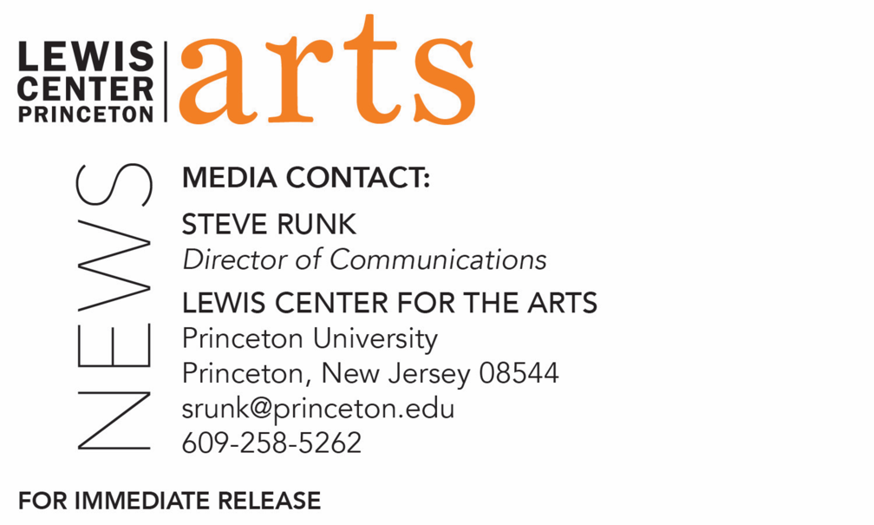

November 1, 2019

Lewis Center for the Arts’ Program in Creative Writing presents
a reading by John Keene
2018 MacArthur Fellow and Chair of the Department of African American and African Studies at Rutgers University will also present a lecture, “Translating Poetry, Translating Blackness.”

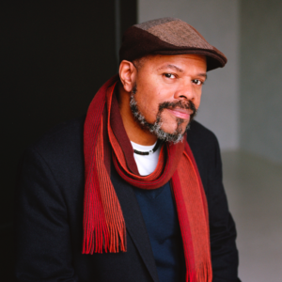
Photo caption: Writer John Keene
Photos credit: Nina Subin/Courtesy of New Directions

What/Who: A reading by John Keene, poet, fiction writer, translator, 2018 MacArthur Fellow, and Chair of the Department of African American and African Studies at Rutgers University
When: November 5 at 7:30 p.m.
Where: Wallace Theater at Lewis Arts complex on the Princeton University campus
Free and open to the public
Related event: John Keene presents a lecture, “Translating Poetry, Translating Blackness,” November 5 at 12 p.m. at 399 Ruehl Family Room in Julis Romo Rabinowitz Building on the Princeton campus, presented by the Interdisciplinary Doctoral Program in the Humanities and cosponsored by the Lewis Center for the Arts’ Program in Creative Writing.

(Princeton, N.J.) The Lewis Center for the Arts’ Program in Creative Writing continues its yearlong 80th anniversary celebration on November 5 with a reading by poet, fiction writer, and translator, John Keene. The reading is at 7:30 p.m. in the Wallace Theater in the Lewis Arts complex on the Princeton University campus. The event is free and open to the public.
Earlier in the day, at 12 noon, Keene will present a lecture, “Translating Poetry, Translating Blackness,” at 399 Ruehl Family Room in the Julis Romo Rabinowitz Building on the Princeton campus, presented by the Interdisciplinary Doctoral Program in the Humanities and cosponsored by the Lewis Center’s Program in Creative Writing.
John Keene’s recent books include the story collection Counternarratives (New Directions, 2015, 2016), and several books of poetry. He also has translated the Brazilian author Hilda Hilst’s novel Letters from a Seducer (Nightboat Books, 2014). His recent honors include an American Book Award and Windham-Campbell Prize for Fiction, as well as a 2018 MacArthur Foundation Fellowship. He chairs the Department of African American and African Studies, and teaches English and creative writing at Rutgers University-Newark.
Keene’s lecture examines the idea that over the last 50 years the field of translation studies has developed a substantial discourse around the topic of translation, in all of its forms. Yet the topic of “race” in relation to translation—literary, cultural, professional, legal, etc.—translation remains little discussed. The presentation will explore a particular aspect of this issue, the translation of Black poets, Black writers more broadly and writing by authors of African descent and heritage, and of “Blackness” itself, particularly with regard to its complex and conflicted relationship with the ideas of “America” and American hegemony.
To learn more about these events, the Program in Creative Writing, and the more than 100 other public performances, exhibitions, readings, screenings, concerts, and lectures presented each year by the Lewis Center, most of them free, visit arts.princeton.edu.
###

