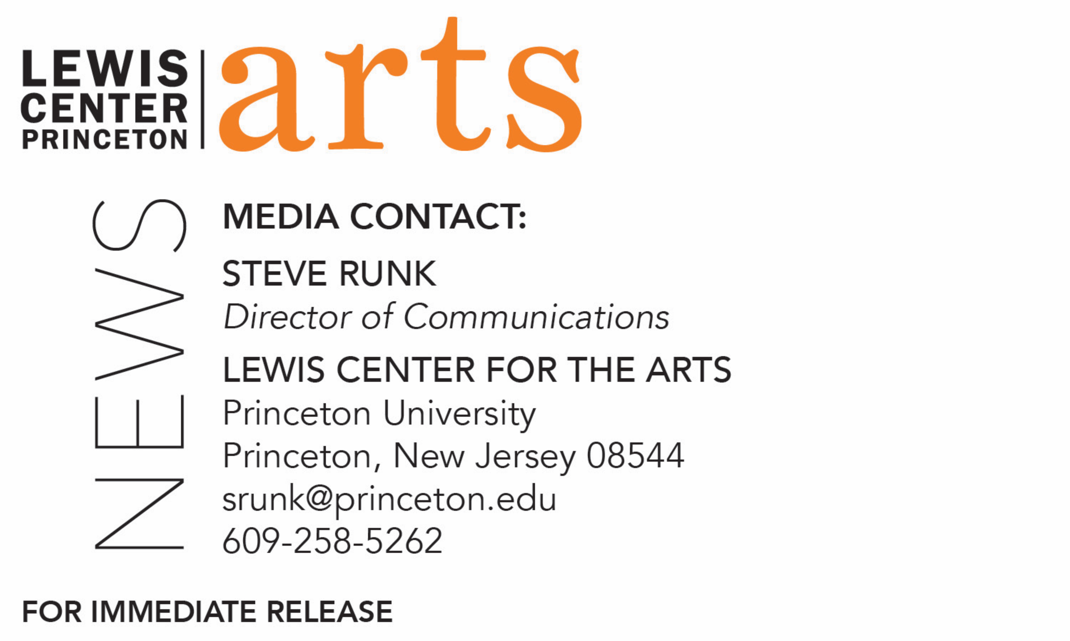

December 2, 2019

Lewis Center for the Arts’ Program in Creative Writing presents
Fall Student Reading
Students in fall courses share recent work as part of the
Althea Ward Clark W’21 Reading Series at Princeton

What: Fall Student Reading, part of Althea Ward Clark W’21 Reading Series
Who: Students in the Lewis Center for the Arts’ Program in Creative Writing read from faculty-selected new work in fiction, poetry, screenwriting and literary translation written during the fall semester
When: Tuesday, December 10 at 5:00 p.m.
Where: Chancellor Green Rotunda on the Princeton University campus
Free and open to the public

(Princeton, NJ) Students in the Lewis Center for the Arts’ renowned Program in Creative Writing will read from their recent work as part of the Program’s Althea Ward Clark W’21 Reading Series on Tuesday, December 10 at 5:00 p.m. in the Chancellor Green Rotunda on the Princeton University campus. The reading is free and open to the public.

Selected by faculty, students will read from new works of fiction, poetry, screenwriting, and literary translation written during the past semester as part of the fall creative writing workshops.

Through the Creative Writing Program, students can take courses or earn a certificate in creative writing in addition to their degree in a major. The small workshop courses offered by the Program are limited in enrollment to ten students to ensure the benefits of working closely with faculty. Workshops meet for up to three hours weekly and are devoted primarily to discussion of student work. Each year, 20 to 30 seniors also work individually with a member of the faculty of practicing, award-winning authors on a creative thesis, such as a novel, a screenplay, or a collection of short stories, poems, or translations. The faculty currently includes Michael Dickman, Aleksandar Hemon, A.M. Homes, Christina Lazaridi, Jhumpa Lahiri, Yiyun Li, Paul Muldoon, James Richardson, Tracy K. Smith, Kirstin Valdez Quade, Susan Wheeler, Monica Youn, and a number of distinguished lecturers.

Alumni of the Program include such well-known writers as Jonathan Ames ’87, Jonathan Safran Foer ’99, Jane Hirshfield ’73 and Monica Youn ’93, who is currently teaching in the program.

The Program is celebrating its 80th anniversary this year with readings by 80 writers, including the emerging writers at this event.

The Althea Ward Clark W’21 Reading Series annually brings a number of distinguished writers to campus to read and discuss their work. Writers reading in the coming months include Joy Harjo and Sheila Heti on February 12, Mei-Mei Berssenbrugge and Yoko Tawada on March 4, and Kaitlyn Greenidge, Helen Oyeyemi, and Nicole Sealey on April 15. All readings are free and open to the public.

To learn more about this reading series, the Program in Creative Writing, and the more than 100 public performances, exhibitions, readings, screenings, concerts and lectures presented each year by the Lewis Center for the Arts, most of them free, visit arts.princeton.edu.

###

