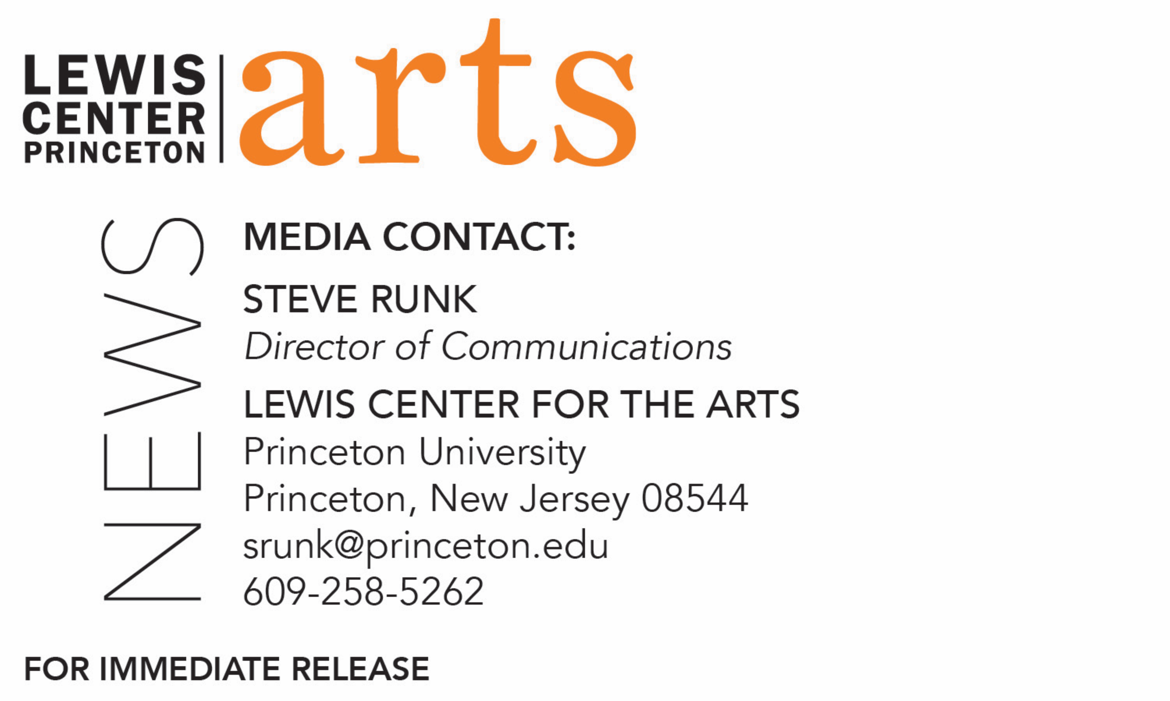

December 4, 2019

Lewis Center for the Arts’ Program in Theater presents

Echoes in Glass

An original story cycle by Princeton senior Alexandra Palocz

What/Who: Echoes in Glass is a theatrical cycle of original stories, poems, and songs. Written, directed, and designed by Princeton senior Alexandra Palocz, it seeks to bring together the realms of theater, oral storytelling, and interactive experience. Audiences are invited into a world of monsters, myths, and memories. Here, stories can be distilled into jars, and spirits are invoked to help bring those stories to life. As spirits, the audience follows three researchers as they delve together through a collection of story-jars in an attempt to untangle and understand the past. Presented by the Lewis Center for the Arts’ Program in Theater at Princeton University.
When: December 8 at 2:00 p.m., December 9 & 10 at 8:00 p.m.

Where: CoLab at the Lewis Arts complex on the Princeton campus
Free and open to the public; no tickets required

(Princeton, NJ) The Lewis Center for the Arts’ Program in Theater at Princeton University will present Echoes in Glass, an interactive cycle of stories, poems, and songs written and directed by Princeton senior Alexandra Palocz that follows the tale of two sisters, a child, a bargain, and a bag of salt. Performances will be December 8 at 2:00 p.m. and December 9 and 10 at 8:00 p.m. in the CoLab at the Lewis Arts complex on the Princeton campus. The show is free and open to the public; no tickets are required.

Echoes in Glass is centered on themes of connection, love, and loss. Bringing together the realms of theater, oral storytelling, and interactive experience, it invites audiences to enter a world of monsters, myths, and memories, where stories are distilled into jars and spirits are invoked to help bring them to life. As spirits, the audience is given the agency to choose how they will move through the world — as watchers, keepers, or active participants, they follow two leader-spirits and a human archivist as they delve together through a collection of story-jars in an attempt to untangle and understand the past.

Palocz, originally from the Boston area, is pursuing a computer science concentration with a certificate in theater. As writer, designer and director of the project, Palocz draws upon her experiences with a wide array of creative work, from theatrical design and performance to visual art, music, and game design. Her theatrical roots at Princeton lie in the world of student-run theater, where she has worked as a technician, designer, and board member for Theatre Intime and performed with the Princeton University Players. It is through the experiences and relationships fostered there that she found her way into theater classes and, eventually, the theater certificate program. She has done lighting design for a number of shows on campus, including Theatre Intime’s 2019 production of Eurydice and the Program in Theater’s production of Legally Blonde: The Musical in 2018. In addition, she worked as assistant technical director for Princeton Summer Theater in summer 2019. After graduation, she hopes to pursue a career at the intersection of technology and the arts.

Palocz notes her inspiration for Echoes in Glass came from myriad sources across her time at Princeton and beyond. Among other things, the show speaks to her relationship with her sisters and her experiences with academic research over the past four years. Her show asks: what does it mean to do research? How are the narratives we make out of the world shaped by our pasts – and how do they, in their turn, shape us? At the center of the piece, Palocz says, lies a fascination with the relationships between objects and memory; truth and fiction; audience and performer, and a desire to explore the limits and potentials of story: as a mirror of our experiences, as a form of connection to the past, and as a vessel for healing.

The presentation of this piece features actors Ally Wonski ’22, Tiffany Huang ’23, and Zyan Wynn ’23, lighting designer Chamari White-Mink ’20, music director Ed Horan ’22, assistant stage manager Jamie Goodwin ’21, and stage manager Gabriela Bourla ’23.
To learn more about this event, the Program in Theater, and the over 100 performances, exhibitions, readings, screenings, concerts, and lectures presented each year at the Lewis Center, most of them free, visit arts.princeton.edu.

###

