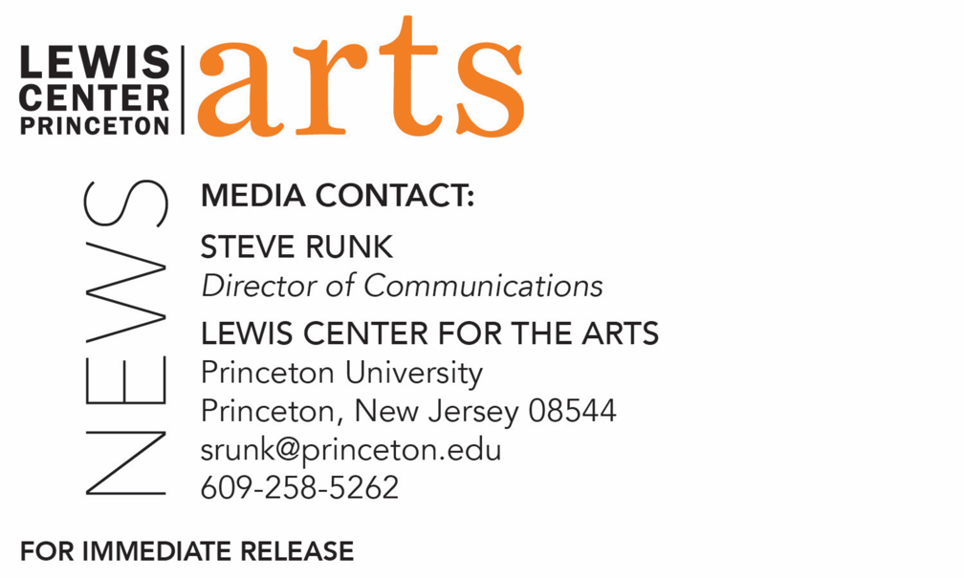

December 5, 2019

Lewis Center for the Arts’ Program in Dance presents
End of Semester Showings in Dance

What: End of semester showings of dance works and new student choreography created during fall 2019 courses in the Program in Dance at Princeton University’s Lewis Center for the Arts
Who: Performed by students in the Program in Dance
When: December 11 at 1:00 p.m., 3:15 p.m. and 3:30 p.m.; December 12 at 5:00 p.m.; and December 13 at 11:30 a.m. and 1:30 p.m.
Where: Various locations in the Lewis Arts complex on Princeton University campus
Free and open to the public
For more information: https://arts.princeton.edu/events/end-semester-showings-dance-fa-19/2019-12-11/

(Princeton, NJ) The Lewis Center for the Arts’ Program in Dance will present a series of showings of dance works and new choreography created during the past semester on December 11 through 13 in various locations in the Lewis Arts complex on the Princeton University campus. All performances are free and open to the public.

The schedule for the end-of-semester showings of student work and performances is as follows:

On Wednesday, December 11 at 1:00 p.m. in the Forum, there will be a presentation from “Introduction to Contemporary Dance,” taught by Alexandra Beller. In this course, students explore the basics of contemporary choreography and technique and strengthen their own physical skill through performance. Following at 3:15 p.m. in the Murphy Dance Studio there will be a presentation from “Introduction to Ballet,” a course taught by Tina Fehlandt which introduces students to the fundamentals of classical ballet, as well as its history, artistry, and absorption of cultural influences. Simultaneously, students from “The American Dance Experience and Africanist Dance Practices,” a studio course taught by Diane Harvey-Salaam, will present at 3:30 p.m. in the Hearst Dance Theater. In this course, students are introduced to the ways in which American dance has evolved through the influence of African American choreographers and dancers, focusing on movement practices from traditional African dances and those of the African diaspora.

Students from both sections of “Choreography Workshop I,” taught by Aynsley Vandenbroucke, will combine to present new choreography they have created on Thursday, December 12 starting at 5:00 p.m. in Ellie’s Dance Studio. During the semester, students in this course are exposed to choreographic thought, improvisation, movement material, and compositional tasks. New choreography is presented weekly for class discussion and evaluation.

On Friday, December 13 at 11:30 a.m. in the Hearst Dance Theater, students will present work from “Choreography Workshop II,” taught by Dean Moss. Students in this course work extensively in movement-based laboratories to develop a greater mastery of compositional tasks, contextualized by course readings and contemporary performance viewings. Following in the Hearst at 1:30 p.m., students from “Choreography Workshop III,” taught by Rebecca Stenn, will present new choreography. In this course, students further develop their choreographic technique by transferring visions to the reality of an ensemble by creating complete works for dancers other than themselves.

For more information on these events, the Program in Dance, or any of the more than 100 performances, exhibitions, readings, screenings, concerts, and lectures presented annually by the Lewis Center for the Arts, most of them free, visit arts.princeton.edu.

###

