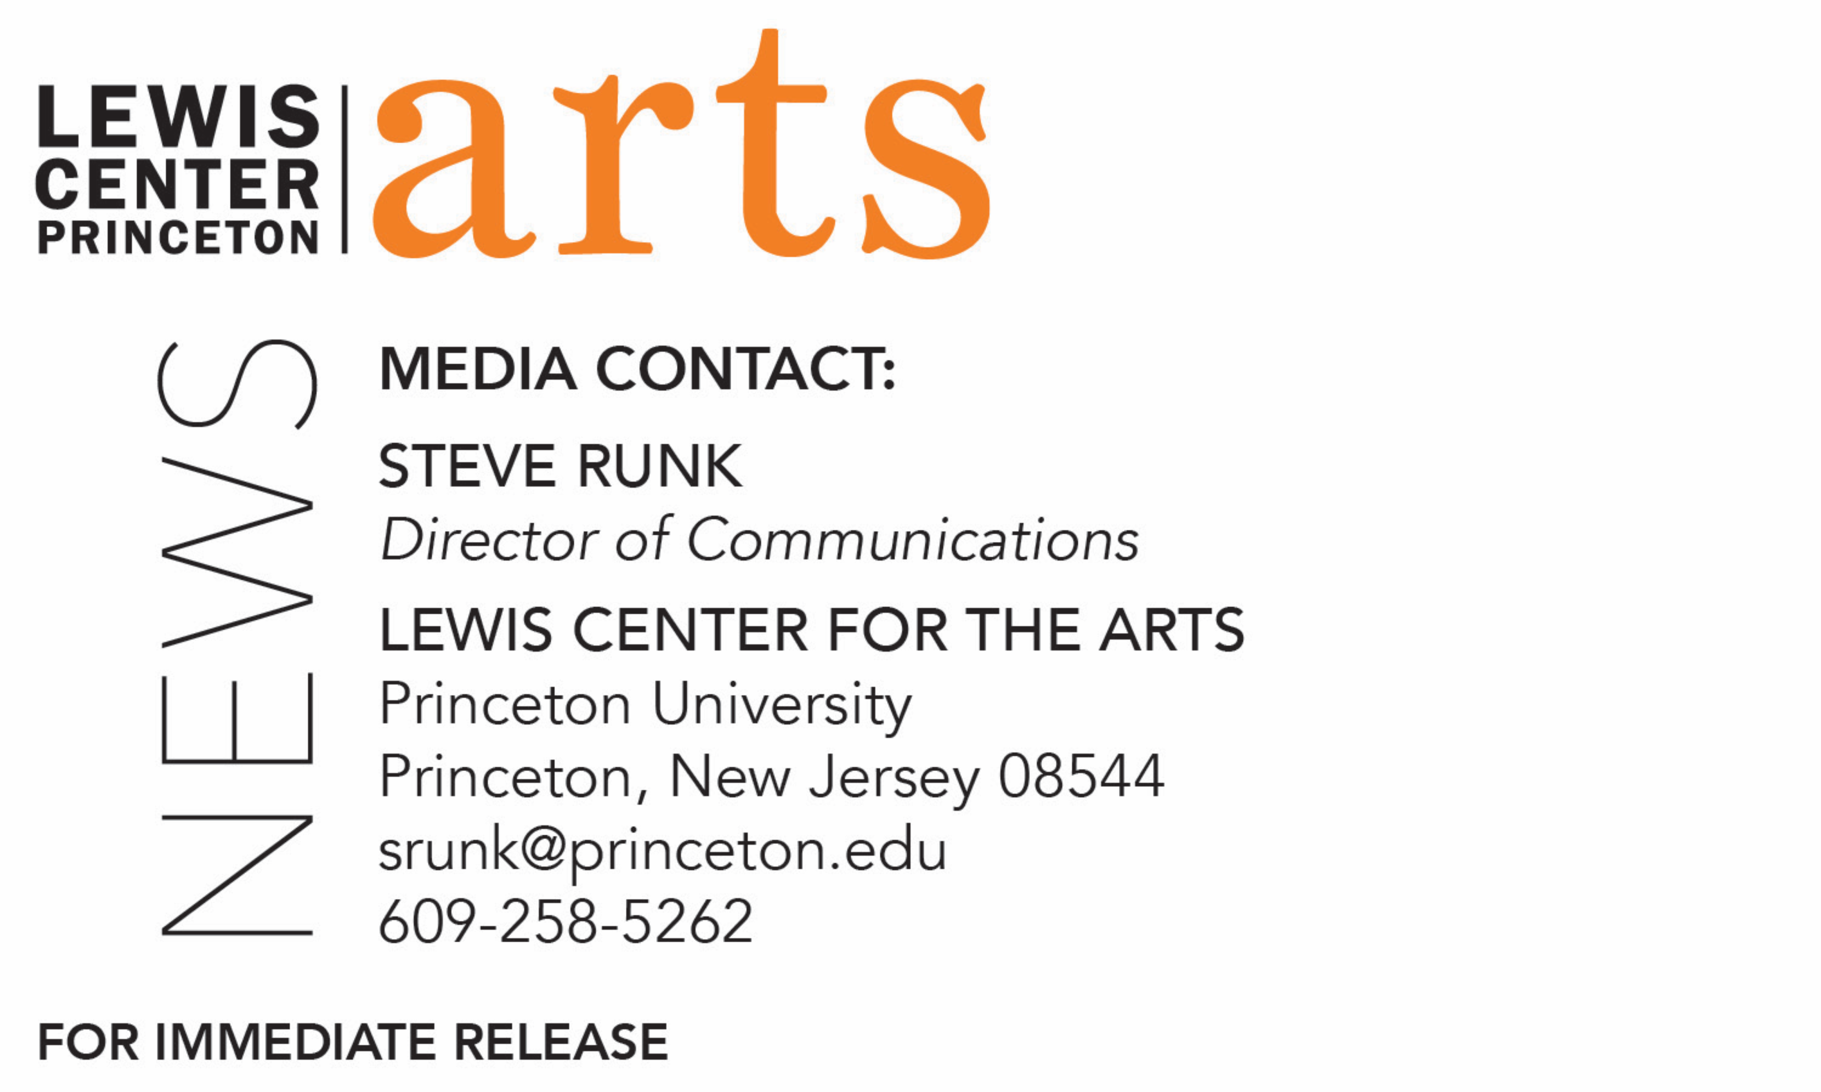

December 2, 2019

Lewis Center for the Arts’ Programs in Theater presents
Feminine Products
A new play by Princeton senior Tessa Albertson featuring senior Katja Stroke-Adolphe

What/Who: Feminine Products, a new play written by Princeton senior Tessa Albertson in which two women, an evangelical and a liberal, meet in college knowing what kind of people, what kind of Americans, what kind of women they want to be, until they don’t. Feminine Products surveys a world in which white feminism falls woefully short and asks us all to consider what must take its place. Directed by sophomore Marc Schorin and featuring senior Katja Stroke-Adolphe, presented by Princeton University’s Program in Theater. Due to the show’s themes of sexual assault, this production may not be suitable for all audiences.
When: December 6 at 8:00 p.m., December 7 & 8 at 2:00 p.m.
Where: Wallace Theater at the Lewis Arts complex on the Princeton campus
Free and open to the public, however tickets are required

(Princeton, NJ) The Lewis Center for the Arts’ Program in Theater at Princeton University will present Feminine Products, a new play written by Princeton senior Tessa Albertson that follows two women, an evangelical and a liberal, as they meet in college thinking they know what kind of women they want to be in a world in which white feminism falls woefully short and asking what must take its place. The production is directed by sophomore Marc Schorin and features senior Katja Stroke-Adolphe. Performances will be presented December 6 at 8:00 p.m., and December 7 and 8 at 2:00 p.m. in the Wallace Theater at the Lewis Arts complex on the Princeton campus. The show is free and open to the public; no tickets are required. Due to the show’s themes of sexual assault, the production may not be suitable for all audiences.

Albertson, who is from New York City and pursuing a degree in English and certificates in theater and American studies at Princeton, is a professional actor, and Feminine Products is her first effort writing a full-length play. The new play represents her independent thesis work in English and the Program in Theater. She has been performing professionally since 2008 on New York stages, in film, and on television including Law & Order SVU, The Good Wife, the Netflix docudrama The Family, and, since 2015, as Sutton Foster’s daughter, Caitlin Miller, on the television series Younger. She has performed at Princeton in the Lewis Center’s production of Into the Woods and the first production of Branden Jacobs-Jenkins’ new play Gurls, in the student groups Theatre Intime and Quipfire! improv comedy, and she was assistant producer of a Women in Comedy Festival at Princeton.

She took her first playwriting course in her junior year with award-winning playwright Nathan Davis, who is an advisor on this project. While experienced as an actor, she wanted to experiment with creating a completely new piece of theater and hopes to one day start her own theater company. With Feminine Products, she was interested in exploring alienation in theater, feminine intersectionalism, pop music's effects on women's psyche and their understanding of romance, and the feminist movement which she finds frequently does not consider issues of race. She received funding through the Lewis Center’s Sam Hutton Fund for the Arts to conduct research last summer. The play takes place in a black box theater, an environment Albertson knows well, and is about women her own age who are in college and negotiating their way in becoming women in 2019. The process of writing the play is most important to her, with the intent to learn what works in the production process and to continue to work on the draft into April. Albertson is also designing costumes and sound for the production.

In addition to Davis, New York director Ethan Heard, who directed the production of Into the Woods, is advising on the new play’s rehearsal/development and direction, playwright and English/theater faculty member R.N. Sandberg is providing advising from the English Department, Lawrence Moten is advising on scenic design, Tess James on lighting design, and faculty member Vivia Font is acting advisor to the cast.

Leading the cast is senior Katja Stroke-Adolphe, who is also an English/Pre-Law major and pursuing a certificate in theater. At Princeton she has performed with the student groups Theatre Intime, Princeton University Players, and Princeton Shakespeare Company, has stage-managed in the Program in Theater, and will appear in the spring production of a new theater/dance work, Hotel on Fremont. Stroke-Adolphe is also a violinist and has performed in The Public Theater’s Public Works production of The Odyssey and at Lincoln Center in New York City. She is also associate news editor for the student newspaper The Daily Princetonian. She plans a career as a public defender and spent the past two summers working for the Legal Aid Society.

The rest of the all-student cast includes graduate student Tess Kichuk, junior Sophie Evans, sophomores Riley Bona and Aliya Ismagilova, and first-year students Anna Allport, Sam Melton, and Chloe Satenberg. Other members of the production team, in addition to director Marc Schorin, include junior Isabella Hilditch as set and lighting designer, junior Haydon John as choreographer and assistant stage manager, sophomore Sally Root as stage manager, and senior Milan Eldridge as stage management mentor. Professional theater-makers Cat Rodriguez and Libby Peterson facilitated an anti-racism workshop for the cast and creative team.
Albertson has partnered with the Princeton student group Menstrual Products Task Force, led by senior Preeti Iyer, for a discussion about the stigma of menstruation and mainstream feminism that will be held in conjunction with the production. This task force states it is dedicated to supporting all menstruators at Princeton by providing free menstrual products in accessible campus restrooms with the hope that by providing these items the task force will alleviate some of the burden placed on low income students who are not able to afford these products, and all students will have access to these items when the need comes up. The task force just completed its first stage implementation of menstrual products this fall and is currently working on expansion.

To learn more about this event, the Programs in Theater and Music Theater, and the over 100 performances, exhibitions, readings, screenings, concerts, and lectures presented each year at the Lewis Center, most of them free, visit arts.princeton.edu.

###

