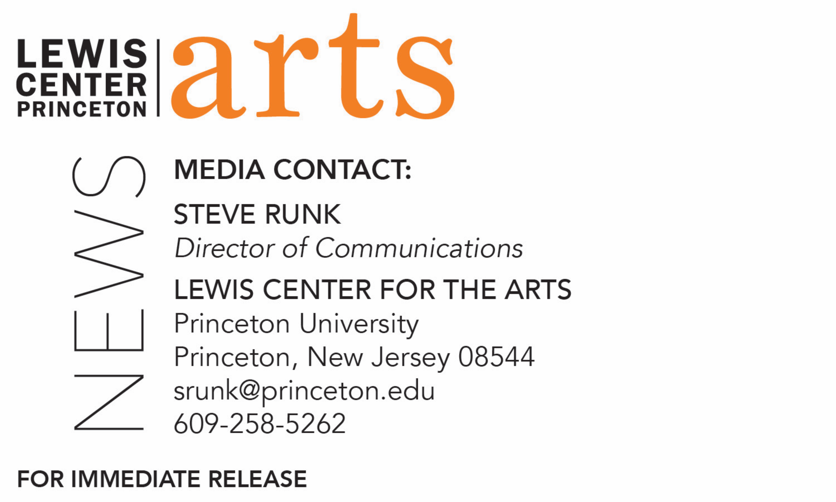

December 19, 2019

Lewis Center for the Arts’ Program in Theater presents
First and Foremost We Are Women of Academia
A new play by Princeton senior E Jeremijenko-Conley
directed by faculty member Elena Araoz

What/Who: First and Foremost We Are Women of Academia, a new, dark comedy written by Princeton senior E Jeremijenko-Conley that explores the underbelly of Princeton culture: that is, how the competitive ethos of valorized, academic suffering physically damages students' bodies and encourages the utilization of trauma as social currency. Directed by faculty member Elena Araoz and presented by Princeton University’s Program in Theater. Recommended only for mature audiences.
When: January 10, 11 and 12 at 8:00 p.m.
Where: Whitman College Theater on the Princeton campus
Free and open to the public (no tickets required)

(Princeton, NJ) The Lewis Center for the Arts’ Program in Theater at Princeton University will present First and Foremost We Are Women of Academia, a new, dark comedy written by Princeton senior E Jeremijenko-Conley that explores the underbelly of Princeton culture: that is, how the competitive ethos of valorized, academic suffering physically damages students' bodies and encourages the utilization of trauma as social currency. The production is directed by faculty member Elena Araoz. Performances will be presented January 10, 11 and 12 at 8:00 p.m. in the Whitman College Theater on the Princeton campus. The show is free and open to the public; no tickets are required. Due to the themes explored in the play, this production is recommended only for mature audiences.

Jeremijenko-Conley is from New York City and pursuing a degree in anthropology and certificates in theater, creative writing, and journalism at Princeton. The new play represents her senior thesis work for the Program in Theater.

Jeremijenko-Conley was involved in theater before arriving at Princeton and has been a performer all four years on campus, appearing in Lewis Center productions of Caryl Churchill’s dark comedy A Dream Play; Phèdre, Jean Racine’s classic French play based on ancient Greek and Roman tragedies in a new English translation by a Princeton alumnus; The Book of Miaou-Wow-Wow: Don’t Drink Everything Your Mother Pours You, a new play by Migdalia Cruz, commissioned by the Lewis Center under its Roger S. Berlind ’52 Playwright-in-Residence program; and she will appear in an all-female production of Shakespeare’s Macbeth in February. She has also worked with the student group Theatre Intime and the semi-professional Princeton Summer Theater.

First and Foremost We Are Women of Academia is the first play Jeremijenko-Conley has written to be staged. She has studied playwriting at Princeton with award-winning playwrights Migdalia Cruz, Nathan Davis, and Jiehae Park. In pursuit of a certificate in the Program in Creative Writing, Jeremijenko-Conley is working on The Girl Who Heard Animals, a novel about a schizophrenic girl who believes she possesses the ability to communicate with animals. Specifically, the main character believes she is the translator across animal species and thus faces pressure to abandon her conspecifics and fight in an interspecies revolution against humans. In her view, this is a centuries-old war—only, humans have not noticed because they have been winning. To inform this work, Jeremijenko's anthropological senior thesis is an ethnography of pet psychics and animal communication.

Jeremijenko-Conley has previously worked with Lecturer in Theater Elena Araoz, who is directing the new play. Araoz directed Jereminjenko-Conley in the new Cruz play, and Jeremijenko-Conley was in Araoz’s courses "Beginning Studies in Acting," "The Art of Speaking," and "Advanced Acting: Performing Comedy." Araoz has been instrumental in working with the playwright in shaping the play through the rehearsal process and has served as an advisor on the project.

Araoz teaches courses in acting, directing and theater making. As a director and actor she works internationally, Off-Broadway and across the country. The Latinx Theatre Commons named her creation of Two Arms and a Noise, a physical theater piece about the life of an indigenous Peruvian woman, as one of "thirty-six plays and writers that everyone should know;” it most recently played in Bucharest, Romania. Her latest productions include Mac Wellman’s A Chronicle of the Madness of Small Worlds at New York Theatre Workshop Next Door, María Irene Fornés Mud with Boundless Theatre Company, Dipika Guha’s Azaan with Oregon Symphony, Catherine Filloux’s Kidnap Road with La MaMa, Octavio Solis' Prospect with Boundless Theatre Company and Virginia Grise’s She-She-She with The New Ohio. Her international credits include the world premiere of Li Tong Chen's The Power in Beijing and A Midsummer Night’s Dream for Prague Shakespeare Festival. Opera productions include La traviata (New York City Opera at BAM’s Howard Gilman Opera House), Lucia di Lammermoor (Opera North), Falstaff (Brooklyn Philharmonic at BAM’s Howard Gilman Opera House), choreography for Latin Lovers (Glimmerglass Opera), and choreography for Sir Jonathan Miller's La traviata (Vancouver Opera). Araoz is a New York Theatre Workshop Usual Suspect, a Time Warner Foundation Fellow Alum of the Director’s Lab at Women’s Project Theatre, a New Georges’ Affiliated Artist and Audrey Resident, a recipient of the Dr. David Farrar Opera Stage Director Grant and the Drama League’s inaugural Beatrice Terry Artist-In-Residence. She is also a founding member of The Sol Project. Upcoming, she will direct Romeo and Juliet for Shakespeare Festival St. Louis and Ibrahim Miari’s In Between for The Walnut Street Theatre.

The rest of the all-student cast includes fellow seniors Ayodele Foster-McCray and Sean Howe. Other members of the production team include seniors Chamari White-Mink as lighting designer and Maddy Dietrich as stage manager, junior Glenna Galarion as assistant stage manager, and senior Hannah Semmelhack as stage management mentor. Professional designer Tess James is lighting advisor.

To learn more about this event, the Program in Theater, and the over 100 performances, exhibitions, readings, screenings, concerts, and lectures presented each year at the Lewis Center, most of them free, visit arts.princeton.edu.

###

