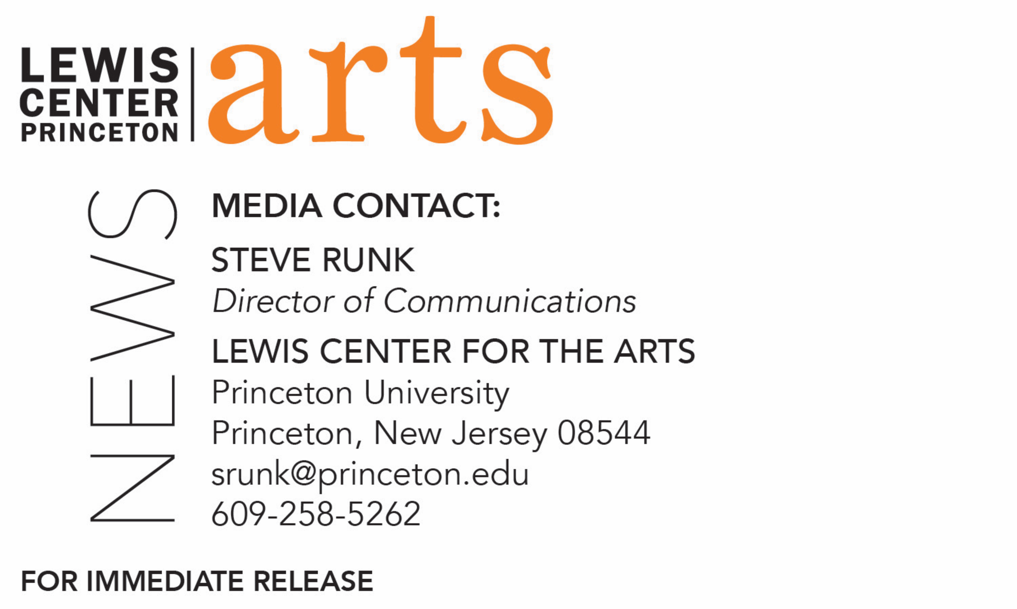

December 23, 2019

Lewis Center for the Arts’ Program in Theater presents
‘t kroos
A new solo performance work by Princeton senior Jhor van der Horst
dedicated to histories with different people over his lifetime

What/Who: ‘t kroos, an original solo performance piece written and performed by Princeton senior Jhor van der Horst and dedicated to histories with different people over his lifetime, traced through his current morning rituals and grown from the cracks between his artistic practice. The work includes structured performances as well as an ongoing installation performance. During the installation, visitors are invited to observe the artist continuing to unearth his stories, by himself or in conversation with friends and mentors. The conversation schedule will be posted online. Presented by the Lewis Center for the Arts’ Program in Theater. Performance includes nudity and may not be suitable for all audiences.
When: Show performances January 9 & 11 at 8 p.m. and January 10 at 11 p.m.; installation performances on same dates, 7 a.m.-12 midnight
Where: Matthews Acting Studio at 185 Nassau St. on the Princeton University campus (entrance for installation performances in through the rear courtyard entrance)
Free and open to the public
For information: https://arts.princeton.edu/events/a-new-theater-piece-by-jhor-van-der-horst/2020-01-09/

(Princeton, NJ) The Lewis Center for the Arts’ Program in Theater at Princeton University will present ‘t kroos, an original solo performance piece written and performed by Princeton senior Jhor van der Horst and dedicated to histories with different people over his lifetime. Structured performances are on January 9 and 11 at 8:00 p.m. and January 10 at 11:00 p.m. The artist will present informal installation performances on these same dates from 7:00 a.m. through 12:00 midnight. Structured and installation performances are in the Matthews Acting Studio at 185 Nassau Street on the Princeton campus. The events are free and open to the public. The performance includes nudity and may not be suitable for all audiences.

‘t kroos traces van der Horst’s histories with people in his life through his current morning rituals and, as he describes, the show “has grown from the cracks between his artistic practice.” In the structured performances he goes through his daily rituals of washing, dressing, and exercising, but also interacting with the audience. A large book of stories and anecdotes as well as personal artifacts also figure into the performance. During what he calls “installation” performances, more informal activity allows the audience to observe the artist from a mezzanine that looks down on the performing space where van der Horst will go about his activities and continue his research with breaks throughout the day to have conversations with friends and mentors; the schedule of conversations and guests with their relationship to the artist will be posted online at arts.princeton.edu/t-kroos.

Van der Horst is from the Netherlands and majoring in visual arts and pursuing certificates in theater and dance. ‘t kroos represents his independent senior thesis work in the Program in Theater. In early March he will present a new choreographic work for his thesis work in the Program in Dance that is related to his theater piece, and later this spring he will present an exhibition capping his work in the Program in Visual Arts.

Van der Horst has always had an interest in combining his academic studies with his work in the arts. European higher education institutions typically offer either an academic track through universities or an artistic track through conservatories. He chose Princeton and study in the U.S. to advance his interests in both areas. He was particularly attracted to Princeton with its strong program in dance and opportunity to create new choreography with significant interaction with the faculty and the ability to create an almost customized course of study. Courses in theatrical design, in particular lighting design, drew him into the Program in Theater, where he has both directed and created original choreography for music theater productions, particularly new plays and musical works written by fellow students. Originally planning to major in philosophy, he changed his major to visual arts after taking a year off following his sophomore year to reassess his goals. He had an interest in visual arts but had not taken studio or art history courses until coming to Princeton. After talking to the working-artist faculty in the Program in Visual Arts, he assembled a portfolio and successfully applied for admittance to the program. His earlier studies in philosophy, particularly ethics, continues to influence the socially focused nature of his artistic work.

Van der Horst’s theater piece is very much a solo work with the artist functioning as writer, performer, director, choreographer, music director (he performs vocals and on guitar during the performance), and designer, with his only other collaborator being fellow senior Allison Spann, with whom he has previously worked. By intentionally taking on all roles in the production, his goal is to thank the artists he was able to study with and the people and forces that have supported him in his artistic exploration process. Associate Professor of Theater Brian Herrera is faculty advisor on the project. In addition to being a theater scholar, Herrera has written and performed a number of original solo works.

For the structured performances, seating is open up until the performance start time and audiences will not be admitted after the performance begins. Audiences are invited to come and go during the installation performances which will run from 7 a.m. to midnight up to two hours before structured performance times and continue afterward on nights with 8:00 p.m. structured performances. During early and late installation performance hours, when 185 Nassau Street is not typically open, entrance to the building is only from the rear courtyard entrance.

To learn more about this event, the Programs in Theater, Dance or Visual Arts, and the more than 100 other performances, exhibitions, readings, screenings, concerts, and lectures presented by the Lewis Center, most of them free, visit arts.princeton.edu.

###

