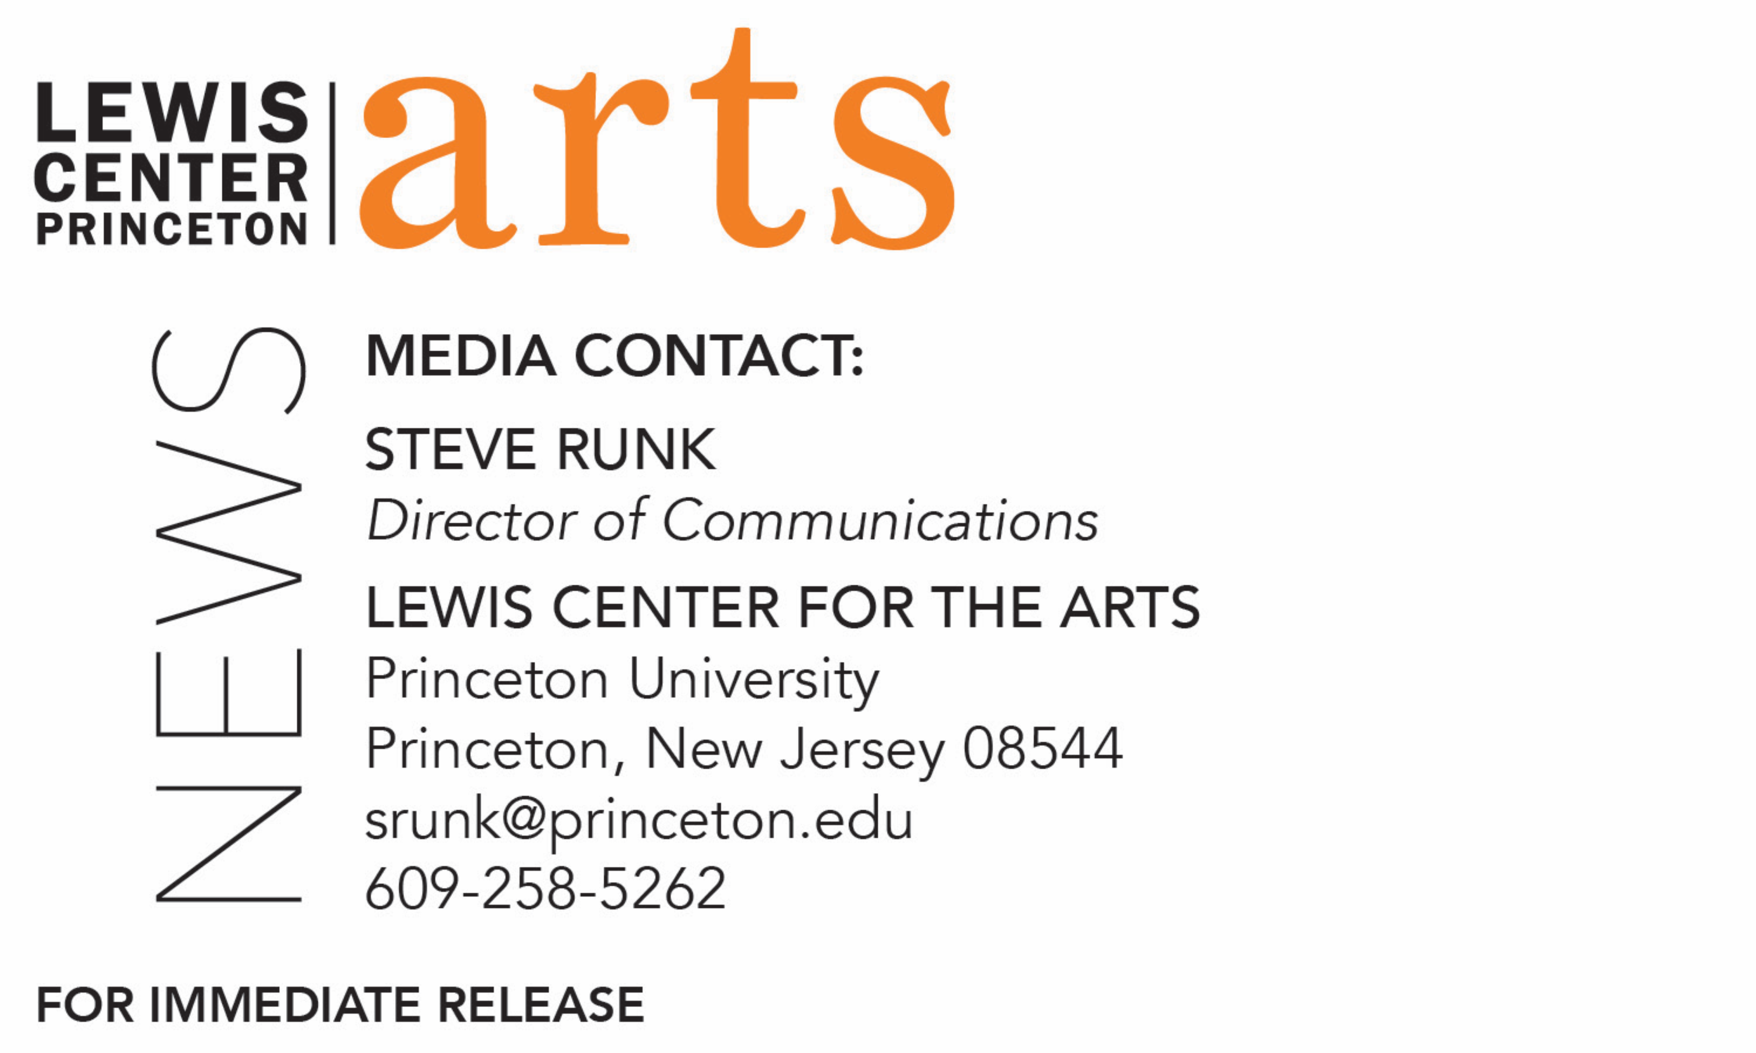

January 27, 2020

Princeton University's Lewis Center for the Arts presents
The Toni Morrison Conversations
Artists Reflect on Toni Morrison’s Gifts to Life, Art and Culture
Anna Deavere Smith and Marlon James join Tracy K. Smith in the second in a series of Princeton Atelier events featuring artists engaging with themes, questions and possibilities relevant to the work and legacy of writer Toni Morrison

Photo caption: Left to right, Nobel Prize-winning writer Toni Morrison; playwright, actor and educator Anna Deavere Smith; novelist and educator Marlon James; and 22nd U.S. Poet Laureate and Lewis Center Chair Tracy K. Smith
Photo credits: Left to right, Sameer Khan, courtesy of ICM Speakers, Mark Seliger, Rachel Eliza Griffiths

What/Who: The Toni Morrison Conversations – Artists Reflect on Toni Morrison’s Gifts to Life, Art and Culture, presented by the Lewis Center for the Arts’ Princeton Atelier. The second in a series of events spanning the 2019-20 academic year featuring artists engaging with themes, questions and possibilities relevant to the work and legacy of writer and Princeton Professor, Emeritus, Toni Morrison. For this event, playwright, actor and educator Anna Deavere Smith and novelist and educator Marlon James are in conversation with 22nd U.S. Poet Laureate and Lewis Center Chair Tracy K. Smith.
When: February 4 at 7:30 p.m.
Location: Richardson Auditorium on the Princeton University campus
Free and open to the public, no tickets required.
For more information: https://arts.princeton.edu/events/the-toni-morrison-conversations-february/

(Princeton, NJ) On February 4, Princeton University's Lewis Center for the Arts will present the second event in The Toni Morrison Conversations - Artists Reflect on Toni Morrison’s Gifts to Life, Art and Culture. This series of events spanning the 2019-20 academic year features artists engaging with themes, questions and possibilities relevant to the work and legacy of writer and Princeton Professor, Emeritus, Toni Morrison. The February 4 event invites playwright, actor and educator Anna Deavere Smith and novelist and educator Marlon James in a conversation with 22nd U.S. Poet Laureate and Lewis Center Chair Tracy K. Smith. The event begins at 7:30 p.m. at Richardson Auditorium on the Princeton campus and is free and open to the public; no tickets are required.

The series pays tribute to Morrison, who passed away on August 5, 2019, at the age of 88. A world-renowned writer and Nobel laureate, Morrison was the Robert F. Goheen Professor in the Humanities, Emeritus, at Princeton, a Professor of Creative Writing, and founder of the Princeton Atelier. The series is co-organized by Smith, who is also Princeton’s Roger S. Berlind ’52 Professor in the Humanities and Professor of Creative Writing, and Paul Muldoon, Princeton’s Howard G.B. Clark ’21 University Professor in the Humanities, Director of the Princeton Atelier, and Professor of Creative Writing.

“In this year following the loss of Morrison’s presence on earth, we are grateful for the chance to celebrate all the many lasting gifts she has given to humanity,” said Smith. “This series affords us the opportunity to talk with a range of artists working in various forms and disciplines about the ongoing relevance of Morrison’s work to their own creative process.”

Morrison joined the Princeton faculty in 1989 and was a member of the University’s Program in Creative Writing until she transferred to emeritus status in 2006. In 1993, she became the first African American to be awarded the Nobel Prize in Literature. Her work has been translated into at least 20 languages. Her groundbreaking novels include The Bluest Eye (1970), Sula (1973), Song of Solomon (1977) Tar Baby (1981), Beloved (1987), Jazz (1992), Paradise (1997), Love (2003), A Mercy (2008), Home (2012), and God Help the Child (2015). Her latest book, The Source of Self-Regard: Selected Essays, Speeches, and Meditations, was published in early 2019.

In addition to the Nobel Prize, Morrison won a Pulitzer Prize for Beloved in 1988 and a National Book Critics Circle Award for Song of Solomon in 1978. In May 2019, she received the gold medal from the American Academy of Arts and Letters. She was awarded the American Academy of Arts and Sciences Emerson-Thoreau Medal in 2016, the Presidential Medal of Freedom in 2012, and the National Humanities Medal in 2000. Evincing her international readership are two major awards from France: the Ordre National de la Légion d’honneur in 2010; and the Commandeur de l’Ordre des Arts et des Lettres in 1993. Morrison was also an acclaimed essayist and librettist. She wrote children’s books with her son Slade Morrison. This past summer, a documentary of her life, Toni Morrison: The Pieces I Am by Timothy Greenfield-Sanders, was released in theaters.

Morrison’s arrival helped to attract other faculty and students from traditionally underrepresented backgrounds to Princeton, and she played a catalytic role in expanding Princeton’s commitments both to the creative and performing arts and to African American studies. In 1994, she founded the Princeton Atelier, bringing together undergraduate students in interdisciplinary collaborations with acclaimed artists and performers such as Jacques d’Amboise, A.S. Byatt, Peter Sellars, Yo-Yo Ma, Richard Danielpour, Bernice Johnson Reagon, Gabriel García Márquez, Anonymous 4, Richard Price, Pig Iron Theatre Company, Maria Tucci and Allegra Kent among others, now directed by Muldoon. In honor of Morrison’s career achievements and contributions to Princeton, the University dedicated Morrison Hall, formerly West College, in 2017. In 1996, she gave the keynote address — “The Place of the Idea, The Idea of the Place” — as the University celebrated its 250th anniversary. In 2005, Morrison was the Baccalaureate speaker for the graduating class. In 2012, she returned “home” to campus to read from her then new novel, Home. Morrison’s papers are part of the Princeton University Library’s permanent collection with a selection of first editions, translations, corrected typescripts, and a handwritten first draft of her novels currently on display in the Firestone Library lobby. Last spring, the Lewis Center awarded its inaugural Toni Morrison Prize, which is given to one or more graduating seniors whose individual or collaborative artistic practice has pushed the boundaries and enlarged the scope of our understanding of issues of race. This prize honors work in any form that, in the spirit of Morrison, is “characterized by visionary force and poetic import.”

“We are delighted to present these events under the aegis of the Princeton Atelier,” said Muldoon, “a program that takes as its major article of faith the idea that art reflects partnerships — between artist and artist, the artist and their community, the artist and audience member.”

Anna Deavere Smith uses her singular brand of theater to explore issues of community, character, and diversity in America. The MacArthur Foundation honored Smith with the “Genius” Fellowship for creating “a new form of theatre — a blend of theatrical art, social commentary, journalism, and intimate reverie.” Best known for crafting more than 15 one-woman shows drawn from hundreds of interviews, Smith turns these conversations into scripts and transforms herself onstage into a number of characters. In her speaking events, Smith discusses the many “complex identities of America,” and interweaves her discussions with portrayals of people she has interviewed to illustrate the diversity of emotions and points of view on controversial issues. Her most recent play, Notes from the Field, looks at the school-to-prison pipeline and injustice and inequality in low-income communities, excerpts of which she brought to Princeton in March 2017. Winner of an Obie Award and the 2017 Lortel Award for Outstanding Solo Show, Notes from the Field was named one of the Top 10 Plays of the year by Time Magazine. The film adaptation of Notes from the Field is available through HBO, while the paperback adaptation is a collection of students and teachers, counselors and congressmen, preachers and prisoners, discussing their direct and indirect experiences with the school-to-prison pipeline. In 2012, Smith was awarded the National Humanities Medal, presented by President Obama, and, in 2015, she was named the Jefferson Lecturer, the nation’s highest honor in the humanities. She also is the recipient of the prestigious Dorothy and Lillian Gish Prize, a Guggenheim Fellowship, and most recently, the 2017 Ridenhour Courage Prize and the George Polk Career Award for authentic journalism. Smith’s breakthrough plays, Fires in the Mirror, a runner-up for the Pulitzer Prize, and the Tony-nominated Twilight: Los Angeles, tackle issues of race and social inequality that have become touchstones of her work. Her portrayals of patients and medical professionals in Let Me Down Easy delivered a vivid look at healthcare in the United States. The show aired on PBS’ Great Performances. Currently, Smith appears on ABC’s hit series Black-ish. She is probably most recognizable as the hospital administrator on Showtime’s Nurse Jackie and the National Security Advisor on NBC’s The West Wing. Her films include The American President, Rachel Getting Married, and Philadelphia. Smith is the founding director of the Institute on the Arts and Civic Dialogue, which was launched at Harvard University and is now housed at New York University, where she is a professor at Tisch School of the Arts. Her books include Letters to a Young Artist and Talk to Me: Listening Between the Lines. She has been an artist-in-residence at MTV Networks, the Ford Foundation, and Grace Cathedral in San Francisco. Smith was appointed to Bloomberg Philanthropies’ 2017 U.S. Mayors Challenge Committee, a nationwide competition urging innovative solutions for the toughest issues confronting U.S. cities. She holds honorary degrees from Yale, the University of Pennsylvania, and Julliard, among others.

Marlon James won the 2015 Man Booker Prize for Fiction for A Brief History of Seven Killings, making him the first Jamaican author to take home the U.K.’s most prestigious literary award. He explores Jamaican history through the perspectives of multiple narrators and genres: the political thriller, the oral biography, and the classic whodunit confront the untold history of Jamaica in the 1970’s, with excursions to the assassination attempt on reggae musician Bob Marley, as well as the country’s own clandestine battles during the cold war. James cites influences as diverse as Greek tragedy, William Faulkner, the L.A. crime novelist James Ellroy, Shakespeare, Batman, and the X-Men. Writing for The New York Times, Michiko Kakutani said of A Brief History of Seven Killings, “It’s epic in every sense of that word: sweeping, mythic, over-the-top, colossal and dizzyingly complex. It’s also raw, dense, violent, scalding, darkly comic, exhilarating and exhausting—a testament to Mr. James’s vaulting ambition and prodigious talent.” In addition to the Man Booker Prize, A Brief History of Seven Killings won the American Book Award, the Anisfield-Wolf Book Prize, the OCM Bocas Prize for Caribbean Literature, the Minnesota Book Award, and was a finalist for the National Book Critics Circle Award. James’ first novel, John Crow’s Devil, tells the story of a biblical struggle in a remote Jamaican village in the 1950s, which went on to become a finalist for the Los Angeles Times Book Prize and the Commonwealth Writers Prize, as well as a New York Times Editor’s Choice. His second novel, The Book of Night Women, is about a slave women’s revolt on a Jamaican plantation in the early 19th century. The work won the 2010 Dayton Literary Peace Prize, Minnesota Book Award, and was a finalist for the 2010 National Book Critics Circle Award in fiction, as well as an NAACP Image Award. James’ short fiction and nonfiction have been anthologized in Bronx Noir, The Book of Men: Eighty Writers on How to Be a Man, and elsewhere, and have appeared in Esquire, Granta, Harper’s, The Caribbean Review of Books and other publications. His widely read essay, “From Jamaica to Minnesota to Myself,” appeared in the New York Times Magazine. In early 2016, his viral video, Are you racist? ‘No’ isn’t a good enough answer, received millions of hits. His best-selling book, Black Leopard, Red Wolf, is the first in the Dark Star Trilogy, a fantasy series set in African legend. Black Leopard, Red Wolf was a finalist for the 2019 National Book Award in the fiction category and was named one of the Washington Post’s 10 Best Books of 2019. James was born in Kingston, Jamaica in 1970. He graduated from the University of the West Indies in 1991 with a degree in Language and Literature, and from Wilkes University in Pennsylvania in 2006 with a Masters in creative writing. He lives in Minneapolis, Minnesota, and teaches English and creative writing at Macalester College. In 2018, he received an American Academy of Arts and Letters Award in Literature. In April 2019, he was named one of Time Magazine’s 100 Most Influential People of 2019 in the Pioneers category.

Tracy K. Smith was appointed Chair of the Lewis Center for the Arts in July 2019. She is the author of the memoir Ordinary Light and four books of poetry: Wade in the Water (2018), awarded the 2019 Anisfield-Wolf Book Award; Life on Mars, which received the 2012 Pulitzer Prize; Duende, recipient of the 2006 James Laughlin Award; and The Body's Question, which won the 2002 Cave Canem Poetry Prize. Smith is also the recipient of the Academy of American Poets Fellowship, a Rona Jaffe Award and a Whiting Award. She was the Literature protégé in the 2009-2011 cycle of the Rolex Mentor and Protégé Arts Initiative. In June 2017, she was named the 22nd U.S. Poet Laureate Consultant in Poetry by the Library of Congress, and, in March 2018, she was re-appointed to a second term for 2018-19. Smith began teaching at Princeton in 2005 and directed Princeton’s Program in Creative Writing from 2015 to 2019.

The Toni Morrison Conversations series will continue on April 28 and is being planned in collaboration with Princeton’s Department of African American Studies and its annual Toni Morrison Lectures, scheduled for April 27 and 29.

To learn more about the Lewis Center for the Arts, the Princeton Atelier, and the more than 100 public theater and dance performances, exhibitions, readings, screenings, concerts and lectures presented each year by the Lewis Center, most of them free, visit arts.princeton.edu.

# # #

