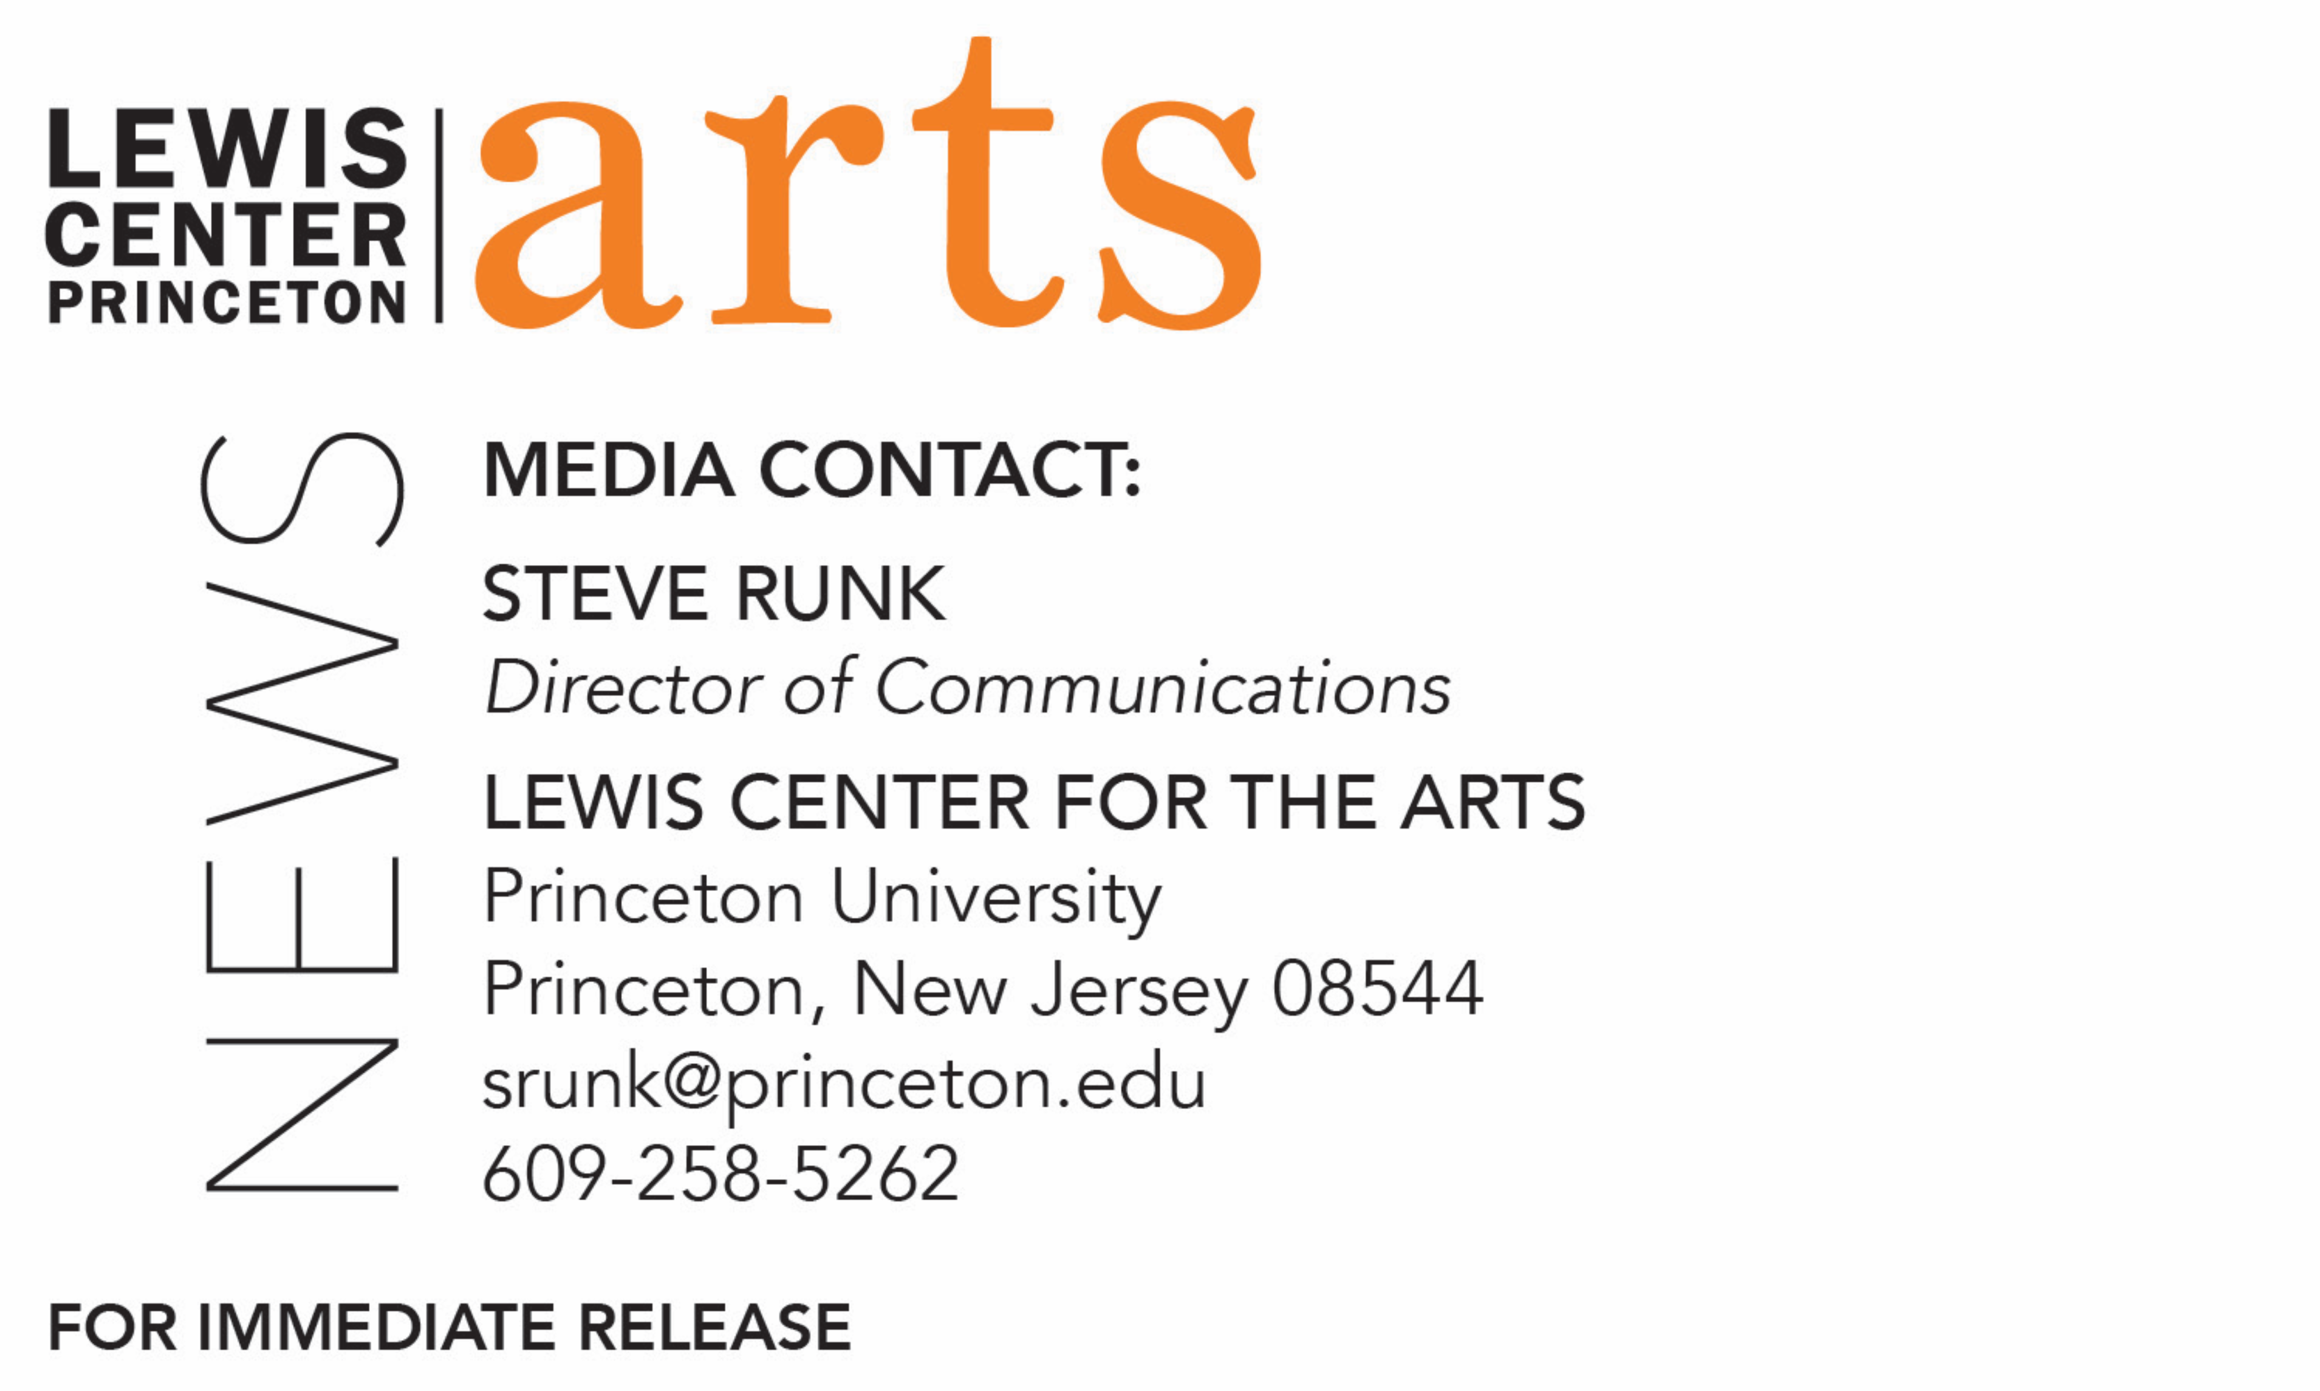

January 2, 2020

The Lewis Center for the Arts’ Program in Dance presents
Legacy + Lineage + Liberation
Open rehearsal of works in Urban Bush Women’s touring program celebrating the legendary company’s 25th anniversary and the power of Women (+), part of Princeton’s Hearst Choreographers-in-Residence Program

Photo caption: Open rehearsal of Urban Bush Women’s Legacy + Lineage + Liberation, will be presented at Princeton University on January 15
Photos credit: Courtesy of Urban Bush Women

What/Who: Join Urban Bush Women as they rehearse various works in Legacy + Lineage + Liberation, their touring program that celebrates the company’s 35th Anniversary and the power of Women(+). This collection of classic works, all choreographed by UBW Founder and Visioning Partner Jawole Willa Jo Zollar, transcend genres and amplify the voices of Women(+) of color. These iconic works give multiple dimensions of life that are timely and relevant and continue to resonate especially in this era of #MeToo and Black Lives Matter. Presented by the Lewis Center for the Arts’ Program in Dance as part of its Hearst Choreographers-in-Residence program.
When: January 15 at 4:30 p.m.
Where: Hearst Dance Theater at Lewis Arts complex on the Princeton University campus
Free and open to the public; no tickets required

(Princeton, NJ) The Lewis Center for the Arts’ Program in Dance at Princeton University will present an open rehearsal of Legacy + Lineage + Liberation, Urban Bush Women’s touring program that celebrates the company’s 35th Anniversary and the power of Women(+). The performance on January 15 is at 4:30 p.m. in the Hearst Dance Theater at the Lewis Arts complex on the Princeton University campus. The event is free and open to the public.

Founded in 1984, the now legendary Urban Bush Women (UBW) works to galvanize artists, activists, audiences and communities through performances, artist development, education and community engagement. With the ground-breaking performance ensemble at its core, ongoing initiatives like the Summer Leadership Institute, Builders, Organizers & Leaders through Dance, and the Choreographic Center, UBW continues to affect the overall ecology of the arts by promoting artistic legacies; projecting the voices of the under-heard and people of color; bringing attention to and addressing issues of equity in the dance field and throughout the United States; and by providing platforms and serving as a conduit for culturally and socially relevant experimental art makers.

The collection of classic works to be presented in this open rehearsal are choreographed by UBW Founder and Visioning Partner Jawole Willa Jo Zollar to transcend genres and amplify the voices of Women(+) of color. These iconic works give multiple dimensions of life that are timely and relevant and continue to resonate especially in this era of #MeToo and Black Lives Matter. The works are directed by new artistic co-directors Chanon Judson and Samantha Speis.

In addition to 34 works for UBW, Zollar has created works for Alvin Ailey American Dance Theater, Philadanco, University of Maryland, Virginia Commonwealth University and others; and with collaborators including Compagnie Jant-Bi from Senegal and Nora Chipaumire, a 2014-15 Hodder Fellow at Princeton. In 2006 Zollar received a New York Dance and Performance Award (Bessie) for her work as choreographer/creator of Walking With Pearl…Southern Diaries. Featured in the PBS documentary, Free to Dance, which chronicles the African-American influence on modern dance, Zollar was designated a Master of Choreography by the John F. Kennedy Performing Arts Center in 2005.

UBW has toured five continents and has performed at venues including Brooklyn Academy of Music, Lincoln Center for the Performing Arts and The Kennedy Center. UBW was selected as one of three U.S. dance companies to inaugurate a cultural diplomacy program for the U.S. Department of State in 2010. In 2011 Zollar choreographed visible with Chipaumire, a theatrical dance piece that explores immigration and migration. In 2012 Zollar was a featured artist in the film Restaging Shelter, produced and directed by Bruce Berryhill and Martha Curtis, and currently available to PBS stations.

“The Hearst Choreographer in Residence program brings many rich experiences to our community,” notes Rebecca Lazier, Associate Director of the Program in Dance and Acting Director for 2019-20. “We are especially excited to bring Urban Bush Women to campus for the first time and share this important program that celebrates a 25-year legacy of innovation, advocacy, and transformation.”

The Caroline Hearst Choreographer-in-Residence program, made possible by a gift from Margaret C. and William R. Hearst, III, is designed to foster the Program in Dance’s connections with the dance field. It provides selected professional choreographers with resources and a rich environment to develop their work and offers opportunities for students, faculty and staff to engage with diverse creative practices. The program, now in its third year, is designed to be flexible enough to create meaningful interaction between artists and students. Each Hearst artist develops engagement activities in coordination with the dance faculty in order to align with students’ interests and course work. The Hearst choreographers and the professional dancers in their companies have several points of contact with students over the course of their residencies.

Other Hearst choreographers in residence at Princeton this academic year include Brian Brooks, Annie B-Parson, and Jumatatu Poe, who will each be presenting on campus in the coming months.

Other recent Hearst Choreographers-in-Residence include Souleymane ‘Solo’ Badolo, Anne Teresa De Keersmaeker, Shannon Gillen, Jessica Lang, Ralph Lemon, Jennifer Nugent and Paul Matteson, Karen Sherman, Raphael Xavier; Olivier Tarpaga, who with his company, presented a new work currently touring the U.S. at Princeton in October, When Bird Refused to Fly; and Abby Zbikowski, who will bring her new work developed during her residency, Radioactive Practice, to Princeton in May.

For more information on the Program in Dance, the Hearst Choreographers-in-Residence program, and the more than 100 other performances, exhibitions, readings, screenings, concerts and lectures offered each year by the Lewis Center for the Arts, most of them free, visit arts.princeton.edu.

###

