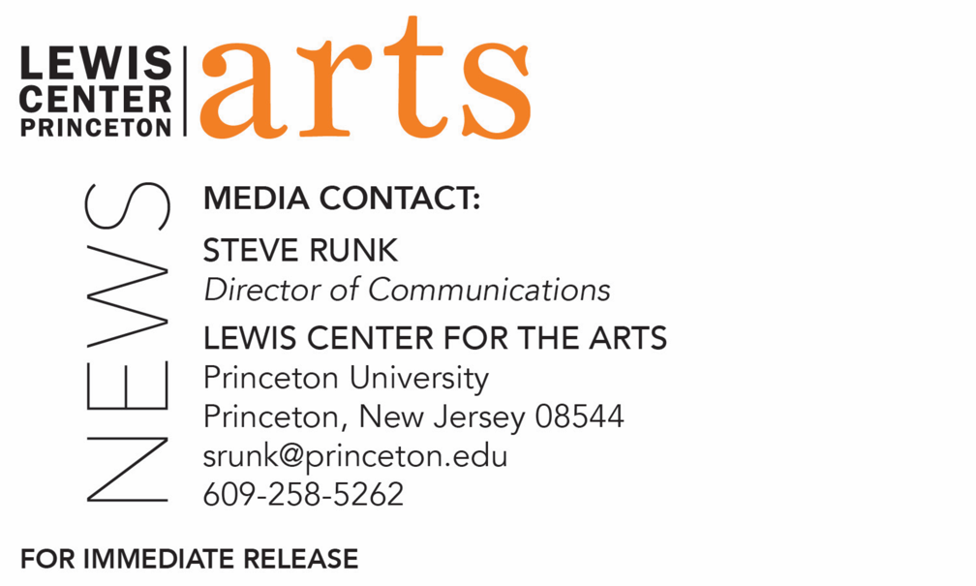

February 25, 2020

Lewis Center for the Arts’ Program in Creative Writing presents a reading by
Mei-mei Berssenbrugge and Yoko Tawada
Award-winning writers next in Althea Ward Clark W’21 Reading Series at Princeton

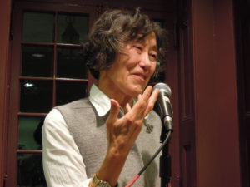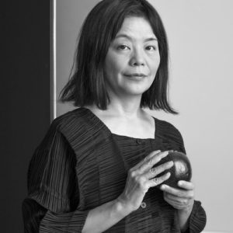
Photo caption 1: Mei-mei Berssenbrugge
Photos credit 1: Courtesy of New Directions
Photo caption 2: Yoko Tawada
Photos credit 2: Nina Subin

What: The next reading in the 2019-20 Althea Ward Clark W’21 Reading Series, part of a year-long celebration of the 80th anniversary of the Lewis Center for the Arts’ Program in Creative Writing at Princeton University
Who: American Book Award-winning poet Mei-mei Berssenbrugge and National Book Award-winning fiction writer Yoko Tawada
When: March 4 at 7:30 p.m.
Where: Donald G. Drapkin Studio at Lewis Arts complex on the Princeton University campus
Free and open to the public
(Princeton, N.J.) On March 4, the Lewis Center for the Arts’ Program in Creative Writing will present a reading by award-winning poet Mei-mei Berssenbrugge and National Book Award-winning fiction writer Yoko Tawada as a continuation of its yearlong 80th anniversary celebration. The reading is the next event in the Althea Ward Clark W’21 Reading Series and begins at 7:30 p.m. in the Donald G. Drapkin Studio in the Lewis Arts complex on the Princeton University campus. The reading is free and open to the public.

Mei-mei Berssenbrugge is the author of The Heat Bird (1983), winner of the American Book Award; Empathy (1989), winner of the PEN West Award; Sphericity (1993); Endocrinology (1997), a collaboration with the artist Kiki Smith; Four Year Old Girl (1998), winner of the Western States Book Award; Nest (2003); I Love Artists: New and Selected Poems (2006); and Hello, the Roses (2013). She has received two fellowships from the National Endowment for the Arts, two American Book Awards, and honors from the Western States Art Foundation and the Asian American Writers Workshop. Berssenbrugge was born in Beijing, the daughter of a Chinese mother and an American father who was the son of Dutch immigrants. Her family moved to the United States when she was a year old, and she earned a B.A. from Reed College and an M.F.A. from Columbia University. She lives in New Mexico.
Yoko Tawada writes in both Japanese and German and has published several books—stories, novels, poems, plays, essays—in both languages. Her reading will be in English. She has received numerous awards for her writing including the Akutagawa Prize, the Adelbert von Chamisso Prize, the Tanizaki Prize, the Kleist Prize, and the Goethe Medal. New Directions published her story collections Where Europe Begins (with a Preface by Wim Wenders) and Facing the Bridge, as well her novels The Naked Eye, The Bridegroom Was a Dog, Memoirs of a Polar Bear, and The Emissary, winner of the 2018 National Book Award for Translated Literature. Tawada was born in Tokyo in 1960, moved to Hamburg when she was 22 years old, and then to Berlin in 2006.
The Lewis Center’s Program in Creative Writing annually presents the Althea Ward Clark W’21 Reading Series, which provides an opportunity for students, as well as all in the greater Princeton region, to hear and meet the best contemporary writers. The series is organized by Lecturer in Creative Writing and award-winning poet Michael Dickman. All readings are at 7:30 p.m. in venues in the Lewis Arts complex and are free and open to the public. The 2019-2020 series continues on April 15 with a reading by Kaitlyn Greenidge, Helen Oyeyemi, and Nicole Sealey, a reading of new work on April 30 by selected students in creative writing courses, as well as readings on May 5 and 6 by seniors in the Program from the novels, collections of short stories, poems or translations, or screenplays written as their senior theses.
To learn more about this event, the Program in Creative Writing, and the more than 100 other performances, exhibitions, readings, screenings, concerts, and lectures presented each year by the Lewis Center, most of them free, visit arts.princeton.edu.
###

