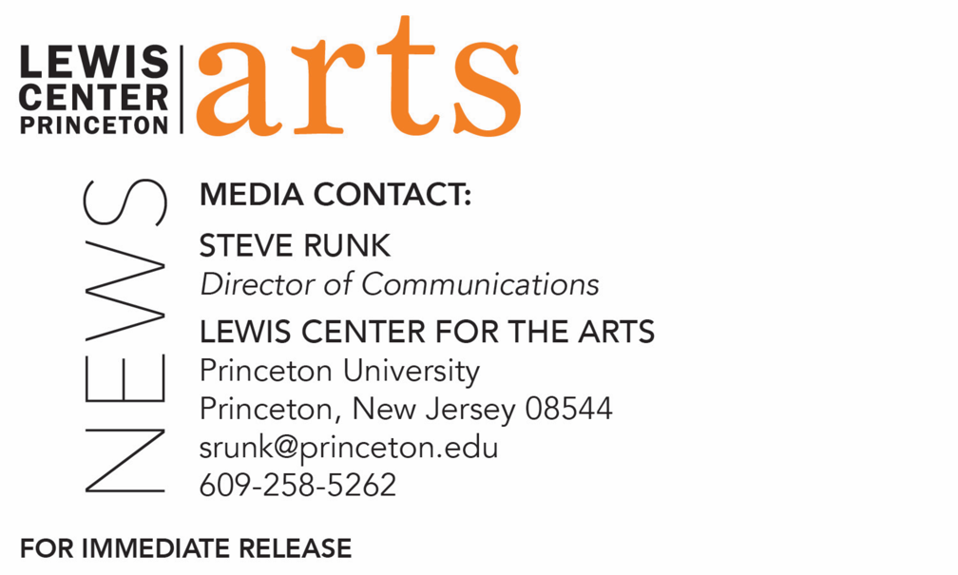

February 27, 2020

Fund for Irish Studies Series at Princeton University presents
A reading with Hannah Sullivan
T.S. Eliot Prize-winning poet next in the series

Photo Caption: Poet Hannah Sullivan
Photo Credit: Courtesy of Hannah Sullivan

Who/What: T.S. Eliot Prize-winning poet Hannah Sullivan reads from her work, presented by Princeton University’s Fund for Irish Studies
When: Friday, March 6 at 4:30 p.m.
Where: James Stewart Film Theater at 185 Nassau Street on the Princeton University campus
Free and open to the public
More info: https://arts.princeton.edu/events/fund-for-irish-studies-reading-hannah-sullivan/

(Princeton, NJ) T.S. Eliot Prize-winning poet Hannah Sullivan will read from her work on Friday, March 6. The event will take place at the James Stewart Film Theater at 185 Nassau Street on the Princeton University Campus at 4:30 p.m. The reading and conversation are free and open to the public as part of Princeton University’s 2019-20 Fund for Irish Studies series.

Three Poems is Hannah Sullivan’s first poetry book, published by Faber in 2018 (reprinted by FSG in 2020). It was awarded the T. S. Eliot Prize for 2018, and also the inaugural John Pollard International Prize for a best first collection. Sullivan grew up in Ealing, West London, and read Classics at Trinity College, Cambridge. She lived in the U.S. for about a decade in her twenties, first as a Ph.D. student at Harvard, and then in San Francisco. She now lives in London and teaches English at Oxford University.
The Fund for Irish Studies affords all Princeton students, and the community at large, a wider and deeper sense of the languages, literatures, drama, visual arts, history, politics, and economics not only of Ireland but of “Ireland in the world.” The series is co-produced by the Lewis Center for the Arts and the 2019-20 edition of the series is organized by Princeton’s Howard G.B. Clark ’21 University Professor in the Humanities and Professor of Creative Writing Paul Muldoon and Senior Lecturer in Theater Michael Cadden, who will introduce Sullivan’s reading.
Information about the Fund for Irish Studies series events can be found at fis.princeton.edu. Other events scheduled in the current series include:
- A reading by award-winning fiction writer Kevin Barry on April 2, cosponsored with Special Collections at Princeton University Library
- A lecture by Laurence Cox on his new book, The Irish Buddhist: The Forgotten Monk Who Faced Down the British Empire, written with Alicia Turner and Brian Bocking, on April 17

The Fund for Irish Studies is generously sponsored by the Durkin Family Trust and the James J. Kerrigan, Jr. ’45 and Margaret M. Kerrigan Fund for Irish Studies.

To learn more about the more than 100 public performances, exhibitions, readings, screenings, concerts, lectures and special events, most of them free, presented each year by the Lewis Center for the Arts, visit arts.princeton.edu.

###

