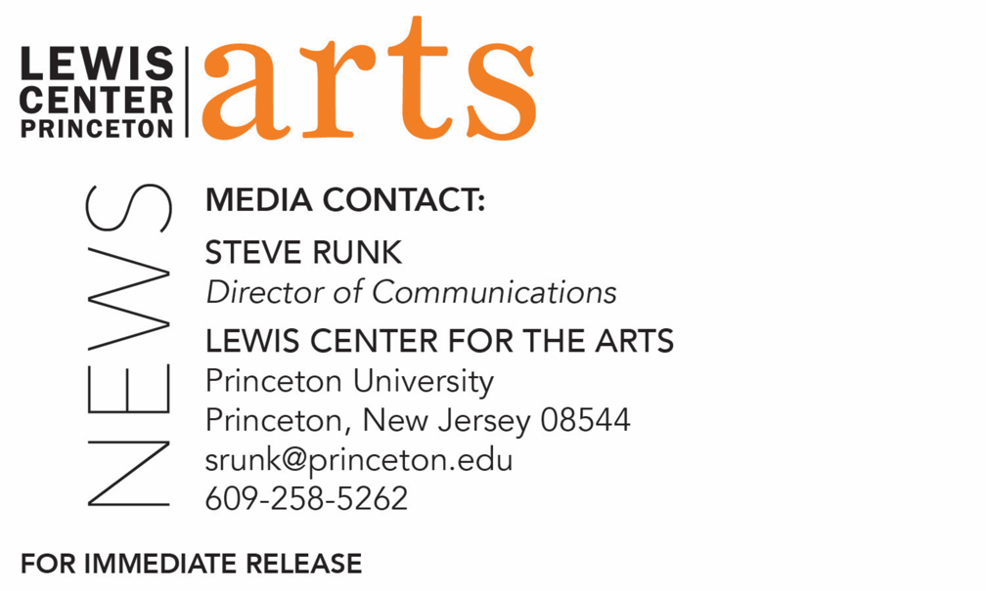

February 10, 2020

William Greaves: Psychodrama, Interruption, and Circulation, presented by the Lewis Center for the Arts’ Program in Visual Arts
A day-long symposium, screening and multi-week exhibition, William Greaves – Sondra Perry – Martine Syms, dedicated to this key figure in American filmmaking organized by artists Fia Backström and Martine Syms

Photo caption: Filmmaker William Greaves
Photo credit: Courtesy of William Greaves Productions

What: William Greaves: Psychodrama, Interruption, and Circulation, a day-long symposium centered on the work of William Greaves, a key figure in American filmmaking with keynote speaker Jacqueline Stewart, and panelists Malik Gaines, Naeem Mohaiemen, and Alex Pittman, moderated by Erin Cristovale, along with a screening of Greaves’ newly restored film Nationtime—Gary, and an exhibition, William Greaves – Sondra Perry – Martine Syms including works by Greaves and internationally renowned artists Martine Syms and Sondra Perry.
Who: Organized by artists Fia Backström and Martine Syms, presented by the Lewis Center for the Arts’ Program in Visual Arts at Princeton University, and cosponsored by Princeton’s Department of African American Studies and Department of Art and Archaeology with support from the John Sacret Young ’69 Lecture Series Fund.
When: Symposium on February 21 1:00 p.m.-7:30 p.m.; screening of newly restored film Nationtime—Gary February 21 at 6:00 p.m. (as part of symposium); and exhibition, William Greaves – Sondra Perry – Martine Syms, with opening reception February 21 1:00 p.m-3:00 p.m. and on view February 21-March 29, open daily 10:00 a.m. – 8:30 p.m.
Where: Hurley Gallery at Lewis Arts complex and James Stewart Film Theater at 185 Nassau St. on the Princeton University campus
Free and open to the public, however advance registration is recommended.
For more information and to register: arts.princeton.edu/william-greaves

(Princeton, NJ) The Lewis Center for the Arts’ Program in Visual Arts at Princeton University presents William Greaves: Psychodrama, Interruption, and Circulation, a series of events centered on the work of William Greaves, an important yet under-represented figure in American filmmaking. The events include a day-long symposium on February 21 from 1:00 p.m. to 7:30 p.m. held in the Hurley Gallery at the Lewis Arts complex and in the James Stewart Film Theater at 185 Nassau Street, both located on the Princeton campus; a screening of Greaves’ recently restored film Nationtime—Gary at 6:00 p.m. in the Stewart Theater; and an exhibition, William Greaves – Sondra Perry – Martine Syms, of works by Greaves and internationally renowned artists Martine Syms and Sondra Perry, both of whom are working in the vein of his legacy, on view February 21 through March 29 at the Hurley Gallery. The events are organized by artists Fia Backström and Martine Syms and cosponsored by Princeton’s Department of African American Studies and Department of Art and Archaeology with support from the John Sacret Young ’69 Lecture Series Fund. All the events are free and open to the public, however advance registration for the symposium is encouraged.

William Greaves (1926-2014) was a film director and producer with an extraordinarily diverse body of work produced over a career spanning 50 years. His work, in addition to Nationtime—Gary, includes Emmy-nominated breakthrough films, as well as sponsored documentaries. Greaves is best known for his early use of cinéma vérité, psychodrama, and split screen techniques. Despite Greaves’ historical and contemporary significance, under-representation has meant that few of his films are restored and available. The William Greaves symposium shares his work with a new generation and gives access to some of his films that have rarely been screened.

Initially unable to break into a U.S. film industry that was closed to African Americans, Greaves left America in 1952 and spent almost a decade in Canada. He worked for many years on the staff of the National Film Board, where he eventually became chief editor of the internationally recognized award-winning Unit B and, in 1958, produced, directed and edited, Emergency Ward. But by 1963, the Civil Rights Movement was beginning to open doors to African Americans in the American media. Greaves had always planned to return to the United States. That year, as a filmmaker with years of training and experience, he returned to the U.S. to play a role in telling the story of African Americans’ centuries-long struggle for freedom and equality at this critical period in American history. Out of this came the films The First World Festival of Negro Arts (1966), Still a Brother: Inside the Negro Middle Class (1968), and From These Roots (1973). From These Roots, the first documentary about the Harlem Renaissance, is considered an African American Studies classic, and Symbiopsychotaxiplasm:Take One (1968) is an exemplar of Greaves’ innovative techniques and is now listed in the Registry of American film at the Library of Congress.

The symposium schedule begins with an opening reception for the exhibition from 1:00 p.m. to 3:00 p.m. in the Hurley Gallery. Starting at 2:30 p.m. buses will shuttle symposium guests from the Lewis Arts complex to 185 Nassau Street for the balance of the day. At 3:00 p.m. Jacqueline Stewart will give the keynote address in the James Stewart Film Theater. Stewart is a professor in the Department of Cinema and Media Studies at the University of Chicago, and she directs the South Side Home Movie Project and the Cinema 53 screening and discussion series. She is the host of Silent Sunday Nights on Turner Classic Movies and is the Director of Arts + Public Life at University of Chicago. Following at 4:00 p.m. there will be a panel discussion with Backström and Syms; Malik Gaines, associate professor of Performance Studies at NYU, Tisch School of the Arts and author of Black Performance on the Outskirts of the Left (2017); Alex Pittman, a term assistant professor of Women’s, Gender, and Sexuality Studies at Barnard College and author of the book-in-progress, Capital in the Flesh: Constrained Intimacies in Black Art after Deindustrialization; and Naeem Mohaiemen, researcher on socialist utopia and incomplete decolonizations and author of Prisoners of Shothik Itihash; and moderated by Erin Christovale, associate curator at the Hammer Museum and the co-founder of Black Radical Imagination. The screening of Nationtime—Gary at 6:00 p.m. will conclude the day.

Until its recent discovery in a Pittsburgh warehouse, amidst thousands of films abandoned when the WRS laboratory went bankrupt, Greaves’ original cut of Nationtime—Gary (1972) was assumed to have been lost. Found and restored by IndieCollect 47 years after the National Black Political Convention took place in Gary, Indiana, the original full-length film documenting this momentous event can now be seen. Greaves had been approached by Amiri Baraka about the possibility of filming the historic convention. Baraka, along with Congressman Charles C. Diggs, Jr., and Mayor Richard M. Hatcher of Gary, Indiana, co-convened the convention. There was no money available in the convention budget, but recognizing the significance of the event, Greaves took up the challenge, put together a three-camera crew, and spent three days covering the event. He later edited the footage into the documentary.

The exhibition, “William Greaves — Sondra Perry — Martine Syms,” includes rarely seen films by Greaves, together with works by internationally renowned artists Martine Syms and Sondra Perry, both of whom are working in the vein of Greaves’ legacy. On view will be Greaves’ In the Company of Men, which uses psychodrama to help bridge the communication gap between a group of the so-called “hard-core unemployed”—largely Black and “underclass”—and the men who hire, train and supervise them—mostly white and middle class. The film was originally commissioned by Newsweek and approaches a social documentary with a social experiment as seen through Greaves’s keen observational eye and editing style. In addition, select episodes of Black Journal will be screened, for which Greaves was the executive producer from 1969 to 1970. Black Journal is a landmark in American broadcast history as the first nationally televised, regularly scheduled African American public affairs program. Black Journal offers an unprecedented inside look at a pivotal period for the Civil Rights and Black Liberation Movements of the 1960s from the perspective of the African Americans making the news and shaping Black opinion. Alongside Greaves’ work, an iteration of Syms’ video installation Lessons will be on view, which is a cumulative poem in many parts in a randomly evolving structure of disconnected experiences and subjects that accumulate in a mass of fragmentary narratives, relating (directly or indirectly) to the lives of Black Americans. Each piece, or commercial, is thirty seconds in duration and articulates a lesson from the Black radical tradition. Perry’s video installation Lineage for a Multiple-Monitor Workstation: Number One is a two-channel video installation, screened on a chroma-key green painted wall. The work takes the form of a family portrait in multiple windows on dual computer screens that invite viewers to reimagine black identity and social history through reconstructed personal and fabricated family traditions. On view for over five weeks following the symposium, the exhibition is open daily 10:00 a.m. to 8:30 p.m.

Backström is an interdisciplinary artist, writer and educator who works on the construction of collective subjectivity through fields images and language use. In 2011 she represented Sweden in the Venice Biennale and was included in the 2008 Whitney Biennial, and Greater New York, PS1 in 2016. She was a Fellow in The Artist’s Institute at Hunter College in fall 2015. Her work has been shown in numerous international institutional exhibitions including: MoMA (2010), White Columns (2008), and the Kitchen (2007), New York; Centre George Pompidou, Paris (2019); Moderna Museet, Stockholm (2010, 2019); The Baltic, Newcastle (2009); Tranzit, Prague (2008); and the Serpentine Gallery, London (2007). Her writings have been published in magazines such as Artforum, Art on Paper and North Drive Press. Her books include COOP A-Script, Primary Information (2016) and Fia Backström, Sternberg Press (2011). In 2018 she received the Bernard Heidsieck Literary Prize – Centre Pompidou. Backström holds a full-time position at Cooper Union and is co-chair of the photography department at Bard MFA. She is represented by Callicoon Fine Arts in New York.

Syms uses video and performance to examine representations of blackness. Her artwork has been exhibited and screened extensively, including presentations at the Museum of Modern Art, Hammer Museum, ICA London, New Museum, Museum of Contemporary Art Los Angeles, and The Studio Museum in Harlem, among other institutions. She has lectured at Yale University, SXSW, California Institute of the Arts, University of Chicago, Johns Hopkins University, and MoMA PS1, among other venues. Syms’ recently presented exhibitions include BOON, Secession; Shame Space, ICA Virginia Commonwealth University; Grand Calme, SCHQ; Big Surprise, Bridget Donahue Gallery; Contemporary Projects: Martine Syms, Serralves Museum; Projects 106: Martine Syms, Museum of Modern Art; Fact and Trouble, ICA London. From 2007-2011 she was the co-director of the Chicago artist-run project space Golden Age, and she currently runs Dominica Publishing, an imprint dedicated to exploring blackness in visual culture. She is the author of Implications and Distinctions: Format, Content and Context in Contemporary Race Film (2011).

A publication will accompany the events with texts by Aria Dean, Devorah Heitner, and Jared Sexton, alongside a conversation with organizers Backström and Syms.

For more information and to register visit: arts.princeton.edu/william-greaves. To learn more about the Program in Visual Arts, and the over 100 performances, exhibitions, readings, screenings, concerts, and lectures presented each year at the Lewis Center, most of them free, visit arts.princeton.edu.

###

