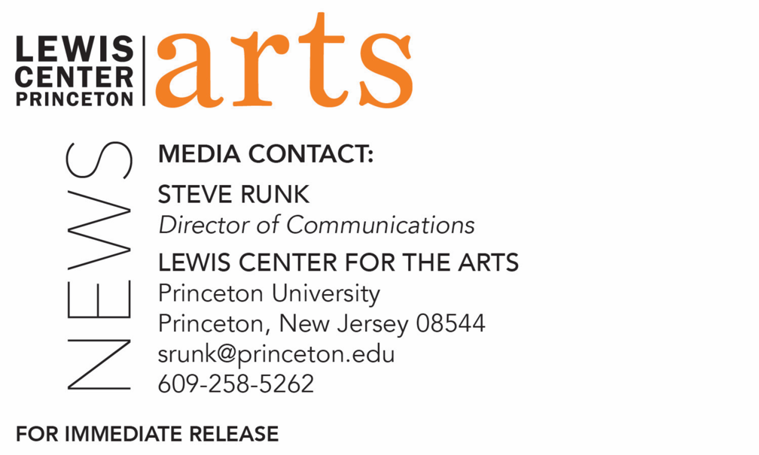

February 21, 2020

Lewis Center for the Arts at Princeton University presents a
Series of Conversations and Master Classes
with Musical Theater Guest Artists
Director Sammi Cannold, dramaturg/literary manager Ken Cerniglia, performer Arielle Jacobs, director/choreographer Emily Maltby, and composer/lyricist Georgia Stitt visit as part of a spring course on the Broadway musical

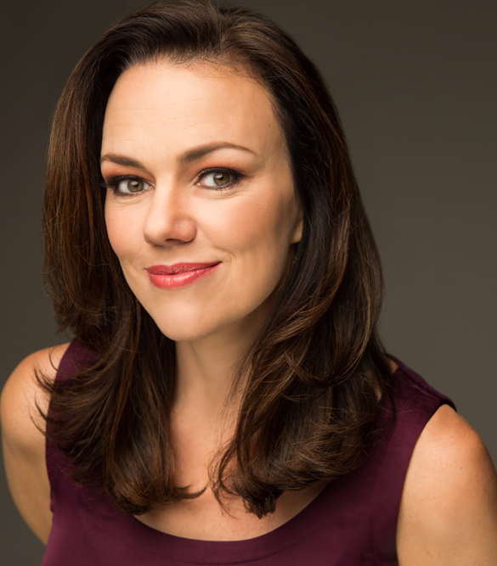

Photo caption 1: Musical theater director Sammi Cannold (Evita, Ragtime)
Photo caption 2: Dramaturg and literary manager Ken Cerniglia (Hadestown, Peter and the Starcatcher)
Photo caption 3: Broadway performer Arielle Jacobs (Aladdin)
Photo caption 4: Musical theater choreographer and director Emily Maltby (Evita)
Photo caption 5: Musical theater composer, lyricist and producer Georgia Stitt
Photo credit: Courtesy of the artists

What: A series of conversations and master classes with musical theater artists who are guests to the spring course “Isn’t It Romantic: The Broadway Musical from Rodgers & Hammerstein to Sondheim” taught by Professor Stacy Wolf
Who/When: Broadway performer Arielle Jacobs on February 25 at 3:00 p.m.; musical theater director Sammi Cannold on March 10 at 1:30 p.m.; director/choreographer Emily Maltby on March 10 at 3:00 p.m.; dramaturg Ken Cerniglia on March 24 at 3:00 p.m.; and composer/lyricist/producer Georgia Stitt on March 31 at 3:00 p.m.
Where: Drapkin Studio in the Lewis Arts Complex, 122 Alexander Street, Princeton, NJ
Free; Conversations open to public; Master classes open to Princeton students to participate with public welcome to observe

(PRINCETON, NJ) On select Tuesdays in February and March, director Sammi Cannold, dramaturg Ken Cerniglia, Broadway performer Arielle Jacobs, choreographer and director Emily Maltby, and composer, lyricist and producer Georgia Stitt will discuss their experiences in the music theater industry and lead masterclasses as part of Director and Professor of Music Theater Stacy Wolf’s spring course, “Isn’t It Romantic: The Broadway Musical from Rodgers & Hammerstein to Sondheim.” The events will take place in the Drapkin Studio at the Lewis Arts complex on the Princeton campus. Presented by the Lewis Center for the Art’s Program in Music Theater and co-sponsored by the Program in American Studies, the events are free to the public. The masterclasses are open to Princeton students to participate and the public to observe; conversations are open to all.

On February 25 at 3:00 p.m., performer Arielle Jacobs will lead a master class and conversation about her experience as a Broadway performer. On March 10, director Sammi Cannold will participate in a conversation at 1:30 p.m., followed by a masterclass and conversation with choreographer/director Emily Maltby beginning at 3:00 p.m. Dramaturg Ken Cerniglia joins in a conversation on March 24 at 3:00 p.m., and the series concludes with a conversation with composer, lyricist and producer Georgia Stitt on March 31 at 3:00 p.m.

Wolf’s course explores conventional and resistant performances of gender and sexuality in the Broadway musical since the 1940s, including, for example, In the Heights and West Side Story. Students examine how musical theater artists, composers, lyricists, librettists, directors, choreographers, and designers have worked with the basic building blocks of song, dance, man and woman to create the Broadway musical – a quintessentially American form of art and entertainment. Their investigations ask the question, why are musicals structured by love and romance? Students in the course take a field trip to New York to see a Broadway musical.

Director Sammi Cannold is one of Forbes Magazine's 30 Under 30 in Hollywood & Entertainment, class of 2019. This winter, she is directing Celine Song's Endlings Off-Broadway at New York Theatre Workshop after having helmed the world premiere at the American Repertory Theater (A.R.T.) in 2019 and the play’s development at Playwrights Realm and the Eugene O’Neill Theater Center in 2018. Other recent credits include Evita at New York City Center, Ragtime on Ellis Island, Violet on a moving bus at the A.R.T, and Allegory at La Jolla Playhouse WOW. Cannold has also served as an artistic fellow at the A.R.T., is a member of Cirque du Soleil's Creative Cognoscenti, and she is a Sundance Institute Fellow. She holds a B.A. from Stanford University and an M.A. from Harvard University.

Ken Cerniglia is a dramaturg and former literary manager for Disney Theatrical Group, where he developed over 50 shows for professional, amateur, and school productions, including Freaky Friday, Aladdin, The Hunchback of Notre Dame, Peter and the Starcatcher, Newsies, High School Musical, Tarzan, and The Little Mermaid. Recent freelance projects include the Tony Award-winning Hadestown (New York Theatre Workshop), Bud, Not Buddy (Kennedy Center), Passion Trilogy (Fisher Ensemble), and Bridges (Berkeley Playhouse). Cerniglia holds a Ph.D. in drama from the University of Washington and is president of Literary Managers and Dramaturgs of the Americas.

Arielle Jacobs was most recently seen playing Princess Jasmine in Aladdin and performed as Nessarose in the Broadway cast of Wicked. She also starred on Broadway as Nina Rosario in the four-time Tony and Grammy Award-winning Broadway musical In the Heights, opposite composer/creator Lin-Manuel Miranda. Off-Broadway, she has starred in two world-premiere plays by Pulitzer-winning playwright and director Nilo Cruz: Sotto Voce (as Lucila Pulpo) and Farhad Or The Secret Of Being (as Farhad). Jacobs was seen in the original national touring companies of In the Heights (as Nina) and Disney’s High School Musical (as Gabriella), in Shakespeare Theatre Company’s production of Two Gentlemen of Verona: A Rock Opera (Julia), and in Dreamcatcher Theatre’s production of Into the Woods (Baker’s Wife), opposite Broadway legend Tituss Burgess as the Witch.

Emily Maltby is a New York City-based director and choreographer. Her current projects include Evita at New York City Center and Allegory at La Jolla WOW Festival. Most recently she directed a reimagining of Lerner and Barry's Lolita, My Love at the York Theatre Company, as well as a new production of Fiddler on The Roof in Singapore. Other credits include West Side Story (Priscilla Beach Theater), Percival… (Adirondack Theater Festival), and the world premiere of Toast (Bloomington Playwrights Project). As an associate, she directed First Daughter Suite (The Public Theater) and The Lion (Manhattan Theater Club). Maltby served as a dramaturg for New York Music Festival for three years and script supervisor for the development and Broadway production of Anastasia. She holds a Bachelor’s degree from Northwestern University.

Georgia Stitt is a composer/lyricist, music director, pianist, and music producer. Her original musicals include Snow Child (commissioned by Arena Stage and directed by Molly Smith); Samantha Spade, Ace Detective (commissioned by TADA Youth Theater and written with Lisa Diana Shapiro, National Youth Theatre 2014 Winner “Outstanding New Musical”); Big Red Sun (NAMT Festival winner in 2010, Harold Arlen Award in 2005, written with playwright John Jiler); The Water (winner of the 2008 ANMT Search for New Voices in American Musical Theatre and written with Jeff Hylton and Tim Werenko); and Mosaic (commissioned for Inner Voices Off-Broadway in 2010 and written with Cheri Steinkellner). She is currently writing The Big Boom (with Hunter Foster), Common Ground (with Lisa Diana Shapiro), Signature Stitch (with Warren Adams), and an as-yet untitled oratorio.

Stacy Wolf is Professor of Theater at Princeton, Director of Fellowships, and Director of Princeton’s Program in Music Theater. She is the author of Beyond Broadway: The Pleasure and Promise of Musical Theatre Across America (Oxford University Press, 2020), which explores musical theater across the country in local and amateur venues like summer camps, high schools, and community theatres. She is also the author of Changed for Good: A Feminist History of the Broadway Musical and A Problem Like Maria: Gender and Sexuality in the American Musical. Wolf received a Guggenheim Fellowship and received a President’s Award for Distinguished Teaching at Princeton University.

The Program in Music Theater is a collaboration among the Lewis Center for the Arts’ Program in Theater and Program in Dance and the Department of Music, which brings together students, faculty, and guest artists in the creation, study, and performance of music theater to support and develop all forms of music theater—that is, any theatrical form that combines singing, acting, and movement—as both an artistic practice and a field of scholarly study.
For more information on the Program in Music Theater and the more than 100 other events offered each year by the Lewis Center for the Arts, visit arts.princeton.edu.

###

