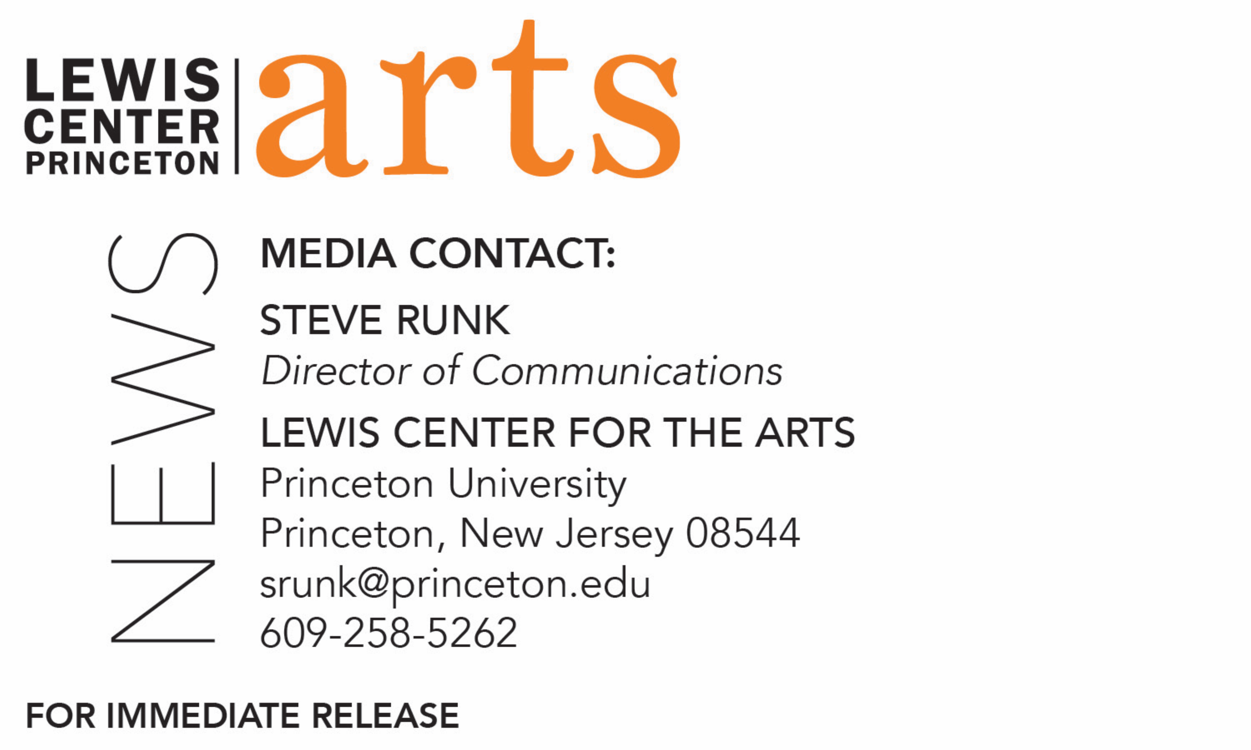

March 9, 2020

Lewis Center for the Arts’ Program in Dance presents
Hindsight: A Collaborative Senior Dance Concert
featuring choreography by Princeton senior Cooper Young and performance of works by acclaimed choreographers Omri Drumlevich, Jessica Lang, and Crystal Pite

Photo caption: Seniors in Princeton’s Program in Dance who will perform together and in solo, duet and group works by guest choreographers and students in their senior dance concert Hindsight
Photo credit: Felicity Audet

What/Who: Hindsight, a collaborative dance concert featuring new choreography by Princeton senior Cooper Young and performances by seniors in Princeton University’s Program in Dance of new and repertory works by acclaimed choreographers Omri Drumlevich, Jessica Lang, and Crystal Pite. Presented by the Lewis Center for the Arts’ Program in Dance.
When: March 26 and 27 at 8:30 p.m. and March 28 at 2:00 p.m. and 8:30 p.m.
Where: Hearst Dance Theater at Lewis Arts complex, 122 Alexander Street, Princeton, NJ
Tickets: Free and open to the public, however advance tickets recommended. Tickets are available through University Ticketing online, or by calling 609-258-9220.

(Princeton, NJ) The Lewis Center for the Arts’ Program in Dance at Princeton University will present Hindsight, a collaborative dance concert showcasing new choreography by Princeton senior Cooper Young and performances by senior dance students of repertory and new works by guest choreographers Omri Drumlevich, Jessica Lang, and Crystal Pite. Performances are on Thursday, March 26 and Friday, March 27 at 8:30 p.m. and Saturday, March 28 at 2:00 p.m. and 8:30 p.m. in the Hearst Dance Theater, located at the Lewis Arts complex on the Princeton campus.

The Program in Dance requires certificate students to undertake a rigorous course of study that includes courses in modern, contemporary, ballet, experimental, urban, and African dance techniques, as well as choreography, dance theory, and history, and to participate in performance opportunities including the annual Princeton Dance Festival. The dance certificate, similar to a minor, is in addition to a student’s major area of study. Hindsight is an opportunity for seniors to collaborate on producing their own choreography and to work with professional choreographers and professional lighting and costume designers to bring their vision to life.

Sarah Betancourt, a French and Italian major, and Peyton Cunningham, a sociology major, are performing an excerpt from Crossed choreographed by Jessica Lang. Crossed was commissioned by The Joffrey Ballet and premiered in 2010 at The Auditorium Theatre in Chicago. This excerpt is set to Handel's Dixit Dominus: De torrente in via bibet.

Jorina Kardhashi, a computer science major, and Serena Lu, a psychology major, are performing an excerpt of Grace Engine choreographed by Crystal Pite and restaged by Alexandra Damiani. Grace Engine was premiered by Cedar Lake Contemporary Ballet in 2012 at La Maison de la Danse, Lyon, France. This powerful and cinematic company piece is set to an electronic score composed by Owen Belton and is a descent into the heart of a poignant and vulnerable final duet, where two women are confronted with loss.

Abigail Kostolansky, a chemistry major, will be performing a new work choreographed by Omri Drumlevich, Catching The Butterfly. The work is a playful journey through the realms of the imagined, a short portrait celebrating childlike freedom.

Cooper Young is a mathematics concentrator and also pursuing a certificate in creative writing. In his piece, Take Your Time, he aims to deconstruct the meaning of the phrase which serves as the title. He notes the expression means to work slowly and thoroughly, but the verb “to take” has the connotation of an active and precipitous action. His piece seeks to embody this contradiction and to explore ways to visualize the passing of time and the ways we try to take it back.

The six seniors noted above are joined by seniors Sofia Bisogno, a civil and environmental engineering major; computer science major Aleksandra Kostic; Siena Dumas Ang, a graduate student in quantitative and computational biology; Jhor van der Horst, a visual arts major; anthropology major Marshall Dylan Schaffer; and Maria Stahl, an ecology and evolutionary biology major. Together, they will perform The Art of Walking Away, a new work by Omri Drumlevich. The Art of Walking Away was created in conversation with the cast and is a goodbye letter to an anonymous figure written by each dancer. The process of developing movement from these letters raised questions about the illusion of separation and what can break this illusion.

Professionally designed costumes and lighting for Hindsight are by Mary Jo Mecca and Aaron Copp, respectively.

Tickets are $12 general admission in advance; $17 general admission day of the event; $12 for seniors; and $10 for Princeton students (Passport to the Arts eligible). Tickets are available online through University Ticketing, by calling 609-258-9220, or at the door on the night of performances.
For more information on this event, the Program in Dance, or any of the more than 100 performances, exhibitions, readings, screenings and lectures presented annually by the Lewis Center for the Arts, visit arts.princeton.edu.

###

