March 3, 2020

Princeton Creative Writing Professor Yiyun Li Wins PEN/Jean Stein Book Award

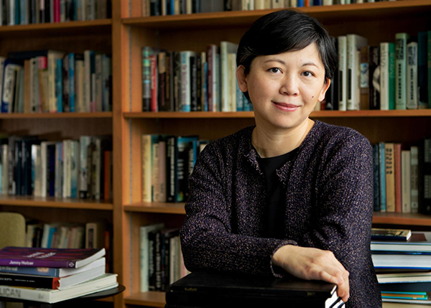

Photo Caption: Writer and Professor of Creative Writing Yiyun Li
Photo Credit: Denise Applewhite

(Princeton, NJ) Yiyun Li, Professor of Creative Writing in Princeton University’s Program in Creative Writing, has received the PEN/Jean Stein Book Award for her novel, Where Reasons End. The award was announced at the annual PEN America Literary Awards Ceremony on March 2 at the Town Hall in New York City.

Where Reasons End records posthumous conversations between a mother and the young son she recently lost to suicide. The novel has received much acclaim since its publication in February 2019 and has been included on several recommended reading lists including TIME Magazine, New York Times, The Irish Times, The Guardian, and NPR. In December, Literary Hub named the novel among “26 Books from the Last Decade that More People Should Read.”

“In this spare, haunting, deeply humane novel, Yiyun Li bends the conventions of narrative to accommodate an extremity of experience that’s often beyond representation,” noted the panel of judges when announcing the award. “…what might have been an unremittingly desolate book instead bristles with humor and playfulness, and achieves finally a profound reconciliation. Li has written a novel unlike anything we have read before, a book that is beautiful and wise, and almost unbearably moving in its portrait of a woman turning to literature as to a last resort, and finding that it might—barely, savingly—suffice.”

The PEN/Jean Stein Award was established in 2016 to honor a book-length work of any genre for its originality, merit, and impact. The selected work must demonstrate that it has broken new ground by reshaping the boundaries of its form and signal a strong potential for lasting influence. The 2020 panel of judges included Marilyn Chin, Garth Greenwell, Rebecca Makkai, Michael Schaub, and William T. Vollmann. The award carries a stipend of $75,000. Past award recipients include Nana Kwame Adjei-Brenyah, Layli Long Soldier, and Hisham Matar.
“It’s a great honor to receive this award from PEN America—an important and essential organization supporting American and international writers,” said Li. “The award for this book is also reassurance that literature lives and gives life.”

Each year, the PEN America Literary Awards confer over $330,000 to writers and translators whose exceptional literary works were published during the past year. Spanning fiction, poetry, essay, science writing, translation, and more, the finalist titles are dynamic, diverse, and thought-provoking examples of literary excellence. The works are judged by panels of esteemed writers, editors, translators, and critics.

Li, a resident of Princeton, grew up in Beijing and came to the United States in 1996 to pursue a science career in immunology before she became a writer. She earned a B.S. from Peking University in Beijing in 1996 and earned her M.S. and an M.F.A. in creative nonfiction writing from the University of Iowa in 2000 and 2005, respectively. Before joining the creative writing faculty at Princeton in September 2017, Li taught fiction at the University of California, Davis, where she received the 2011 Chancellor’s Fellowship, one of the highest and most prestigious faculty honors at the University.

Li is the author of six books, including, in addition to Where Reasons End, the story collections A Thousand Years of Good Prayers and Gold Boy, Emerald Girl; the novels The Vagrants, and Kinder Than Solitude; and an essay collection, Dear Friend, from My Life I Write to You in Your Life. Her work has been translated into more than 20 languages. Li was named a MacArthur Foundation Fellow in 2010 and was chosen by The New Yorker as one of the 20 fiction writers under 40 to watch. Her other awards include the Frank O’Connor International Short Story Award, a PEN/Hemingway Award, the Guardian First Book Award, an Asian American Literary Award for fiction, the Benjamin H. Dank Award from American Academy of Arts and Letters, Sunday Times EFG Short Story Award, and others. A Thousand Years of Good Prayers, an independent film directed by Wayne Wang and adapted by Li from her short story of the same name, was the winner of the Golden Shell for best film at the 55th San Sebastian International Film Festival.

Where Reasons End is also included on the longlist for the 2020 PEN/Faulkner Award for Fiction. Winners will be announced in April.

Li teaches introductory and advanced fiction courses in Princeton’s Creative Writing Program. These undergraduate writing workshops of no more than 10 students are taught by some of the nation’s most celebrated writers. Li’s renowned faculty colleagues include Michael Dickman, Aleksandar Hemon, A.M. Homes, Christina Lazaridi, Jhumpa Lahiri, Paul Muldoon, James Richardson, Tracy K. Smith, Kirstin Valdez Quade, Susan Wheeler, Monica Youn, and a number of distinguished lecturers. Each year these faculty members also work individually with 20 to 30 seniors on a creative writing thesis, such as a novel, screenplay, or a collection of short stories, poems, or translations.

To learn more about the Program in Creative Writing, course offerings, faculty and visiting writers, or upcoming readings, please visit arts.princeton.edu.

###

