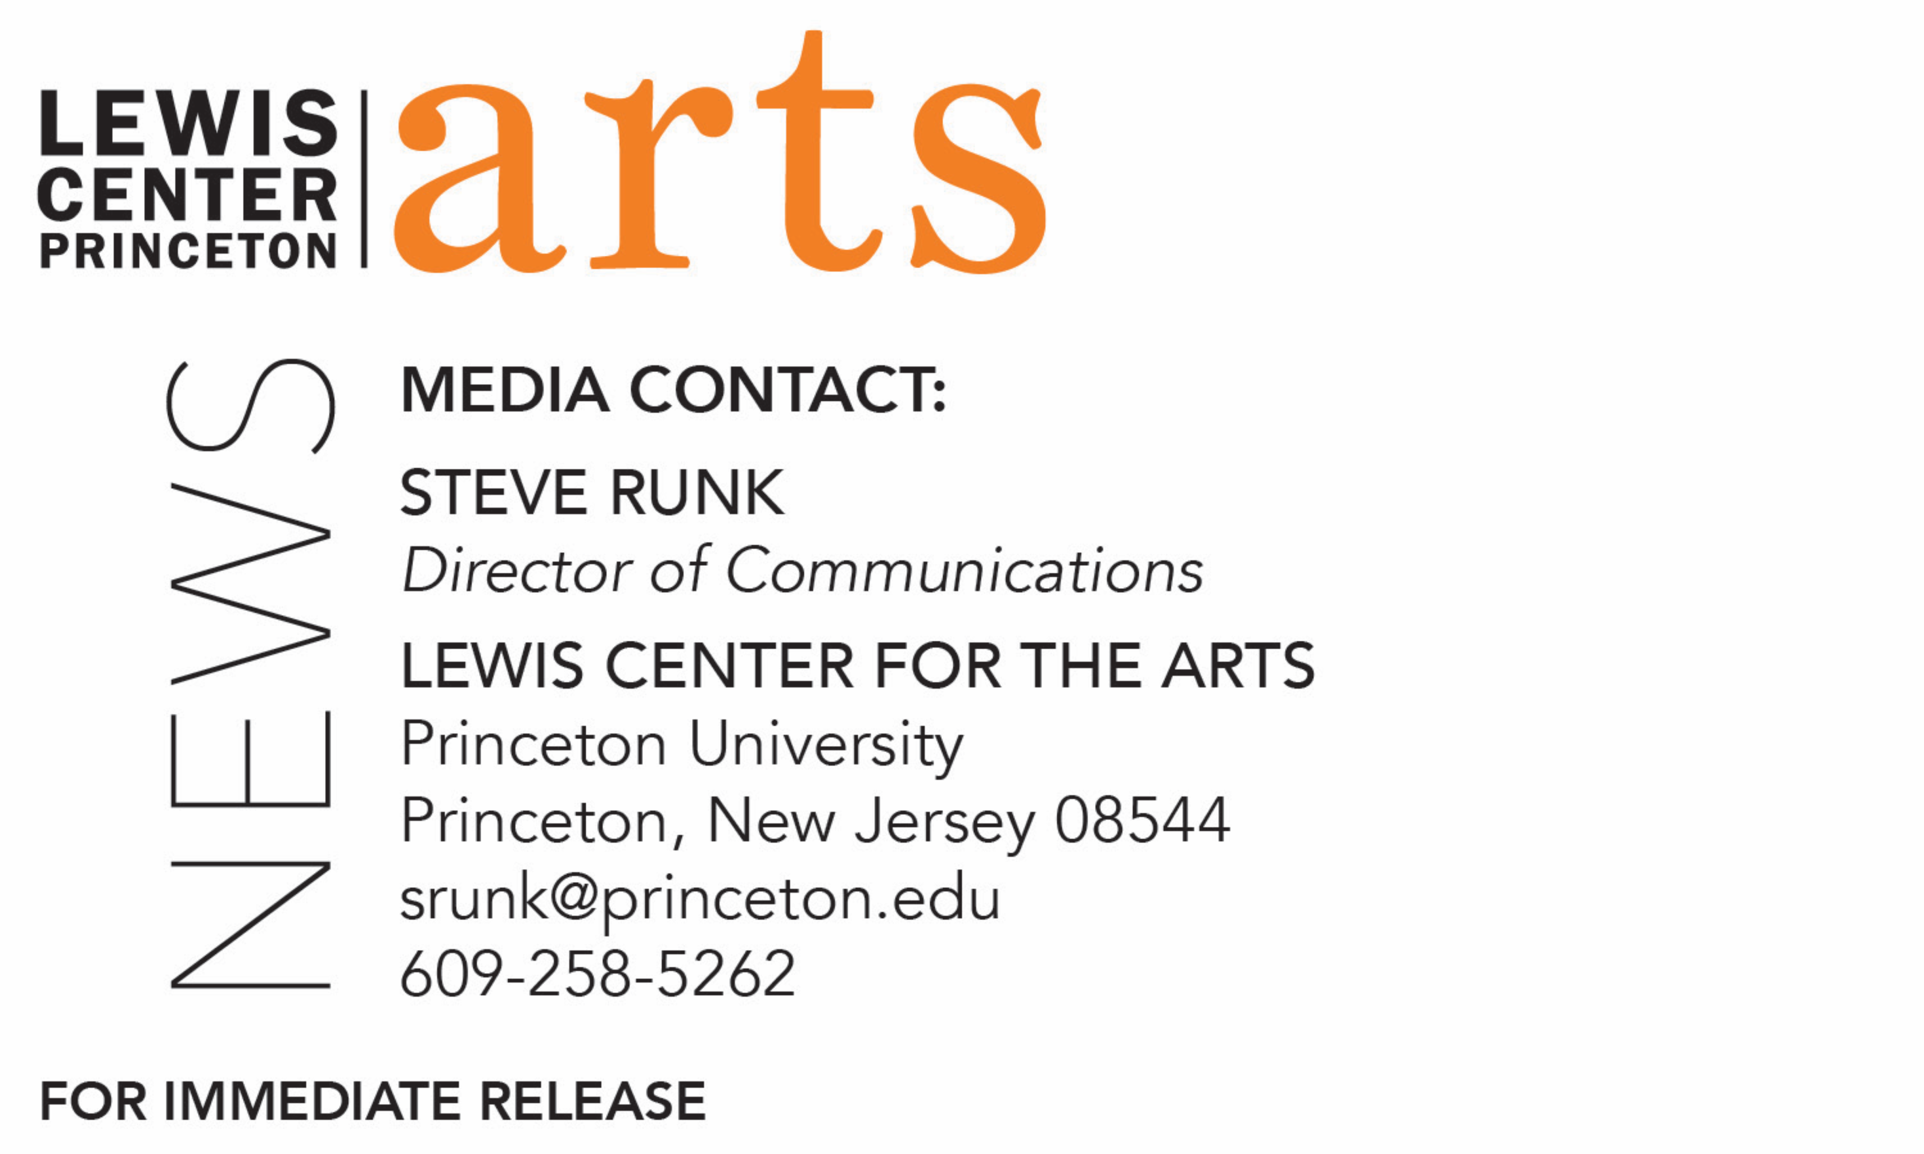
April 20, 2020

Princeton Arts Fellows for 2020-22 Announced
Theater director Will Davis and writer Danez Smith

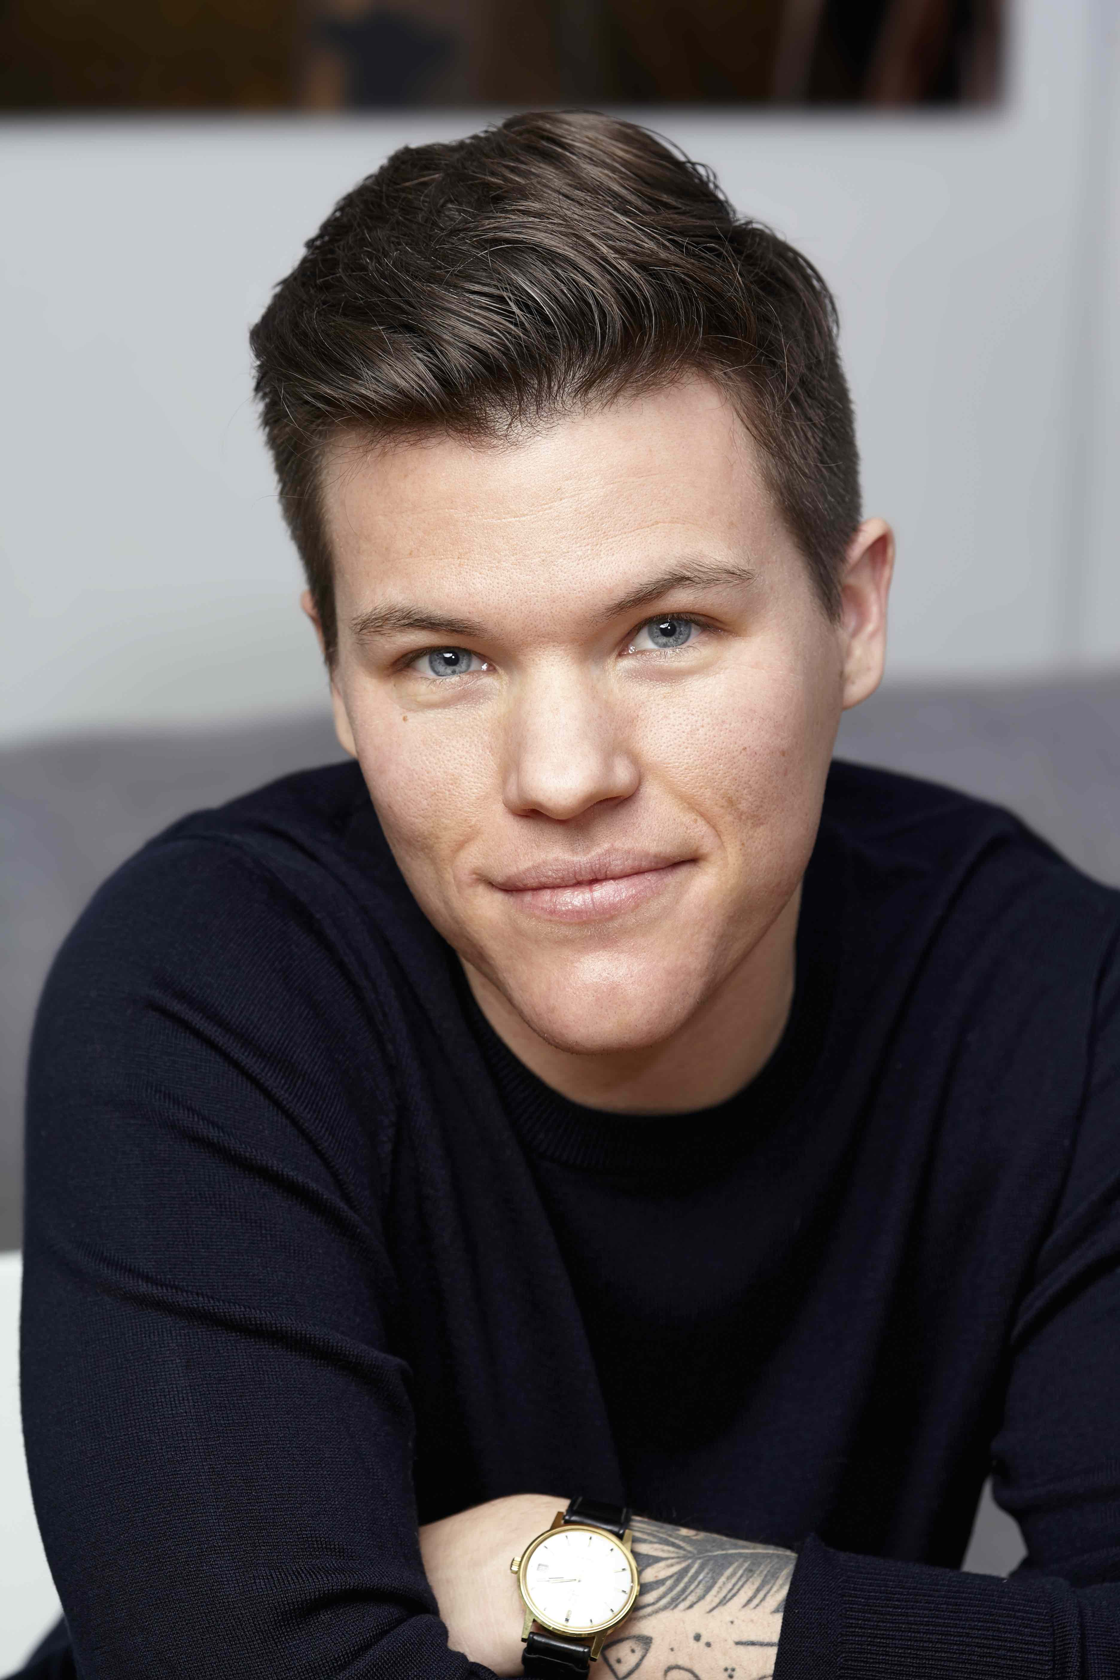
Photo caption (left): Theater director Will Davis
Photo credit: Missy Davis
Photo caption (right): Writer Danez Smith
Photo credit: Courtesy of Danez Smith

(Princeton, NJ) Theater director Will Davis and writer Danez Smith have been named Princeton University Arts Fellows for 2020-22 by the Lewis Center for the Arts and will begin two years of teaching and community collaboration in September.

The Arts Fellows program of the Lewis Center provides support for early-career artists who have demonstrated both extraordinary promise and a record of achievement in their fields with the opportunity to further their work while teaching within a liberal arts context. Funded in part by the Andrew W. Mellon Foundation, the David E. Kelley ’79 Society of Fellows Fund, and the Maurice R. Greenberg Scholarship Fund, fellows are selected for a two-year residency to teach a course each semester or, in lieu of a course, to undertake an artistic assignment that deeply engages undergraduate students, such as directing a play, conducting a music ensemble, or choreographing a dance piece. Fellows are expected to be active members of the University’s intellectual and artistic community while in residence; in return, they are provided the resources and spaces necessary for their work.

Davis and Smith were selected from a large, diverse, and multi-talented pool of over 500 applicants in dance, music, creative writing, theater, and the visual arts.

“We had our strongest pool of applicants ever this year, across all disciplines,” notes Stacy Wolf, Director of Fellowships, Professor of Theater, and Director of the Program in Music Theater. “Danez and Will will be phenomenal additions to our community as artists and as teachers, and we’re thrilled to support their work for the next two years. We’re especially happy to share good news, which we all need during these challenging times.”

Will Davis is a trans-identified director and choreographer focused on physically adventurous new work for the stage. His off-Broadway credits include Road Show at Encores! Off-Center; India Pale Ale at Manhattan Theatre Club; Bobbie Clearly at Roundabout Underground; Charm at MCC Theater; Men on Boats at Clubbed Thumb and at Playwrights Horizons, which received a Lucille Lortel Award nomination; and Duat at Soho Rep. Davis’ regional theater credits include Spamtown, USA at Children’s Theatre Company; Everybody at Shakespeare Theatre Company; A Doll’s House, Part 2 at Long Wharf Theatre; The Carpenter at Alley Theatre; Colossal at Mixed Blood Theatre and at Olney Theatre Center, for which Davis received a Helen Hayes Award for Outstanding Director of a Play; Evita at Olney Theatre Center, which received a Helen Hayes Award nomination; and multiple productions for American Theater Company in Chicago, where Davis also served as artistic director. He is an alumnus of the Soho Rep. Writer/Director Lab, the New York Theatre Workshop 2050 Directing Fellowship, the Brooklyn Art Exchange’s Artist-in-Residence program, and he currently serves on the Theatre Communications Group board of directors.
In the fall, he will collaborate with another artist to teach a new, multi-disciplinary course, “Maximizing the Minimal.” The class, part of the Princeton Atelier, will explore how to make theater with simple tools.

Danez Smith is a Black, Queer, Poz writer and performer from St. Paul, Minnesota. Smith is the author of Homie (Graywolf Press, 2020); Don’t Call Us Dead (Graywolf Press, 2017), winner of the Forward Prize for Best Collection, the Midwest Booksellers Choice Award, and a finalist for the National Book Award; and [insert] boy (YesYes Books, 2014), winner of the Kate Tufts Discovery Award and the Lambda Literary Award for Gay Poetry. They are the recipient of fellowships from the Poetry Foundation, the McKnight Foundation, Cave Canem, and the National Endowment for the Arts. Smith’s work has been featured widely including on Buzzfeed, The New York Times, PBS NewsHour, Best American Poetry, Poetry Magazine, the 2020 Pushcart Prize Anthology, and on the Late Show with Stephen Colbert. Smith is a member of the Dark Noise Collective and is the co-host of the podcast VS with Franny Choi, sponsored by the Poetry Foundation and Postloudness.

In the fall Smith will teach a creative writing course on writing and performance.

“Once again, we’re thrilled to welcome world-class artists to the Princeton community as Princeton Arts Fellows,” said Tracy K. Smith, Chair of the Lewis Center. “Danez Smith’s work has made an indelible and world-clarifying imprint upon poetry in America and abroad. And Will Davis’s work affirms theater’s miraculous ability to transform the humble and familiar into the extraordinary and revelatory. What a privilege it will be to engage with such remarkable and generous artists.”

The next round of Fellowship applications will begin in July with a mid-September deadline. Guidelines will be posted on the Lewis Center website at arts.princeton.edu. For questions about the Fellowship program, write to lca-fellowships@princeton.edu.

###

