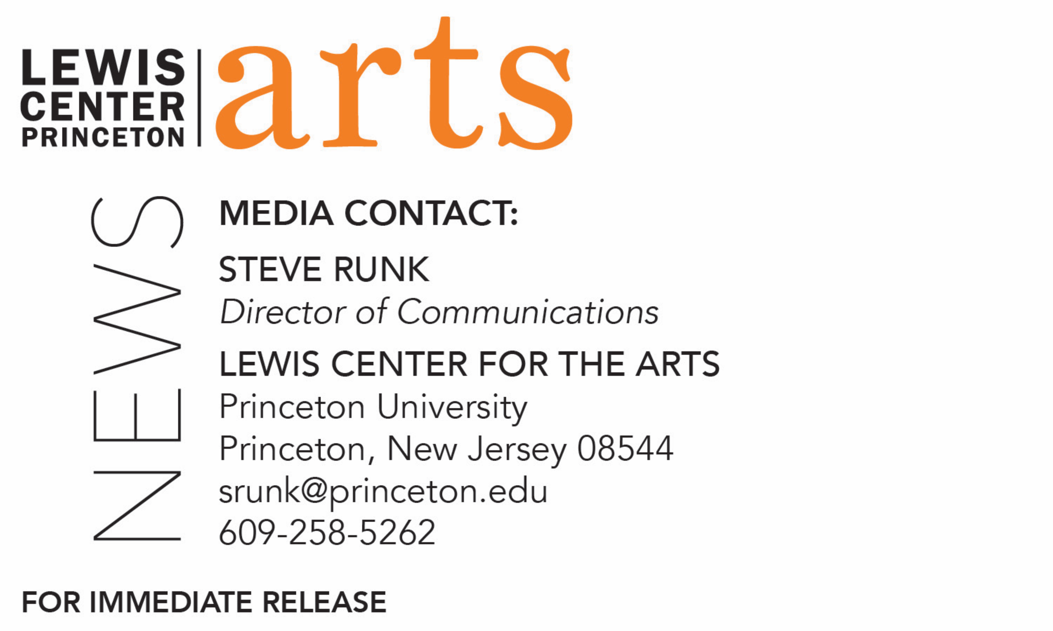

June 2, 2020

Lewis Center for the Arts celebrates the Class of 2020
A virtual Class Day ceremony on June 1 recognizes 76 Princeton graduates, awards top prizes in the arts, and celebrates a year like no other

Photo caption: Lewis Center seniors and faculty gather virtually to honor the Class of 2020

Photo credit: Captured on Zoom

(Princeton, NJ) At a historic virtual ceremony on Monday afternoon, June 1, the Lewis Center for the Arts at Princeton University celebrated 76 graduates of the Class of 2020 who earned 84 certificates and four degrees through the Programs in Creative Writing, Dance, Theater, Music Theater, and Visual Arts. The ceremony, attended by more than 200 guests, was held via Zoom Webinar in response to restrictions on public gatherings due to the COVID-19 pandemic. This meeting format has become all too familiar to the graduates who spent the final six weeks of their time at Princeton in online classes.

The event also awarded prizes to the top seniors and included a special live address to the graduates by Thelma Golden, Director and Chief Curator of The Studio Museum in Harlem.

“Today’s Class Day ceremony is a celebration of your commitment, throughout your time at Princeton, to asking the big questions in creative and arresting ways,” said Lewis Center Chair Tracy K. Smith in addressing the graduates. “If ever the world has needed bright, young, creative people helping us to look at the world and ourselves with more courage and compassion, it is now.” She added, “Artists are no strangers to change, challenge and upheaval. We dive into uncertainty with the desire to make headway, to find new kinds of sense, to startle ourselves out of anxiety and into new and sometimes unsettling forms of clarity. Each of you has risen to that occasion time and again during your time at Princeton. And this spring, in a time of global uncertainty, glaring injustice and grave loss, your commitment to paying attention, staying present, and being honest and vulnerable has helped to keep our community intact. Witnessing you bring your independent work to fruition in one of the strangest semesters in living memory has been a source of hope and continuity for more people than you may realize.”

In addition to undergraduate degrees in a concentrated area of study, Princeton offers “certificates of proficiency,” which enable students to supplement their work in their departmental concentrations with focused study in another, often interdisciplinary, field. Certificate programs are similar in many ways to the minors offered at other universities. By purposeful design as part of a liberal arts-rooted education, most of the courses of study in the arts at Princeton are not offered as majors.

The 76 graduates earning certificates in the arts have also earned degrees in such diverse fields as physics, neuroscience, politics, molecular biology, economics, philosophy, English, history, psychology and electrical engineering. Students often explore a completely different field than their major through their engagement with the Lewis Center or connect the arts in innovative ways to their major area of study. In addition to those pursuing certificates, nearly one-fourth of the undergraduate student body takes a course in creative writing, dance, theater, music theater, visual arts, or in the Princeton Atelier each year.

The certificate programs require students to follow an additional course of study and to complete a body of independent artistic work, such as a novel, screenplay, or a collection of short stories, poems, or translations; choreographing an original dance work or performing a new or repertory work by a guest artist; directing, performing, writing, designing or producing a theatrical work; or creating and exhibiting a body of visual artwork or a film. This independent work is undertaken with the mentorship and guidance of faculty who are working artists or scholars.

The 27 certificate graduates in Creative Writing are: Serena Alagappan, David V. Babikian, Sarah K. Barnette, Liana T. Cohen, Robert Cody Cortes, Yousef M. Elzalabany, Arianah F. Hanke, Nathaniel Hickok, Matthew T. Igoe, E Jeremijenko-Conley, Somi S. Jun, Eunice Lee, Scooter Liapin, Allegra E. Martschenko, Liza Milov, Abigail B. Minard, Rasheeda Saka, Destiny Salter, Peter C. Schmidt, Grace C. R. Searle, Alexandra M. Spensley, Emilie G. Szemraj, Khanh K. Vu, Heather D. Waters, Jacob D. Wheeler, Alice Xu, Cooper Young, and Kevin J. Zou.

The 10 certificate graduates in Dance are: Sarah Anne Betancourt, Sofia Bisogno, Peyton Cunningham, Abigail Kostolansky, Marshall Dylan Schaffer, Cooper Young, Aleksandra Kostic, Tsjum Jhor Kai van der Horst, Serena Lu, and Jorina Kardhashi.

The 26 certificate graduates in Theater and/or Music Theater, several earning certificates in both programs, are: Tessa Rose Bernstein Albertson, Jonathan Lee Alicea, Rose Carolyn Arbittier, Hannah Jayne Chomiczewski, Milan Renée Eldridge, Jaclyn L. Hovsmith, Reed Sawyer Hutchinson, E Jeremijenko-Conley, Nicholas Judt, Jenny Kim, Carol Lee, Jonathan Andrew Makepeace, Kateryn Lina McReynolds, Alexandra Palocz, Richard Peng, Marshall Dylan Schaffer, Billie Anna Runions, Calvin James Rusley, Hannah Marlena Semmelhack, Allison Marie Spann, Abigail Teagan Spare, Katja Anita Stroke-Adolphe, Carl Sun, Tsjum Jhor Kai van der Horst, Chamari Marquis White-Mink, and Jianing Zhao.

The 14 certificate graduates in Visual Arts are: Sebastian Benzecry, Julian Axel Castellon, Christina Maria de Soto, Nazenin Elçi, Tom Hoopes, Janette Tong Lu, Estibaliz Matulewicz, Roland Mounier, June Ho Park, Gabriella Pollner, Irene Ross, Katherine Evelyn Schneer, Yunzi Shi, Elizabeth Wallace, and Charity Young.

The four graduates achieving a Practice of the Art degree, a collaborative program between the Lewis Center and the Department of Art and Archaeology, focusing on studio work, are: Milan Renée Eldridge, Abigail Hack, Tsjum Jhor Kai van der Horst, and Ivy Xue.

A number of seniors received awards for outstanding achievement in each Program and top academic prizes were awarded by the Lewis Center Program Directors and the Chair of the Music Department for overall achievement in the arts.

Lewis Center Chair Smith announced recipients of two major prizes. The Louis Sudler Prize in the Arts, presented annually to one or more graduating seniors who have demonstrated excellence or the highest standard of proficiency, in performance or execution or in the field of composition in the following general areas: music, theater, dance, painting, sculpture or photography, was awarded to E Jeremijenko-Conley, who earned certificates in both creative writing and theater, and Tsjum Jhor Kai van der Horst, a visual arts major who also earned certificates in dance and theater.

The Toni Morrison Prize honors the late Toni Morrison, Nobel Prize Laureate and Princeton’s Robert F. Goheen Professor in the Humanities, Emeritus, and is given to one or more graduating seniors whose individual or collaborative artistic practice has pushed the boundaries and enlarged the scope of our understanding of issues of race. This prize honors work in any form that, in the spirit of Morrison’s, is “characterized by visionary force and poetic import,” and was awarded to Jenny Kim, who earned certificates in theater and music theater, and Destiny Salter, who earned a certificate in creative writing.

Guest speaker Thelma Golden’s remarks to the seniors and their guests referenced the recent death of George Floyd by a police officer and others who have been murdered in a spate of racially motivated killings. She noted that in times like these, “I always turn to art to make sense of the world and make sense of history, and I’m here today trying to make sense of it with all of you, as artists, as you begin this path.” She noted that art is as critical to this moment as it has always been in difficult times like these and advised the graduates, “You’ve trained for this moment. It is your creativity, your ingenuity and your courage that will not only allow you to make creative statements of your vision and your voice, but also to create the kind of world that allows us – your audiences, your families, your friends – to see the world through your eyes. That is the gift you have been given, but it is also the responsibility that you hold.”

Golden began her career in 1987 at the Studio Museum in Harlem before joining the Whitney Museum of American Art in 1988. She returned to the Studio Museum in 2000 as Deputy Director for Exhibitions and Programs and was named Director and Chief Curator in 2005. As Director, Golden is leading the effort to build a new home for the Museum, designed by architect Sir David Adjaye OBE, recently announced as the architect for the new Princeton University Art Museum. Golden was appointed to the Committee for the Preservation of the White House by President Obama in 2010, and in 2015 she joined the Barack Obama Foundation’s Board of Directors. She also serves on the Board of the Los Angeles County Museum of Art, the Andrew W. Mellon Foundation, and the Crystal Bridges Museum. She was a 2008 Henry Crown Fellow at the Aspen Institute and a recipient of the 2016 Audrey Irmas Award for Curatorial Excellence. In 2018, Golden was awarded a J. Paul Getty Medal.

The Lewis Center’s Class Day ceremony followed Princeton’s virtual commencement celebration held on May 31. Plans are underway for Princeton’s Class of 2020 to return to campus in May 2021 for an in-person graduation ceremony.

To learn more about the Lewis Center for the Arts and the more than 100 other performances, exhibitions, readings, screenings, concerts, and lectures presented by the Lewis Center, most of them free, visit arts.princeton.edu.

###

