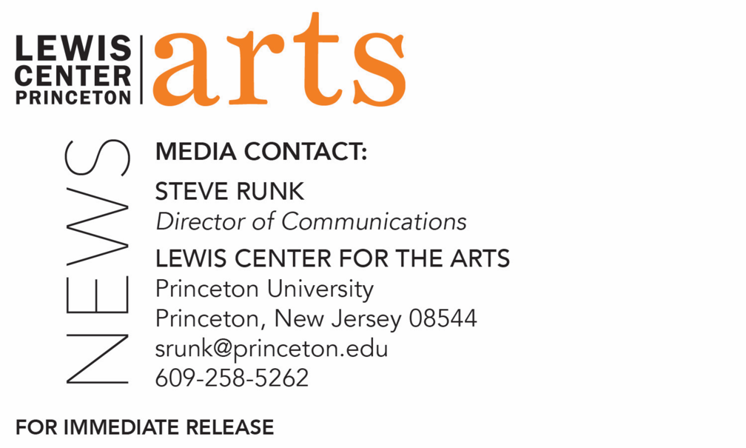

September 21, 2020

Reading by Novelist Rabih Alameddine followed by a Conversation with
Princeton Senior Hamza Hashem on September 30
Kicks off the C.K. Williams Reading Series organized by
Princeton’s Creative Writing students and presented this year virtually

Photo caption: Novelist Rabih Alameddine
Photo credit: Bernito Ordonez

What/Who: A reading by novelist Rabih Alameddine, author of five novels and a book of short stories, followed by a conversation with Alameddine and Princeton Program in Creative Writing senior Hamza Hashem – kicks off the 2020-21 season of the C.K. Williams Reading Series, presented virtually this year by the Lewis Center for the Arts’ Program in Creative Writing at Princeton University
When: September 30, 2020 at 6:00 p.m.
Where: Virtually via Zoom Webinar
Free and open to the public
For more information and Zoom link: https://arts.princeton.edu/events/c-k-williams-reading-by-rabih-alameddine/

(Princeton, NJ) Novelist Rabih Alameddine will read from his work at 6:00 p.m. on September 30 via Zoom Webinar. The reading will be followed by a conversation with Alameddine and Hamza Hashem, a senior in Princeton’s Program in Creative Writing. This event opens the 2020-21 C.K. Williams Reading Series, named after the late Pulitzer Prize and National Book Award-winning poet C.K. Williams, who also served on Princeton’s faculty for 20 years. This virtual event, presented by the Lewis Center for the Arts, is free and open to the public.

The series showcases senior thesis students of the Program in Creative Writing alongside established writers as special guests.

Rabih Alameddine is the author of five novels, Koolaids: The Art of War, I, the Divine: A Novel in First Chapters, The Hakawati, An Unnecessary Woman, and The Angel of History, and a collection of short stories, The Perv, which in 2019 won the Dos Passos Prize. His sixth novel, The Wrong End of the Telescope, will be published by Grove in Spring/Summer 2021. His pieces have appeared in Zoetrope, The Evening Standard and Al-Hayat, among others. Alameddine was born in Amman, Jordan, to Lebanese parents and grew up in Kuwait and Lebanon. He was educated in England and the U.S., and he has an engineering degree from UCLA and an M.B.A. from the University of San Francisco. He has lectured at numerous universities including M.I.T and the American University of Beirut in Lebanon. Alameddine was the recipient of a Guggenheim Foundation fellowship in 2002. He divides his time between San Francisco and Beirut.

Hashem, who will engage Alameddine in a conversation following the reading, is among 24 Princeton seniors who are pursuing certificates in creative writing in addition to their major areas of study. Each is currently working on a novel, a screenplay, translations, or a collection of poems or short stories as part of a creative thesis for the certificate. Thesis students in the Program in Creative Writing work closely with a member of the faculty, which includes award-winning writers Michael Dickman, Aleksandar Hemon, A.M. Homes, Daphne Kalotay, Christina Lazaridi, Jhumpa Lahiri, Yiyun Li, Paul Muldoon, James Richardson, Tracy K. Smith, Kirstin Valdez Quade, Susan Wheeler, Monica Youn, and a number of distinguished lecturers.

Upcoming guests in the 2020-21 C.K. Williams Series include Flora Thomson-DeVeaux, Princeton Class of 2013, Craig Santos Perez, Ottessa Moshfegh, Nana Kwame Adjei-Brenyah, and Franny Choi. In addition, students in the Program in Creative Writing will read from work written in fall and spring semester workshops selected by faculty, and seniors in the program will read from their final thesis works in the spring.

To learn more about the reading series, the Program in Creative Writing, and the more than 100 public performances, exhibitions, readings, screenings, concerts and lectures presented each year by the Lewis Center for the Arts, most of them free, visit arts.princeton.edu.

###

