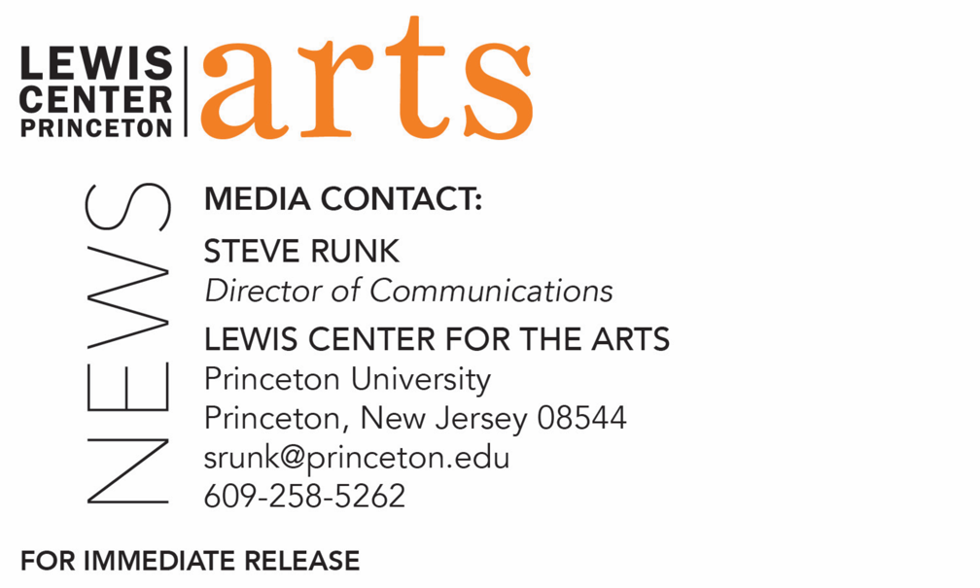

September 4, 2020

Fund for Irish Studies at Princeton University presents
“Sweet Dancers: An Illustrated Talk on Irish Dance”
Dance historian, documentary filmmaker, and host of Dance Ireland’s 30th Anniversary podcast Deirdre Mulrooney opens the 2020-21 virtual series

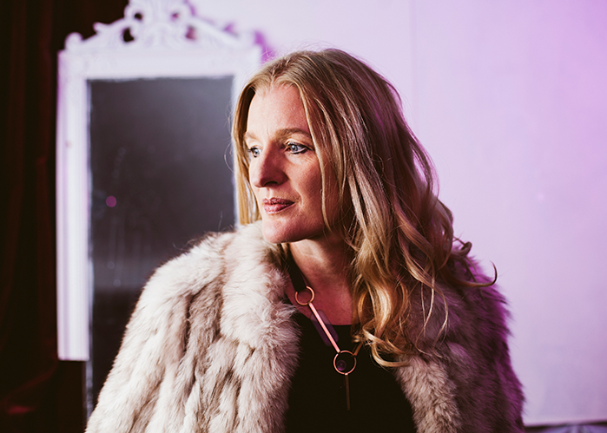
Photo caption: Dance historian, documentary filmmaker, and host of Dance Ireland’s 30th Anniversary podcasts Deirdre Mulrooney
Photo credit: Ishmael Claxton

What/Who: “Sweet Dancers: An Illustrated Talk on Irish Dance” presented by Deirdre Mulrooney, dance historian, documentary filmmaker, author of Irish Moves: An Illustrated History of Dance and Physical Theatre in Ireland, and host of Dance Ireland’s 30th Anniversary podcasts. Lecture opens the 2020-21 virtual Fund for Irish Studies event series. Presented by Princeton’s Fund for Irish Studies
When: Friday, September 18, 2020 at 4:30 p.m. (EDT)
Where: Online via Zoom
Admission: Free and open to the public
For more information and the Zoom link: https://arts.princeton.edu/events/fund-for-irish-studies-sweet-dancers-an-illustrated-talk-on-irish-dance-by-deirdre-mulrooney/

(Princeton, NJ) Dance historian, documentary filmmaker, and host of Dance Ireland’s 30th Anniversary podcasts Deirdre Mulrooney will present a virtual lecture, “Sweet Dancers: An Illustrated Talk on Irish Dance,” on Friday, September 18 at 4:30 p.m. via Zoom. The talk opens the 2020-21 Fund for Irish Studies series at Princeton University, which will be virtual for the fall. The event is free and open to the public.

Mulrooney’s talk, which will include both live and recorded content, traces the links from Yeats’ and De Valois’ Abbey Theatre Ballets (1927-1933), through Lucia Joyce, a professional dancer and daughter of writer James Joyce, to modern dance pioneer Erina Brady (1940s), on to what is happening in dance in Ireland today. This history will touch on the Irish dancing background of Riverdance, and what its stars are forging now in contemporary dance. Mulrooney’s presentation will include her short film on Lucia Joyce starring Evanna Lynch and brief clips from several of her other dance documentary films.

Mulrooney is author of Irish Moves: An Illustrated History of Dance and Physical Theatre in Ireland (2006), and Orientalism, Orientation, and the Nomadic Work of Pina Bausch (2002). Her ongoing dance history research and reclamation project began in 2004 with her five-part RTE Radio One documentary series Nice Moves, in conjunction with the 2nd International Dance Festival Ireland. Her first short documentary film, 1943 – A Dance Odyssey about Irish-German Modern Dance pioneer Erina Brady, was broadcast on RTE One television in 2013. In 2015 her TG4 Splanc! feature documentary, Dance Emergency/Damhsa na hÉigeandála starring Olwen Fouéré as Erina Brady, was selected for various film festivals. Her biographical essay, “Erina Brady: Irish-German Harbinger of Modern Dance to 1940s Ireland,” was published in Selected Irish-German Biographies (2015), and “Erina Brady: Mary Wigman’s Irish Disciple?” appeared in Dance and Modernism in Irish and German Literature and Culture (2019). Her short dance film Lucia Joyce: Full Capacity premiered at Bloomsday Trieste 2019 and was selected for Kerry International Film Festival and Richard Harris International Film Festival. The film was part of James Joyce Centre’s first Virtual Bloomsday Festival 2020 and made its Welsh premiere at the Elysium Gallery, Swansea, in August 2020 as part of IFF International Film Festival. Mulrooney has made several BAI-funded feature radio documentaries for RTE Lyric FM relating to the Abbey Theatre Ballets, including her recent feature radio documentary on Lucia Joyce’s modern dance career which was part of Bloomsday Festival 2020. She is currently a University College Dublin Arts and Humanities Creative Fellow.

The Fund for Irish Studies affords all Princeton students, and the community at large, a wider and deeper sense of the languages, literatures, drama, visual arts, history, politics, and economics not only of Ireland but of “Ireland in the world.” The series is co-produced by the Lewis Center for the Arts and organized by Paul Muldoon, Princeton’s Howard G.B. Clark ’21 University Professor in the Humanities, Founding Chair of the Lewis Center, Director of the Princeton Atelier, and Chair of the Fund for Irish Studies.

Information about the Fund for Irish Studies series virtual events can be found at fis.princeton.edu. Other upcoming events in the current series, remaining virtual at least through the fall, include:
- Christine Kinealy (Quinnipiac), Colum McCann (author of Transatlantic), and Autumn Womack (Princeton) in a symposium on “The 175th Anniversary of Frederick Douglass’s Tour of Ireland” — November 13
- Patrick Radden Keefe (The New Yorker) on “Say Nothing: A True Story of Murder and Memory in Northern Ireland” — November 20
- Eiléan Ní Chuilleanáin, Professor (emeritus) School of English at Trinity College Dublin, reads her poetry — December 4
- Laurence Cox (Maynooth) on “Irish Hobo, Buddhist Monk, Anticolonial Celebrity: The Strange Story of U Dhammaloka/Laurence Carroll” — February 5
- Fintan O’Toole presents the Robert Fagles Memorial Lecture on “1921 and 2021: The Partition of Ireland, Then and Now” — February 26
- Tara Guissin-Stubbs (Oxford University) on “Symbols from within, and symbols from without: The Celtic Revival and the Harlem Renaissance” — March 19
- Alan Hayden (University College, Dublin) on “Irish Archaeology Now” — April 16

The Fund for Irish Studies is generously sponsored by the Durkin Family Trust and the James J. Kerrigan, Jr. ’45 and Margaret M. Kerrigan Fund for Irish Studies.

To learn more about the more than 100 public performances, exhibitions, readings, screenings, concerts, lectures and special events, most of them free, presented each year by the Lewis Center for the Arts, visit arts.princeton.edu.

###

