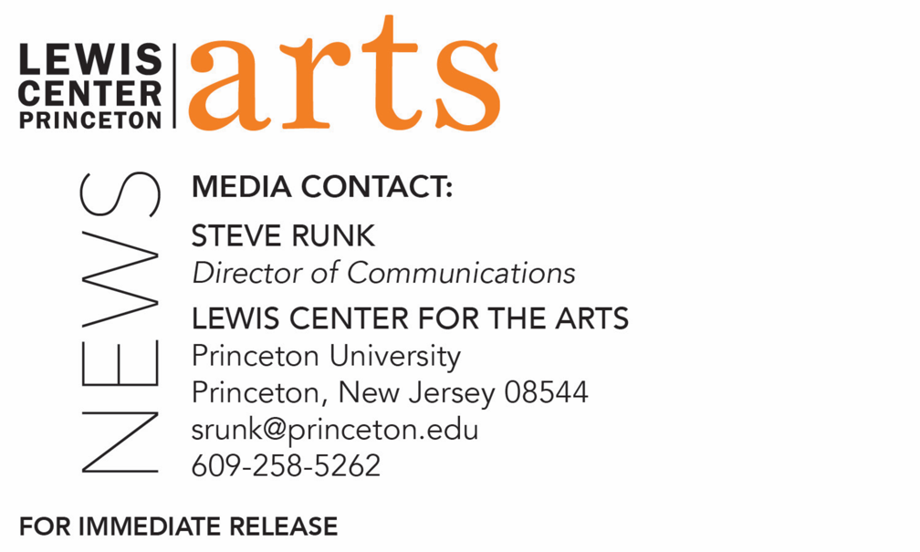

September 22, 2020

Film Series - Combahee Experimental: Celebrating Black Women's Experimental Filmmaking
presented by Lewis Center for the Arts’ Program in Visual Arts
A three-event series celebrating the work of Black women filmmakers and their unique cinematic contributions to contemporary visual culture,
curated by Simone Leigh and Tina Campt

Photo caption/credit 1: A still from Madeleine Hunt-Ehrlich’s film Spit on the Broom (2019)
Photo caption/credit 2: A still from Garrett Bradley’s film Alone (2017)

What: Combahee Experimental: Celebrating Black Women's Experimental Filmmaking, a film series of three screenings and conversations celebrating the work of Black women filmmakers and their unique cinematic contributions to contemporary visual culture.
Who: Curated by award-winning multimedia artist Simone Leigh and Black feminist theorist of visual culture and contemporary art Tina Campt, with guests Julie Dash, Angela Davis and Barbara McCullough for Filmmaking in Troubled Times on 10/7; Nuotama Bodomo and Madeleine Hunt-Ehrlich for The Black Surreal on 10/22; and Garrett Bradley and Rungano Nyoni for Experiments in Narrative on 10/29. Presented by the Lewis Center for the Arts’ Program in Visual Arts at Princeton University and cosponsored by Princeton’s Department of Art & Archaeology
When: October 7, 22 and 29 at 6:00 p.m.
Where: Virtual via Zoom Webinar
Admission: Free and open to the public; registration is required and advance registration is encouraged
For more information and registration link: arts.princeton.edu/vis-film-series

(Princeton, NJ) Combahee Experimental: Celebrating Black Women's Experimental Filmmaking, a film series of three screenings and conversations celebrating the work of Black women filmmakers and their unique cinematic contributions to contemporary visual culture, will be presented virtually on October 7, 22 and 29 at 6:00 p.m. The series is curated by award-winning multimedia artist Simone Leigh and Black feminist theorist of visual culture and contemporary art Tina Campt, with guests Julie Dash, Angela Davis, Barbara McCullough, Nuotama Bodomo, Madeleine Hunt-Ehrlich, Garrett Bradley, and Rungano Nyoni. Presented online via Zoom Webinar by the Lewis Center for the Arts’ Program in Visual Arts at Princeton University, the series is free and open to the public and cosponsored by the Department of Art and Archaeology.

“The voices, insights and the complex artistic and conceptual ideas of Black women filmmakers, and experimental filmmakers in particular, is frequently absent from public discourse on cinema,” said Campt. “Combahee Experimental responds to that absence by screening their work and asking them to talk to each other about it. By celebrating the work of earlier experimental filmmakers who broke new ground and contemporary ones who are continuing to create such work today, we hope to create a space that opens new possibilities for other artists.”

The series extends a collaboration begun with the 2018 Loophole of Retreat conference convened at the Guggenheim Museum as a commitment to using public programming platforms to highlight the creative, artistic, and intellectual labor of Black women. Looking back while also looking forward to Black women experimental filmmaking from the late seventies to the present day, the series’ point of departure is a reexamination of the early work of two female members of the influential LA Rebellion movement and the unique cinematic intervention it initiated. It is an intervention that the UCLA Film and Television Archive characterizes as driven by the group’s commitment to a “utopian vision of a better society, their sensitivity to children and gender issues, their willingness to question any and all received wisdom, their identification with the liberation movements in the Third World, and their expression of Black pride and dignity.”

“We are thrilled with the series that Simone and Tina have put together,” said Martha Friedman, Director of the Program in Visual Arts. “It is a long overdue engagement with the work of Black women working in experimental film. We are committed to making more space for such explorations and look forward to continuing to support this kind of programming.”

Kicking off on October 7, the series begins with Filmmaking in Troubled Times with activist, scholar and writer Angela Davis and filmmakers Julie Dash and Barbara McCullough in conversation with Campt and Leigh. Davis taught at University of California at Los Angeles and at Santa Cruz, is the author of several books on feminism, race and civil rights, and a former member of the Black Panthers and Che-Lumumba Club, an all-Black branch of the Communist Party. McCullough and Dash are pioneering artists whose early work created in the context of this movement has until recently been overlooked and undervalued. Following the conversation, the curators will screen a selection of early works from the women of the LA Rebellion movement including Dash’s film Illusions (1982), McCullough’s Water Ritual #1: An Urban Rite of Purification (1979), Camille Billops and James Hatch’s Suzanne, Suzanne (1982), and Zeinabu irene Davis’ Cycles (1989).

On October 22 and 29, this reflection on the work of these early visionary Black artists will be followed by dialogues and screenings featuring the work of emerging Black women filmmakers from across the diaspora.

The conversation on October 22, The Black Surreal, welcomes filmmakers Nuotama Bodomo and Madeleine Hunt-Ehrlich in discussion with Campt and Leigh followed by screenings of Hunt-Ehrlich’s Spit on the Broom (2019) and Outfox the Grave (2020) and Bodomo’s Afronauts (2014) and Boneshaker (2014).

Experiments in Narrative on October 29 begins with Campt and Leigh in conversation with filmmakers Garrett Bradley and Rungano Nyoni followed by Bradley’s film Alone (2017) and Nyoni’s I Am Not a Witch (2017).

Tina Campt is Owen F. Walker Professor of Humanities and Modern Culture and Media at Brown University and a Research Associate at the Visual Identities in Art and Design Research Centre (VIAD) at the University of Johannesburg, South Africa. She is the author of three books: Other Germans: Black Germans and the Politics of Race, Gender and Memory in the Third Reich (2004), Image Matters: Archive, Photography and the African Diaspora in Europe (2012), and Listening to Images (2017). Her forthcoming book, A Black Gaze, will be published by MIT Press in 2021.

Simone Leigh’s practice incorporates sculpture, video, and installation; all are informed by her ongoing exploration of Black female-identified subjectivity. Leigh works in a mode she describes as auto-ethnographic. Her objects often employ materials and forms traditionally associated with African art; her performance-influenced installations create spaces where historical precedent and self-determination comingle. Through her investigations of visual overlaps between cultures, time periods, and geographies, she confronts and examines ideas of the female body, race, beauty, and community. She is a recipient of the Foundation for Contemporary Art Grant (2018), Joyce Alexander Wein Artist Prize (2017), John Simon Guggenheim Fellowship (2016), and Anonymous Was a Woman Award (2016). Recent projects and exhibitions include: Simone Leigh (2020) at David Kordansky Gallery, Los Angeles; Whitney Biennial (2019) at the Whitney Museum of American Art, New York; Trigger: Gender as a Tool and as a Weapon (2017) at the New Museum of Contemporary Art, New York; Psychic Friends Network (2016) at Tate Exchange, Tate Modern, London; The Waiting Room (2016) at the New Museum of Contemporary Art, New York; The Free People’s Medical Clinic (2014), a project commissioned by Creative Time; inHarlem, a public installation presented by The Studio Museum in Harlem at Marcus Garvey Park, New York; and a solo exhibition at the Hammer Museum, Los Angeles. Leigh’s work was featured in Loophole of Retreat, a major exhibition at the Guggenheim Museum, New York, to commemorate her achievements as the winner of the Hugo Boss Prize 2018. Leigh is the first artist to be commissioned for the High Line Plinth, where she presents a new monumental sculpture that started in April 2019.

Registration via Zoom Webinar is required and advance registration is encouraged.

Patrons in need of access accommodations are invited to contact the Lewis Center at 609-258-5262 or LewisCenter@princeton.edu for assistance at least two weeks prior to the selected event.

The film series is supported through the John Sacret Young ’69 Lecture Series fund. Sacret Young is a 1969 graduate of Princeton and an author, producer, director, and screenwriter. He has been nominated for seven Emmy Awards and seven Writers Guild of America (WGA) Awards, winning two WGA Awards. He is perhaps best known for co-creating, along with William F. Broyles Jr., China Beach, the critically acclaimed ABC-TV drama series about medics and nurses during the Vietnam War, and for his work on the television drama The West Wing. Young has also received a Golden Globe and a Peabody Award, and his original mini-series about the Gulf War, Thanks of a Grateful Nation, was honored with his fifth Humanitas Prize nomination.

For more information on the Program in Visual Arts and the more than 100 performances,
exhibitions, readings, screenings, concerts and lectures presented each year by the Lewis Center
for the Arts, most of them free, visit arts.princeton.edu.

###

