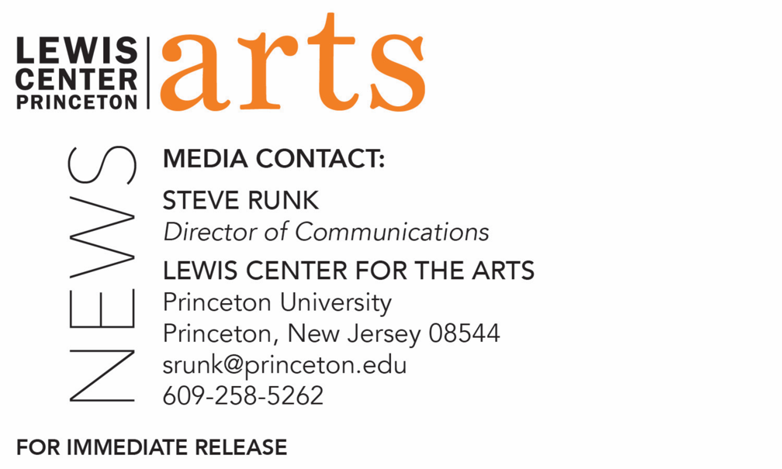

October 2, 2020

A Conversation with award-winning author, editor, music scribe, producer, screenwriter and Princeton alum Selwyn Seyfu Hinds ’93 on October 14
Author of the novel Washington Black and adaptation of the graphic novel Prince of Cats, and writer/producer on Jordan Peele’s new iteration of the Twilight Zone will be in conversation with Princeton Lecturer in Creative Writing A.M. Homes

Photo caption: Award-winning author, editor, music scribe, producer, screenwriter and Princeton alum Selwyn Seyfu Hinds ’93
Photo credit: Courtesy of Selwyn Seyfu Hinds

What/Who: An informal talk and Q&A with award-winning author, editor, music scribe, producer, screenwriter and Princeton alum Selwyn Seyfu Hind, Class of 1993. The author of the novel Washington Black and adaptation of the graphic novel Prince of Cats, and writer/producer on Jordan Peele’s new iteration of the Twilight Zone will be in conversation with Princeton Lecturer in Creative Writing A.M. Homes, a novelist and film and television writer and producer. Presented by the Lewis Center for the Arts, the Department of African American Studies, and the Center for Career Development at Princeton University
When: October 14, 2020 at 6:00 p.m. (EDT)
Where: Virtually via Zoom Webinar
Admission: Free and open to the public
For more information and Zoom link: https://arts.princeton.edu/events/a-conversation-with-selwyn-seyfu-hinds-93/

(Princeton, NJ) Princeton University’s Lewis Center for the Arts, in partnership with the Department of African American Studies and the Center for Career Development, present a conversation with award-winning author, editor, music scribe, producer, screenwriter and Princeton alum Selwyn Seyfu Hinds, Class of 1993 at 6:00 p.m. (EDT) on Wednesday, October 14 via Zoom Webinar. Engaging Hinds for this informal talk and Q&A will be Princeton Program in Creative Writing faculty member A.M. Homes, a novelist and film and television writer and producer. This virtual event is free and open to the public and accessible at arts.princeton.edu.

Selwyn Seyfu Hinds’ most recent project is writer and showrunner on Hulu’s adaptation of Esi Edugyan’s novel Washington Black starring Sterling K. Brown and directed by Anthony Hemingway. Hinds also recently served as a writer/producer on Jordan Peele’s new iteration of the Twilight Zone for CBS All Access, penning the critically hailed police brutality episode “Replay,” starring Sanaa Lathan. The episode earned Hinds a finalist nomination in the Drama Teleplay category for the 45th annual Humanitas Prize. Hinds has also served as Consulting Producer on HBO Max’s DC universe anthology Strange Adventures; and he has worked in development at HBO with George R.R. Martin. Hinds’ current feature film work includes Legendary Entertainment’s adaptation of the graphic novel, Prince of Cats, a mash-up of Shakespeare, hip-hop, and samurai warrior culture, to be directed by Spike Lee; an adaptation of Running A Thousand Miles For Freedom, the true-life tale of the extraordinary escape of enslaved couple William and Ellen Craft, which he developed for Big Beach Films, with Hanelle Culpepper set to direct; Arkham, a Gotham City set thriller for DC/Warner Bros; and, most recently, an adaptation of the classic David Eddings fantasy series The Belgariad (over 20 million books sold worldwide) for City Hill Arts and Game of Thrones producer Vince Geradis.
Hinds’ work before screenwriting includes co-creating the Vertigo comic-book series, Dominique Laveau: Voodoo Child; serving as consulting producer of original programming and executive producer of news and documentaries at BET Networks; penning two critically hailed non-fiction books, his memoir Gunshots in My Cook-Up: Bits and Bites of a Hip-Hop Caribbean Life, and To a Young Jazz Musician: Letters from the Road, written with Wynton Marsalis; and serving as editor-in-chief of The Source magazine during the late 1990s. Hind has also written for a wide array of major publications, including The New York Times, The Village Voice, Vanity Fair, USA Today, Spin, and Vibe Magazine, and his essays have been collected in numerous anthologies. Hinds attended Guyana’s Queens College in the Caribbean and Princeton where he received degrees in English and African-American Studies.

A.M. Homes’ most recent book is a collection of short stories, Days of Awe. In 2021 she will publish a new novel, Phoenix: The Unfolding. Her previous books include, May We Be Forgiven, which won the 2013 Women’s Prize for Fiction (formerly known as the Orange Prize). Homes’ memoir, The Mistress's Daughter, the story of being "found" by her biological family and a literary exploration and investigation of identity, adoption and genealogical ties that bind, was published to international acclaim. Other works include the novels: This Book Will Save Your Life, Music For Torching, The End of Alice, In a Country of Mothers, and Jack; as well as the short-story collections, Days of Awe, Things You Should Know and The Safety of Objects; the travel memoir, Los Angeles: People, Places and The Castle on the Hill; and the artist's book, Appendix A:. Her work has been translated into 22 languages, and she writes frequently on the arts for publications such as Art Forum, Granta, McSweeney's, The New Yorker and the New York Times and is a contributing editor to Vanity Fair, Bomb and Blind Spot. Homes is active in the world of film and television and is currently developing television shows for BBC/AMC, and Hulu along with supporting the development of adaptations of her works, including This Book Will Save Your Life by Benedict Cumberbatch/SunnyMarch and Music for Torching with Julie Bowen/Carl Beverly. She was co-executive producer of the television show Falling Water and worked with David E. Kelly on the adaptation of Stephen King’s Mr. Mercedes. Previously, Homes was a writer/producer of The L Word, in 2004-2005 and wrote the adaptation of her first novel, Jack, for Showtime. Homes has also written original television pilots for ABC, CBS, FX and HBO. She has been the recipient of numerous awards including fellowships from the John Simon Guggenheim Foundation, the National Endowment for the Arts, New York Foundation for the Arts, and The Cullman Center for Scholars and Writers at The New York Public Library, along with the Benjamin Franklin Award and the Deutscher Jugendliteraturpreis. She is active in the LGBTQ community and in the arts community including serving on the board of directors of Yaddo, the Writers Guild of America East Council, as well as on the boards of directors of The New York Foundation for the Arts, Poets and Writers, and The Elizabeth Dance Company, and as advisor to The Fine Arts Work Center in Provincetown.

Patrons in need of access accommodations in order to participate in this event, are asked to contact the Lewis Center at LewisCenter@princeton.edu at least two weeks in advance of the event date.

To learn more about the reading series, the Program in Creative Writing, and the more than 100 public performances, exhibitions, readings, screenings, concerts and lectures presented each year by the Lewis Center for the Arts, most of them free, visit arts.princeton.edu.

###

