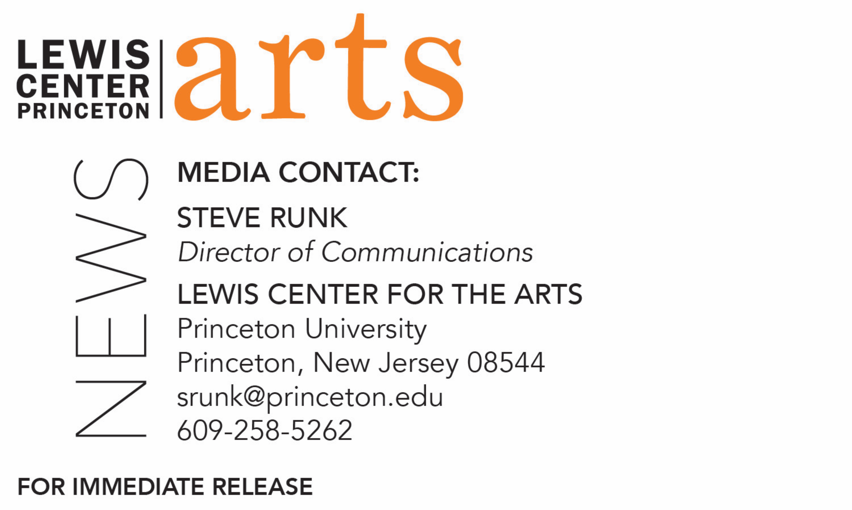

November 9, 2020

Lewis Center for the Arts’ Program in Dance presents
Princeton Dance Festival Reimagined
Annual festival goes all virtual this year with innovative work led by
a diverse group of six choreographers

Photos caption 1: Senior Ysabel Ayala interacting with Henry Moore’s sculpture “Oval with Points” on the Princeton campus rehearsing a solo work she created that will be among the pieces presented in Princeton Dance Festival Reimagined
Photo caption 2: First-year student Crystal Liu rehearsing her site-specific solo work interacting with Maya Lin’s sculpture “Einstein’s Table" on the Princeton campus that she created for Princeton Dance Festival Reimagined
Photo caption 2: Faculty member Olivier Tarpaga rehearses with students and musicians for a new work created for Princeton Dance Festival Reimagined
Photos credit: Jonathan Sweeney

What/Who: Princeton Dance Festival Reimagined features new works created for a virtual environment led by professional choreographers Peter Chu, Francesca Harper, Rebecca Lazier, Dean Moss, Silas Riener, and Olivier Tarpaga. The choreographers have created innovative dances with Princeton dance students despite the restrictions of the COVID pandemic. Works explore the intersections of dance and multimedia performance, digital animation, filmmaking, site-based work, and music. Each evening is a completely different and unique experience followed by a question and answer session with the choreographers. Presented by the Lewis Center for the Arts’ Program in Dance at Princeton University.
When: November 23 at 8:30 p.m. (EST), December 3, 4 & 5 at 8:00 p.m. (EST)
Where: Virtual online via Zoom Webinar
Admission: Free and open to the public; registration for each evening is required
For information and link: http://arts.princeton.edu/dance-reimagined

(Princeton, NJ) The Lewis Center for the Arts’ Program in Dance at Princeton University presents Princeton Dance Festival Reimagined, a virtual edition of its major annual concert exploring dance in the COVID era through innovative new works. Works to be presented have been led in their creation by professional choreographers Peter Chu, Francesca Harper, Rebecca Lazier, Dean Moss, Silas Riener, and Olivier Tarpaga, working with Princeton dance students to explore the intersections of dance and multimedia performance, digital animation, filmmaking, site-based work, and music.

Performances will take place November 23 at 8:30 p.m. and December 3, 4 and 5 at 8:00 p.m.; each evening is a completely different and unique experience followed by a question and answer session with the choreographers. The Dance Festival is free and open to the public with registration required for each evening.

Pre-recorded content will be closed captioned and live performances and conversations will be open captioned. If you are in need of other access accommodations in order to participate in this event, please contact the Lewis Center at 609-258-5262 or email LewisCenter@princeton.edu at least 2 weeks in advance of the event date.

Along with the entire global dance community, the Program in Dance is exploring the challenges of dance in a socially distanced world. Work over the past semester culminates in the Dance Festival to consider how dance artists can create new methods of dance and choreography for the online environment that reimagine frontiers of physical practice and the choreographic space. Participating students are currently taking their Princeton courses online from throughout the U.S. and abroad.

“The creativity and commitment of our faculty choreographers to meet the challenge of choreographing and teaching virtually has been astounding,” said Susan Marshall, Director of the Program in Dance. “They and our extraordinary students responded with innovation and resilience to the limitations and potentials of dancing physically apart while virtually collaborating and learning together. These performances are powerful testimony our students’ resolve to grow and flower creatively despite these trying times. Please join this far flung community of dancers as they come together for what promises to be an amazing series of performances.”

On November 23 Peter Chu and his students present Welcome HOME: The Princeton Series,
a thought-provoking yet playful journey that evokes the viewer's spatial perception. Viscerally charged with moving imagery, Welcome HOME celebrates raw, curious, and honest communication.

Chu was born in the Bronx, New York, and raised in Cocoa Beach, Florida. He began his training as a competitive gymnast, later nurturing his artistry at Dussich Dance Studio. Upon
graduation from The Juilliard School, he performed with BJM Danse, EZdanza, Aszure Barton & Artists, Kidd Pivot,and in Celine Dion’ s Vegas spectacular, A New Day. In 2008, Chu formed a Las Vegas project-based dance company, chuthis., which showcases the work of Chu and his collaborators. He has created works for Hubbard Street Dance Chicago, Staatstheater Augsburg, Charlotte Ballet II, Orlando Ballet Theatre, Hubbard Street 2, Giordano Dance Chicago, SYTYCD, Houston MET Dance, New Dialect, SALT Contemporary Dance, HSPro, and The Juilliard School, among others. Last season, he premiered works for Giordano Dance Chicago and Gibney Dance Company and choreographed for Cirque du Soleil’s Vitori in Malta. He is currently commissioned to create for Paul Taylor Dance Company and will develop a new work with his own company, chuthis.

The program on December 3 features Emergence and Discovery: Digital Dance Portraits led by Francesca Harper. The project facilitates collaborative construction and the development of 10 short, personal films allowing movement, filmmaking, images, text, music, and discovery in natural and industrial habitat to be accessible and serve as inspiration. The films ask: as dance artists emerge from isolation and reshape their lives, how do they preserve the moment? This existential question has been translated into art.

Harper joined and performed soloist roles with The Dance Theater of Harlem and later as a Principal Artist in William Forsythe’s Ballet Frankfurt. She has choreographed for The Alvin Ailey American Dance Theater, Dance Theatre of Harlem, Richmond Ballet, and her own company, The Francesca Harper Project, which was founded in 2005 and tours internationally. Harper performed in four Broadway productions including The Color Purple, then toured in leading roles in Sweet Charity, Sophisticated Ladies and Lady Day at Emerson Bar and Grill. She also served as a ballet consultant for the Oscar-winning film, Black Swan. She was movement and casting director for the “Bessie” Award-winning piece “The Let Go,” commissioned by the Park Avenue Armory, and for Zendaya and Tommy Hilfiger’s Apollo Theater production for Fashion Week in 2019. Harper is currently engaged as executive producer with Sony Pictures on a series in development while pursuing a M.F.A. in performance creation at Goddard College.

On December 4 works led by Rebecca Lazier and Dean Moss are featured. In SITE DANCE Lazier and her students ask: Where can dance happen and what can it do? The students will share site-based performance projects built from research into their communities. Each project traces different intersections of personal, cultural, and geographic stories with movement, dance, and performance. In Live & Surreal: Lucy Sirrs, sophomore Sirrs was mentored by Moss in creation of a video dance project inspired by women's historic struggle for reproductive rights and the surreal artwork of Martha Rosler. The piece portrays Sirrs’ exploration of her desires, her pride, and her courage through the lens of her childhood bedroom.

Lazier is a choreographer and dance educator currently living in Nova Scotia. Her upcoming project, The Understory, is a collaboration with visual artist Janet Echelman and engineer Sigrid Adriaenssens and is being developed with partners Halifax-based Live Art Dance, Mocean Dance, and Breaking Circus. Her past work, There Might be Others, created in collaboration with Dan Trueman, Sō and Mobius Percussion, was commissioned by New York Live Arts and won a New York Dance and Performance Award (Bessie) for Outstanding Score. Lazier has been an artist-in-residence at The Joyce Theater Foundation, Movement Research, The Yard, Djerassi, and Chulitna Lodge and has received grants from Harkness Foundation for Dance, American Turkish Society, Trust for Mutual Understanding, Polish Cultural Institute, Peter B. Lewis Center for the Arts, New Music USA, Puffin Foundation, and the Canada Council for the Arts. She is currently a senior lecturer and associate director of the Dance Program at Princeton.

Moss is an interdisciplinary choreographer and video artist who makes work investigating perception and the fluidity of self. He directs a project-based company called Gametophyte Inc. Its work has been presented internationally and commissioned by New York Museum of Modern Art, The Whitney Museum of American Art, The Massachusetts Museum of Contemporary Art, among others. Moss was awarded a “Bessie” for his work Spooky action at a distance. He was the curator of dance and performance at The Kitchen, and he currently lectures in choreography at Princeton, Sarah Lawrence College, and The New School. He serves on the board of directors for the Foundation for Contemporary Arts.

The Festival concludes on December 5 with work led by Silas Riener and Olivier Tarpaga.
Riener, a former member of the Merce Cunningham Dance Company, leads a project in hybrid dance experiments blurring natural, virtual, and augmented environments. Rooted in Merce Cunningham Technique, students studied, practiced, and performed excerpts from Cunningham dances spanning over 50 years of choreography for stage and camera. In tandem students created new work for an evolving digital platform by adapting and misusing some of Cunningham’s methods: scores for chance procedures, indeterminacy, fixed and mobile camera perspectives, layers of structural complexity, and animation. Out of Sync is a hybrid dance work/video choreographed remotely by Tarpaga in collaboration with his dancers with music composed and performed by Tim Motzer on guitar, Daniel John T. Johnson on tabla and Tarpaga.

Riener graduated from Princeton University in 2006. As a dancer he has worked with Chantal Yzermans, Takehiro Ueyama, Christopher Williams, Joanna Kotze, Jonah Bokaer, Rebecca Lazier, Kota Yamazaki, Tere O’Connor, Wally Cardona and Jennifer Lacey. He was a member of the Merce Cunningham Dance Company (MCDC) from November 2007 until its closure at the end of 2011, and he received a 2012 New York Dance and Performance Award (Bessie) for his solo performance in Cunningham's Split Sides. While performing with MCDC, Riener completed his M.F.A. in Dance at New York University's Tisch School of the Arts (2008). Since 2010 he has collaborated with Rashaun Mitchell. In 2013, along with Rashaun Mitchell, he was named one of Dance Magazine's "25 to Watch." He is a licensed stager for the Merce Cunningham Trust.

Tarpaga is a Lester Horton Award-winning choreographer and musician, a guest dance lecturer and the director of the African music ensemble for Princeton University’s Department of Music. His dance and music work — described as “unforgettable” by the Los Angeles Times, “extraordinary” by the New York Times and "Exceptionally smart work" by Broad Street Review - Philadelphia — is hybrid contemporary dance theater with an emphasis on live music.
Tarpaga is the founder and artistic director of Dafra Drum and Dafra Kura Band and co-founder of the Baker & Tarpaga Dance Project. He danced with David Rousseve/ REALITY from 2006 to 2010, when he was also a State Department Art Envoy in South Africa, Botswana, Burkina Faso, and Sri Lanka. His commissions include Wind of Nomads for Malaysia’s HANDS percussion; RESIST, RESURGE: Traces of Hope for MAYA dance theater of Singapore; The way of sands for the Temple of Fine Arts in Perth, Australia; and Visage for Zig Zag Ballet in Connecticut.

For Zoom registration links and to learn more about Princeton Dance Festival Reimagined, the Program in Dance, and the more than 100 performances, exhibitions, readings, screenings, concerts and lectures presented each year by the Lewis Center for the Arts visit: arts.princeton.edu.

###

