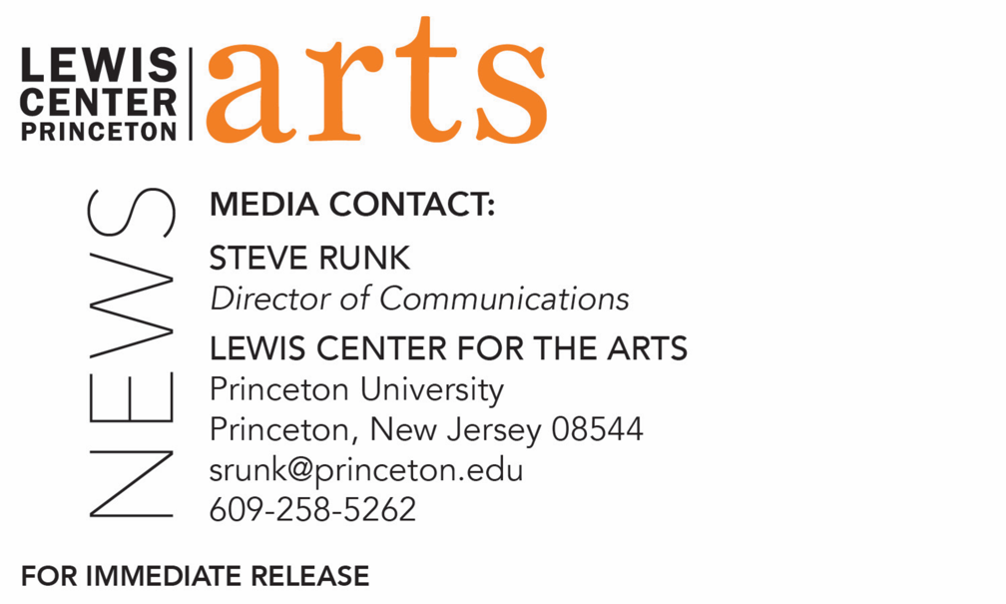

November 24, 2020

Fund for Irish Studies at Princeton University presents
A Reading by Poet Eiléan Ní Chuilleanáin
Award-winning poet and Ireland Professor of Poetry 2016-19 next in the series

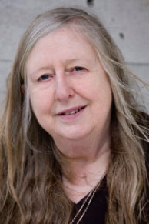
Photo caption: Poet Eiléan Ní Chuilleanáin
Photo credit: Patrick Redmond

What/Who: Eiléan Ní Chuilleanáin, award-winning poet and translator, Ireland Professor of Poetry 2016-19, and Professor emeritus in the School of English at Trinity College Dublin, reads from her work, presented by Princeton’s Fund for Irish Studies
When: Friday, December 4 at 4:30 p.m.
Where: Online via Zoom
Admission: Free and open to the public
Accessibility: This event will be live captioned. Viewers in need of other access accommodations are invited to contact the Lewis Center at least 2 weeks in advance at LewisCenter@princeton.edu
For more information and the Zoom link: https://arts.princeton.edu/events/fund-for-irish-studies-reading-by-eilean-ni-chuilleanain/

(Princeton, NJ) Princeton University’s Fund for Irish Studies presents a reading by Eiléan Ní Chuilleanáin, award-winning poet and translator, Ireland Professor of Poetry 2016-19, and Professor emeritus in the School of English at Trinity College Dublin, on December 4 at 4:30 p.m. online via Zoom. The reading is free and open to the public.

Eiléan Ní Chuilleanáin is the author of numerous poetry collections including The Mother House (2020); The Boys of Bluehill (2015), which was shortlisted for the Forward Prize for Best Collection; The Sun-fish (2010), which won the International Griffin Poetry Prize; Selected Poems (2009); The Magdalene Sermon (1989), which was selected as one of the three best poetry volumes of the year by the Irish Times/Aer Lingus Poetry Book Prize Committee; and Acts and Monuments (1966), which won the Patrick Kavanagh Award. She translated two books by the Romanian poet Ileana Malancioiu, The Legend of the Walled-Up Wife (2012) and After the Raising of Lazarus (2005), as well as Nuala Ní Dhomhnaill’s The Water Horse (2001), co-translated with Medbh McGuckian. Ní Chuilleanáin’s work has been featured in several anthologies, including The Wake Forest Book of Irish Women’​​​​​​​s Poetry, 1967–2000 (1999), edited by Peggy O’Brien. Since 1975 she has edited the literary magazine Cyphers, and she has also edited Poetry Ireland Review.

Ní Chuilleanáin’s honors include the Patrick Kavanagh Award for Poetry in 1973; O’Shaughnessy Prize for Poetry from the Irish-American Cultural Institute in 1992; and election to Aosdána in 1996. The Sun-fish was shortlisted for the T.S. Eliot Prize in 2009 and received the Griffin International Poetry Prize in Toronto in 2010. The Boys of Bluehill was shortlisted for the Forward Prize and the Pigott Prize. The Mother House received the Irish Times/Poetry Now Award in 2020.

Ní Chuilleanáin was born in Cork in 1942, educated at University College, Cork, and at Oxford. She is a Fellow and Professor emeritus in the School of English, Trinity College, Dublin.

The Fund for Irish Studies affords all Princeton students, and the community at large, a wider and deeper sense of the languages, literatures, drama, visual arts, history, politics, and economics not only of Ireland but of “Ireland in the world.” The series is co-produced by the Lewis Center for the Arts and organized by Paul Muldoon, Princeton’s Howard G.B. Clark ’21 University Professor in the Humanities, Founding Chair of the Lewis Center, Director of the Princeton Atelier, and Chair of the Fund for Irish Studies.

Information about the Fund for Irish Studies series virtual events can be found at fis.princeton.edu. Other upcoming events in the current series, anticipated to remain virtual into 2021, include:
- Laurence Cox (Maynooth) on “Irish Hobo, Buddhist Monk, Anticolonial Celebrity: The Strange Story of U Dhammaloka/Laurence Carroll” - February 5
- Fintan O’Toole presents the Robert Fagles Memorial Lecture on “1921 and 2021: The Partition of Ireland, Then and Now” - February 26
- Tara Guissin-Stubbs (Oxford University) on “Symbols from within, and symbols from without: The Celtic Revival and the Harlem Renaissance” - March 19
- Alan Hayden (University College, Dublin) on “Irish Archaeology Now” - April 16

The reading will be live captioned. Viewers in need of other access accommodations are invited to contact the Lewis Center at least 2 weeks in advance at LewisCenter@princeton.edu.

The Fund for Irish Studies is generously sponsored by the Durkin Family Trust and the James J. Kerrigan, Jr. ’45 and Margaret M. Kerrigan Fund for Irish Studies.

To learn more about the more than 100 public performances, exhibitions, readings, screenings, concerts, lectures and special events, most of them free, presented each year by the Lewis Center for the Arts, visit arts.princeton.edu.

###

