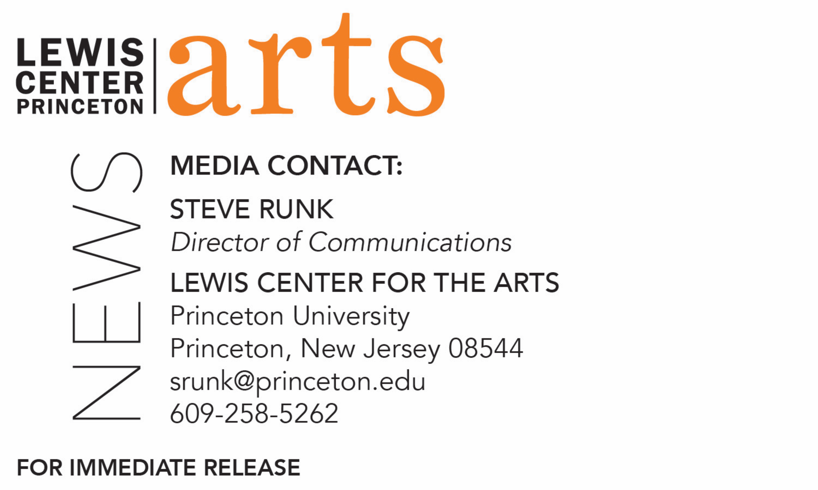

December 4, 2020

Lewis Center for the Arts’ Program in Theater premieres
All Her Power
A film of original performance works celebrating the 50th anniversary of
coeducation at Princeton University

Photo caption: Archival photo of alumni marching in the 1983 p-rade, marking the first year that women who fully matriculated at Princeton graduated.
Photo credit: Alumni Reunions 1983; Princeton Alumni Weekly Photograph Collection, AC126, Princeton University Archives, Department of Special Collections, Princeton University Library.

What: Premiere of All Her Power: The 50th Anniversary of Undergraduate Coeducation Theater Project, celebrating the milestone of the first undergraduate co-ed class’ arrival at Princeton. Three generations of Princeton women came together. Current students were paired with professional artist alumnae to research and create new, short performances about women who graduated from Princeton in the first few years of co-education. A live conversation with project leaders and some of the early women graduates follows the premiere screening.
Who: Led by Program in Theater Director Jane Cox and Lecturer in Theater, director and Princeton alumna Suzanne Agins ’97 working with student-alumnae pairs and alumna Milan Eldridge ’20 as film editor. Presented by the Lewis Center for the Arts’ Program in Theater
When: Premiere event December 18 at 7:00 p.m. (EST) followed by live conversation; film available on-demand starting December 19
Where: Virtual via livestream at allherpower.princeton.edu
Admission: Free and open to the public; no registration required
Accessibility: The film will be closed captioned and the conversation will be live captioned. Viewers in need of other access accommodations are invited to contact the Lewis Center at least 2 weeks in advance at LewisCenter@princeton.edu
For more information and to view the live premiere and the film on-demand: allherpower.princeton.edu

(Princeton, NJ) The Lewis Center for the Arts’ Program in Theater at Princeton University will premiere All Her Power: The 50th Anniversary of Undergraduate Coeducation Theater Project on December 18 at 7:00 p.m. Three generations of Princeton women have come together to celebrate the milestone of the first undergraduate co-ed class’ arrival at Princeton in 1969. Current students were paired with professional artist alumnae to research and create new, short performances about women who graduated from Princeton in the first few years of co-education. A live conversation with project leaders and some of the early women graduates follows the premiere screening. This online event is free and open to the public at allherpower.princeton.edu; no registration required.

The project was conceived in early 2019 by Program in Theater Director Jane Cox and Theater Lecturer, director, and Princeton alumna Suzanne Agins, Class of 1997, who serves as producing artistic director for the project

Eight alumnae who are professional theater artists were engaged for the project: Gwynn MacDonald ’87, a theater, television, film and radio director/producer; Whitney Mosery ’08, a theater director, dramaturg and art activist; Ronee Penoi ’07, theater maker, producer and associate producer at Octopus Theatricals; Cara Reichel’96, a co-founder and producing artistic director of Prospect Theater Company; Marisol Rosa-Shapiro ’07, a theater artist specializing in original works; Najla Said ’96, an actor, playwright and author; Jill Sigman ’89 GS ’98, a movement artist working at the intersection of dance, visual installation, and social practice; and Kay-Megan Washington ’88, an actor, voiceover artist and vocalist. These alumnae worked with students to interview seven alumnae from the 1970s and create original performance works in response to their research. The students include Leila Abou-Jaoude ’22, Paige Allen ’21, Patricia Chen ’20, Eliana Cohen-Orth ’21, Glenna Galarion ’21, Haydon John ’21, Katharine Matthias ’21, Kateryn McReynolds ’20, Magdalena Poost ’22, Myrha Qadir ’22, Vydhourie Thiyageswaran ’21, and Rosamond van Wingerden ’20.

The women whose experiences as early co-eds formed the basis for the works are:
Alice Eve Cohen ’76, who studied anthropology, was the first recipient of a certificate in theater at Princeton and founded Princeton Jewish Theatre, is a playwright, solo theater artist and author. Tina deVaron ’78, an English major and founding member and former music director of the Princeton Katzenjammers a cappella group, is currently at work on several musicals and song cycles, has had top song placements on the Gospel and the Billboard Club/Dance charts, and performed with Frank Sinatra and Billy Joel. Vera Marcus ’72 graduated in three years with a degree in philosophy becoming the first African American woman to graduate who fully matriculated at Princeton, has worked as assistant secretary to Governor Jerry Brown’s cabinet secretary for natural resources, as a lobbyist for environmental and women’s issues, and as an attorney. Debra Meloy Elmegreen ’75 was the first female astrophysical sciences major at Princeton, a member of Quadrangle Club, and is Professor of Astronomy and the Maria Mitchell Chair and Department Chair of Physics and Astronomy at Vassar College. Helena Novakova ’72 left a life behind the Iron Curtain to attend Princeton as a Slavics major, was one of the first two women to compete in an athletic event for Princeton, earned her MAT at Stanford, and is in a second career as a financial advisor. Carla Gail Wilson ’71 was one of 12 Black women admitted to Princeton the first year of co-education, was a philosophy major and member of the Association of Black Collegians, and went on to law school and to write poetry. Helen Lee Zia ’73, a public affairs major, is a writer, activist and Fulbright Scholar (which followed stints as a medical student, a construction laborer, an autoworker, and a community organizer), and in 2010 she was a witness in the federal marriage equality case decided by the Supreme Court.

The project launched in the summer of 2019 and was intended to culminate in an evening of live theater in April of this year on the Berlind stage at McCarter Theatre Center. However, those plans were revised after the pandemic shut down theaters. The project team spent the past summer revising the works for presentation in a virtual environment. The performances were filmed throughout the fall and have been edited into a film by recent theater and visual arts alumna Milan Eldridge ’20 with sound designer and Program in Theater faculty member Rob Kaplowitz.
The eight original works documented in the film take many forms including film collage, solo performance, audio drama, original music, choreography and animation.

The cast of performers, directors of individual works, dramaturgical and stage management staff, designers, and artistic collaborators are drawn from current students and alumni from a range of class years. Other members of the project team include alumna director Chamari White-Mink ’20; student director Juliette Carbonnier ’23; stage managers Ally Wonski ’22, Aleeza Schoenberg ’22, and Madeleine LeBeau ’24; primary researcher Jessica Mack GS ’19; and alumna ambassador Jane Shidler ’96.

The project is supported by a 2019-20 David A. Gardner ’69 Magic for innovation and a grant from the Princeton Histories Fund.

Following the December 18 premiere, the film will be available to view free on-demand at allherpower.princeton.edu.

The film will be closed captioned and the conversation following the premiere screening will be live captioned. Attendees in need of other access accommodations are invited to contact the Lewis Center at least two weeks in advance at LewisCenter@princeton.edu.

To learn more about the Program in Theater and the more than 100 performances, exhibitions, readings, screenings, concerts, and lectures presented each year at the Lewis Center, most of them free, visit arts.princeton.edu.

###

