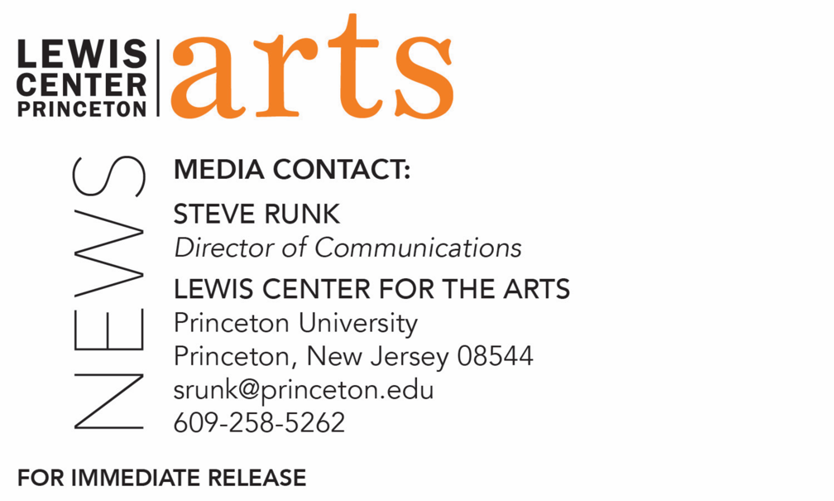

December 14, 2020

The Art of Anti-Racism and Social Justice
presented by Lewis Center for the Arts at Princeton University
Multidisciplinary artist and equality advocate Indrani Pal-Chaudhuri, Princeton alum, shares work created by students in her fall course and discusses the powerful role film and art are playing in movements for rights and justice, with special guests Mo'Nique, Hawk Newsome, Eugene Brave Rock, Daryl Davis, Lazarus, Gina Belafonte, and co-host U.N. curator Kunal Sood

Photo caption 1: A still from first-year student Thomas Hughes’ public service announcement “Connecticut Bail Reform – Justice for Desiree” promoting criminal justice reform
Photo credit 1: Courtesy of Thomas Hughes
Photo caption 2: Filmmaker and social justice advocate Indrani Pal-Chaudhuri
Photo credit 2: Courtesy of Indrani Pal-Chaudhuri

What/Who: Across the United States — and the entire world — film and art have become central to ongoing movements for rights and justice, which have intensified since the killing of George Floyd. This event honors leaders and artists at the forefront of social change, engaging in dialogue about their work and perspectives on mobilizing anti-racism, equality, and social justice. This discussion is a part of the virtual opening of the exhibition, “The Art of Anti-Racism and Social Justice,” an expanding archive of Princeton University student art dedicated to public service and social justice. Presented in partnership by Princeton’s Lewis Center for the Arts, Office of the Dean of Undergraduate Students, and the Freshman Seminar Program, this initiative is an extension of the 2020 Fall seminar, “Moving Millions with Art and Film for Human Rights and Social Justice,” taught by filmmaker and social justice advocate Indrani Pal-Chaudhuri, a Tribeca Film Festival Disruptive Innovation-awarded director, Princeton alum, and co-host of the Global People’s Summit at the United Nations. Hosted by Indrani and #WeThePlanet U.N. curator Kunal Sood, this event brings together leaders of contemporary art and justice movements, to share insights to inspire positive cultural and socio-political change including actress Mo'Nique, activist Hawk Newsome, actor Eugene Brave Rock, musician Daryl Davis, COVID-19 frontline physician and Detroit-born Pakistani-American rapper Lazarus, and actress/producer Gina Belafonte.
When: Live conversation December 15 at 7:00 p.m. (EST); exhibition available online starting Dec. 15.
Where: Virtual via Zoom Webinar
Admission: Free and open to the public; Zoom registration required
Accessibility: The conversation event will be live captioned. Viewers in need of other access accommodations are invited to contact the Lewis Center at least 2 weeks in advance at LewisCenter@princeton.edu
For more information, Zoom registration link and to view the exhibition: https://arts.princeton.edu/events/the-arts-of-anti-racism-and-social-justice-exhibition-and-conversation/

(Princeton, NJ) On December 15 Princeton University’s Lewis Center for the Arts presents The Art of Anti-Racism and Social Justice, a conversation and virtual exhibition recognizing that across the United States — and the entire world — film and art have become central to ongoing movements for rights and justice, which has intensified since the killing of George Floyd. This event honors leaders and artists at the forefront of social change, engaging in dialogue about their work and perspectives on mobilizing anti-racism, equality, and social justice.

At 7:00 p.m. filmmaker and social justice advocate Indrani Pal-Chaudhuri, a Tribeca Film Festival Disruptive Innovation-awarded director, Princeton alum, and cohost of the Global People’s Summit at the United Nations will host the conversation, with #WeThePlanet United Nations curator Kunal Sood. They will welcome leaders of contemporary art and justice movements to share insights to inspire positive cultural and socio-political change, including Mo'Nique, Academy Award-winning actress and talk show host, perhaps best known for her performance in the film Precious; Hawk Newsome, co-founder of Black Lives Matter of Greater New York; Eugene Brave Rock, an actor best known for his performance as the first Indigenous superhero, The Chief, in Wonder Woman (2017); Daryl Davis, a jazz musician, who has convinced more than 200 people to leave the Ku Klux Klan white supremacist hate group; Lazarus, a COVID-19 frontline physician and Detroit-born Pakistani-American rapper; and Gina Belafonte, actress and producer, known for BlacKkKlansman, and executive director of Sankofa.org, founded by Harry Belafonte, which educates, motivates and activates artists and allies in service of grassroots movements and equitable change.

This virtual event, which is free and open to the public, launches an online exhibition and expanding archive of Princeton student art dedicated to public service and social justice. Presented in partnership with Princeton’s Office of the Dean of Undergraduate Students and the Freshman Seminars Program, this initiative is an extension of the 2020 fall seminar, “Moving Millions with Art and Film for Human Rights and Social Justice,” taught by Pal-Chaudhuri. The students’ public service announcement videos created during the course address a range of issues including immigration reform, Black Lives Matter, ending forced labor, promoting STEM fields to girls, voter suppression, colorism, mental health resources, racial microaggressions, marine pollution, and criminal justice reform.

“Believing that artists and filmmakers are myth-makers, shaping the parameters of the possible,” said Pal-Chaudhuri, “my work explores transformation, ethics with aesthetics, and the intersection between fantasy and reality from diverse perspectives, to inspire positive social change."

Indrani Pal-Chaudhuri is a biracial, multidisciplinary artist and Princeton graduate, working in film, photography, and social justice. A “leading director and voice for female empowerment” (Tribeca Film Festival), "at the crossroads of pop culture and critical acclaim"(Lincoln Center), collaborating with legendary artists, her work empowers diversity, equality and environmental sustainability. Discovered by David Bowie while she was still a student, she helped launch Beyoncé and Lady Gaga's solo careers, creating their debut album art. She is also a director of music videos and philanthropic and art films, shown in museums worldwide, from the Center Pompidou Paris, to the Brooklyn Museum, and the National Portrait Gallery, and on CNN, HBO, and the BBC. Known for her “iconic imagery and visionary storytelling” (Huffington Post), her work has won 29 awards including The Tribeca Film Festival 2019 Disruptive Innovation Award, The Max Mark-Cranbrook 2019 Global Peacemaker Award, Best Picture and Best Director at the Los Angeles Independent Film Festival, two Gold Lions at Cannes Festival of Creativity, and Best Film at the CNN 2018 Expose Awards. A prolific speaker, she is cohost of the Global People’s Summit during the General Assembly at the United Nations; a U.N. Women’s Entrepreneurship Distinguished Fellow; host of New York Live Arts – AI Live Ideas Gala; and co-founder and executive director of the Shakti Empowerment Education Foundation.

Freshmen Seminars are unique opportunities open only to members of the first-year class and designed to provide students an early opportunity to experience the excitement of working closely with an instructor and a small group of fellow students on a topic of special interest.

The conversation event will be live captioned. Viewers in need of other access accommodations are invited to contact the Lewis Center at least two weeks in advance at LewisCenter@princeton.edu

For more information about this event and the more than 100 performances, exhibitions, readings, screenings, concerts and lectures presented each year by the Lewis Center
for the Arts, most of them free, and this year all virtual, visit arts.princeton.edu.

###

