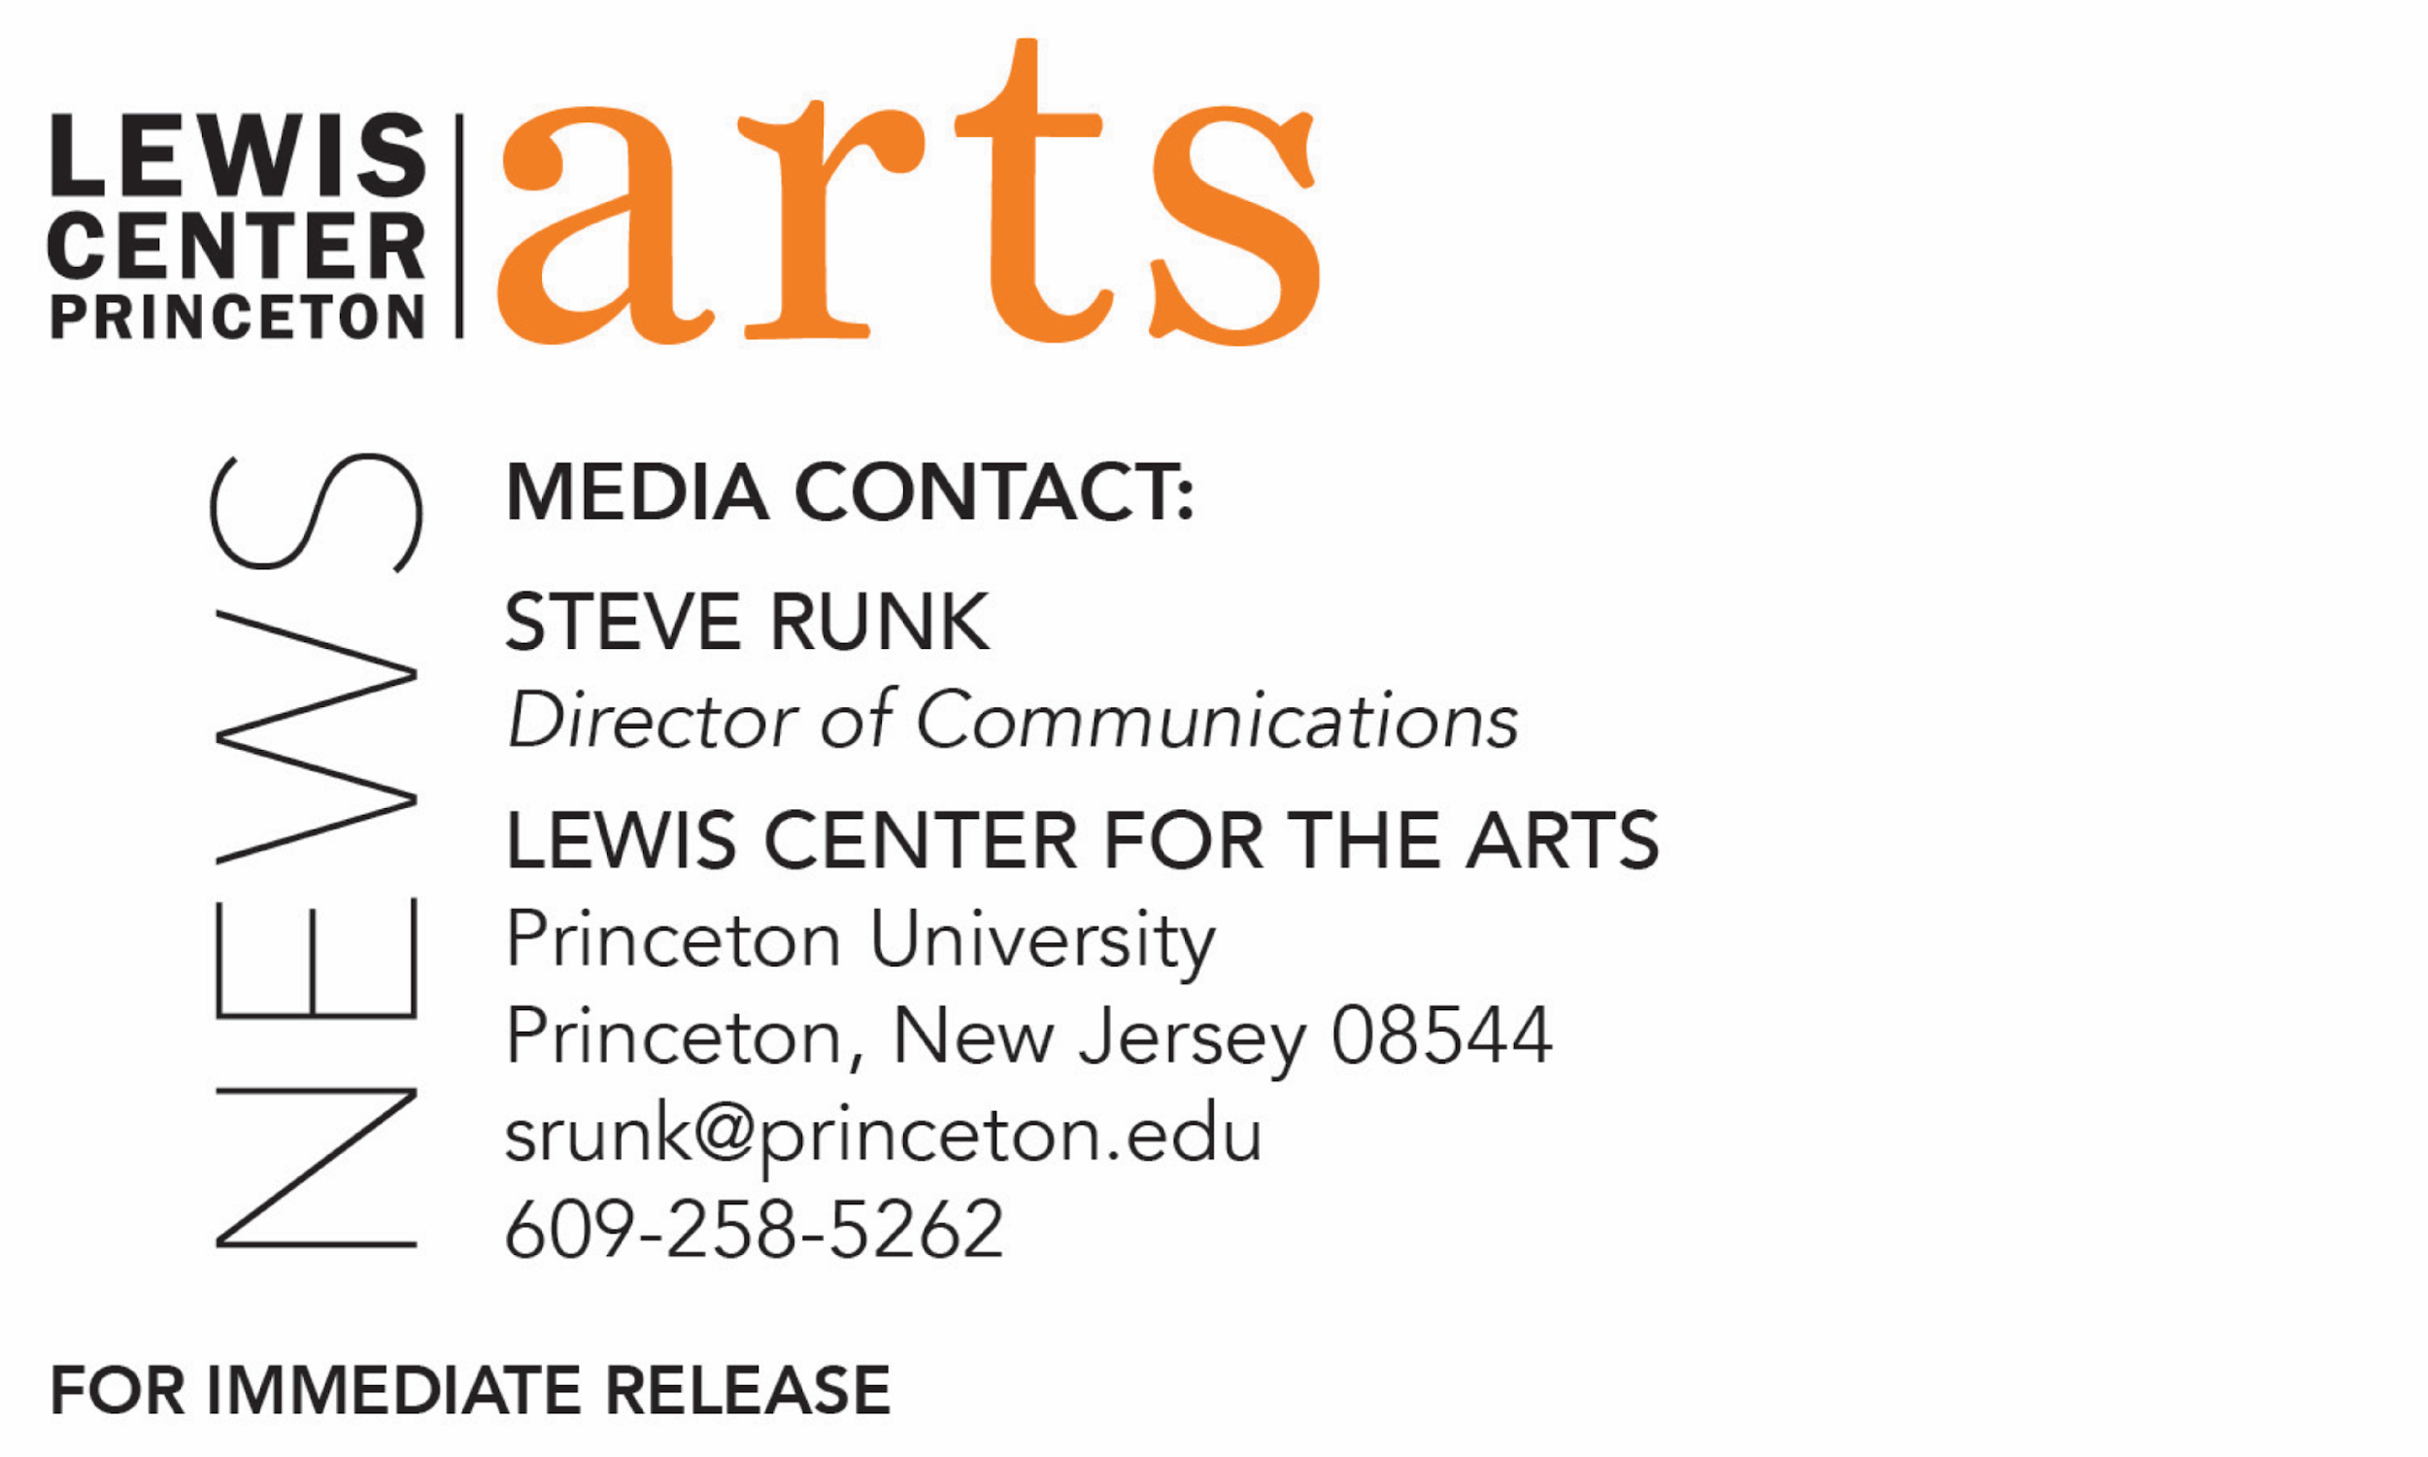

December 22, 2020

Lewis Center for the Arts’ Program in Theater presents
Unbecoming by Emma Catherine Watkins
First full production of a new play by Princeton alumna inspired by the story of the first person to translate the Mabinogion — a collection of ancient Welsh stories — into English. Features seniors Paige Allen as dramaturg and Eliana Cohen-Orth as director with both also performing in this filmed production

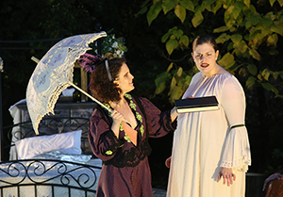
Photo caption: Princeton seniors Eliana Cohen-Orth (left) and Paige Allen perform in the filmed production of Unbecoming, in which they also serve as director and dramaturg, respectively.
Photo credit: Cathy Watkins

What: First full production of Unbecoming, a new play by Princeton alumna Emma Catherine Watkins ’18 that is inspired by the story of the real-life Lady Charlotte Guest, a Victorian housewife and mother. Much to her husband’s dismay, Charlotte aspires to become the first person to translate the Mabinogion — a collection of ancient Welsh stories — into English. Through her translation, she encounters Blodeuwedd, a woman conjured from flowers as a wife for her creator and punished for her infidelity. As Charlotte struggles to reconcile her creative ambitions with 19th-century expectations of marriage and motherhood, she must also confront the power and responsibility she holds in retelling Blodeuwedd’s story.
Who: Performed by a cast of six Princeton students, who lived as a quarantine pod through the fall, in a unique outdoor setting and presented as a filmed theatrical production. Unbecoming serves as the senior thesis for Paige Allen (dramaturg, Charlotte) and Eliana Cohen-Orth (director, Wife of England/Gwydion). Presented by the Lewis Center for the Arts’ Program in Theater.
When: Streaming January 15 at 7:00 p.m., January 16 at 2:00 & 8:00* p.m., and January 17 at 2:00* p.m. *Live conversations follow these broadcasts.
Where: Virtual via streaming; conversations via Zoom
Admission: Free and open to the public
Accessibility: The film will be closed captioned and the conversations will be live captioned. Viewers in need of other access accommodations are invited to contact the Lewis Center at least 2 weeks in advance at LewisCenter@princeton.edu
For more information and access: https://arts.princeton.edu/events/unbecoming/2021-01-15/

(Princeton, NJ) The Lewis Center for the Arts’ Program in Theater at Princeton University will present the first full production of Unbecoming, a new play by Princeton alumna Emma Catherine Watkins. The play is inspired by the story of real-life Lady Charlotte Guest, a Victorian housewife and mother who aspires to become the first person to translate the Mabinogion — a collection of ancient Welsh stories — into English, and the encounters that ensue as the mythic characters of these legends invade Charlotte’s world. The filmed outdoor production features Princeton seniors Paige Allen and Eliana Cohen-Orth, who also serve as dramaturg and director, respectively. The film can be viewed on January 15 at 7:00 p.m., January 16 at 2:00 and 8:00 p.m., and January 17 at 2:00 p.m. Live conversations follow the final two broadcasts. The event is free and open to the public; the conversations require registration on Zoom.

Lady Charlotte Elizabeth Guest (1812-1895) was an English aristocrat and a leading figure in the study of literature and the wider Welsh Renaissance of the 19th century. Throughout her long life, Charlotte was recognized for her work in education, management of her husband’s ironworks, and philanthropy. Unbecoming focuses on her early adulthood and her best-known accomplishment: her translation of the Mabinogion.

Rooted in ancient Welsh traditions of oral storytelling, the tales of the Mabinogion intertwine myth, tradition, and history to produce some of Wales’ earliest prose literature, stories of redemption, loyalty, metamorphosis, and magic. Unbecoming takes inspiration from the story of Blodeuwedd, a woman conjured from flowers as a wife and punished for her infidelity, and its themes of autonomy and betrayal.

Watkins wrote Unbecoming as her dissertation at Cardiff University in Wales, where she was a Fulbright Scholar and studied performance adaptations of Welsh myths and folklore. In Watkins’ play, Charlotte’s efforts to translate the Mabinogion are met by her husband with dismay. Through her translation, she encounters Blodeuwedd, and as Charlotte struggles to reconcile her creative ambitions with 19th-century expectations of marriage and motherhood, she must also confront the power and responsibility she holds in retelling Blodeuwedd’s story. Unbecoming was developed in collaborations with PlayPenn in Philadelphia, Princeton, and Cardiff.

Watkins’ plays have also been shared at McCarter Theatre Lab’s In the Writer’s Voice, Chapter Arts Centre in the U.K., and Princeton’s Theatre Intime. She was recently nominated for the National Theatre Conference’s Barry and Bernice Stavis Playwriting Award. She has worked as a dramaturg and literary assistant for productions of Gloria: A Life, Mary Shelley’s Frankenstein, Sleuth, and the world premiere of Rachel Bond’s Goodnight Nobody at McCarter Theatre Center, as well as Into the Woods at the Lewis Center for the Arts. Watkins has presented her research at conferences in the U.S. and the U.K. and recently co-authored a chapter on feminist musical theater pedagogy with Princeton Professor of Theater Stacy Wolf in Teaching Critical Performance Theory (Routledge.) Watkins graduated magna cum laude from Princeton, where her play Trailing Rhiannon, based on a Welsh mythic figure, was awarded Princeton English Department’s Alan S. Downer Thesis Prize, Princeton Lewis Center for the Arts’ Music Theater Prize, and Princeton Environmental Institute’s Environmental Humanities Book Prize. She received her Master’s degree in Welsh and Celtic Studies with Distinction from Cardiff University, where Unbecoming was honored with the Sioned Davies Award for best dissertation in the School of Welsh. She is the co-founder of Humbug! Theatre Co., an organization committed to providing theatrical opportunity to young people during the pandemic, where she teaches playwriting and devising.

Allen first encountered Unbecoming as a participant in a short development workshop hosted by Princeton in January 2020 and shared the script with Cohen-Orth. In addition to the prospect of collaborating with Watkins to develop the piece further, Allen and Cohen-Orth were excited by the piece’s directorial design challenges, emphasis on women’s voices, engagement with history, and potential for ensemble storytelling, so they proposed the project to the Program in Theater as their senior theses.

Unbecoming was originally proposed as a live theater production; however, the project had to be rethought with the suspension of gatherings in theaters as a result of the COVID pandemic. Allen and Cohen-Orth introduced the play to the four other Princeton students they were planning to live with in a house off-campus for the fall semester, and the six of them decided to perform the show as a quarantine pod. Over the course of nine weeks, the team explored the script, workshopped revisions, and rehearsed the play in the house’s backyard before filming the production. The team both performed and served in a number of production roles with equipment, costumes, and props shipped or delivered via contactless drop-off outside the house by the Lewis Center’s production staff. Though a challenging and unexpected experience, Allen and Cohen-Orth found that the limitations and unconventional circumstances led to an especially collaborative rehearsal process and new artistic breakthroughs.

Allen, who is from Mountain Top, Pennsylvania, is pursuing a degree in English with certificates in creative writing, humanistic studies, theater, and music theater. She has contributed to a number of productions with the Lewis Center for the Arts including performing in Fnu Lnu, The Book of Miaou, Mad Dreams, and Fun Home; stage managing Mother Courage and her Children; providing dramaturgy for A Little Night Music; and writing a short screenplay for All Her Power: The 50th Anniversary of Undergraduate Coeducation. She has been heavily involved in student theater groups, most notably serving for two years as president of Princeton’s only entirely student-run musical theater group Princeton University Players, directing Godspell with PUP and Antigonick with Theatre Intime, and playing the title role in Theatre Intime’s Richard III. Professionally, she stage managed Princeton Summer Theater’s 2019 production of Topdog/Underdog. She received funding from the Lewis Center’s Sam Hutton Fund for the Arts to learn about theatrical criticism and review performances in New York City during the summer of 2019, self-publishing those reviews to her blog, The College Critic. She served as head editor of The Prospect Arts & Culture section of The Daily Princetonian after helping revive the section in February 2020, and she received the 2019-2020 Excellence in Arts Writing Award from the newspaper. In October 2020, she participated in the Association for Theatre in Higher Education’s virtual colloquium, giving a talk entitled, “Not Pretty or Safe or Easy: Unhealthy Relationships in the Works of Stephen Sondheim.” Allen is a member of Phi Beta Kappa, a two-time winner of the Shapiro Prize for Academic Excellence, and a recipient of the Princeton English Department Fellowship for Summer Thesis Research. She is a member of the Behrman Undergraduate Society of Fellows, the Edwards Collective, and the Wesley Foundation, and she serves as a head fellow at the Writing Center, an Orange Key tour guide, a peer arts advisor, a humanities mentor, and a representative to the Undergraduate Advisory Council of the English Department. For her written senior thesis, she is writing a collection of short stories exploring monstrosity, identity, and the Gothic tradition.
Cohen-Orth, a resident of New York City, is pursuing a degree in English and a certificate in theater. Throughout her time at Princeton, she’s worked on a number of shows as a director, producer, actor, playwright, and lighting designer. Last summer, she held the role of artistic director for Princeton Summer Theater—a professional nonprofit theater—for their unique, virtual season. For three years, she served on the board of Princeton’s one hundred-year-old student theatre group, Theatre Intime, most recently as general manager. She directed for the first time as a first-year student with Theatre Intime’s Student Playwrights Festival and went on to direct productions of Jen Silverman’s The Moors and Sarah Ruhl’s Eurydice with Theatre Intime, and children’s productions of Peter and the Starcatcher and Check Please. In addition, she worked with Princeton’s Sexual Harassment/Assault Advising, Resources and Education Office (SHARE) to revise and direct the annual production of The Way You Move, which was presented to all newly arrived first-year students. She has been involved in several productions with the Lewis Center for the Arts, including acting in Peerless and the first production of Branden Jacob-Jenkins’ play Gurls, assistant stage managing The Odyssey, and writing and developing a short documentary play for All Her Power: The 50th Anniversary of Undergraduate Coeducation. For her independent work in the English Department, she is writing a play inspired by the life of nineteenth-century actress Charlotte Cushman.

The film was edited by Adam Olkin, who also served as technical director. Olkin is a junior at New York University’s Tisch School of the Arts where he is majoring in film and television. He is a filmmaker and videographer in New York City and Princeton, working with organizations such as The Princeton Festival, Tisch New Theatre, and Princeton University’s L’Avant Scene. He has been the director of photography for several music videos and directed a number of short films. He has technical directed and directed several live concerts and events and sound designed Legally Blonde for Tisch New Theatre in the Skirball Performing Arts Center.

Following the January 16 evening screening, the live conversation will feature Cohen-Orth, Olkin, and other members of the project cast and crew discussing the process of making this unique filmed theater piece in pandemic conditions. Following the January 17 screening, the live conversation will feature Watkins and scholar Sioned Davies in a discussion on the Mabinogion, Charlotte Guest, and the arts of translation and adaptation. Davies is a Professor Emerita at Cardiff University, where she was the first ever female professor of Welsh, and the first woman to translate the Mabinogion since Charlotte Guest. Her translation, published by Oxford World Classics, is the first to place emphasis on the tales’ oral origins, translating them with regard to the rhythm and tempo of the originals, preserving their formulaic elements, and displaying the rhetorical passages. Both talkbacks will be held via Zoom and require registration.

The rest of the cast includes sophomore Eliyana Abraham, senior Nora Aguiar who also served as stage manager, senior Naomi Park who also served as lighting designer, and senior Hannah Wang. Students working remotely or socially distanced in other production roles include junior Isabella Hilditch as set designer, first-year student Casey Beidel as assistant stage manager, senior Minjae Kim as sound designer, junior Ruth Schultz as an acrobatics and movement coach, junior Delaney McMahon as composer, and sophomore Halle Mitchell as music director.

Faculty and guest artists/advisors on the project include Noelle Quanci as costume designer, Lawrence Moten as set advisor, Tess James as lighting advisor, G Clausen as sound advisor, and Will Davis as faculty advisor.

The film will be closed captioned and the conversation events will be live captioned. Viewers in need of other access accommodations are invited to contact the Lewis Center at least two weeks in advance at LewisCenter@princeton.edu

To learn more about this event, the Program in Theater, and the over 100 performances, exhibitions, readings, screenings, concerts, and lectures presented each year at the Lewis Center, most of them free and this year virtual, visit arts.princeton.edu.

###

