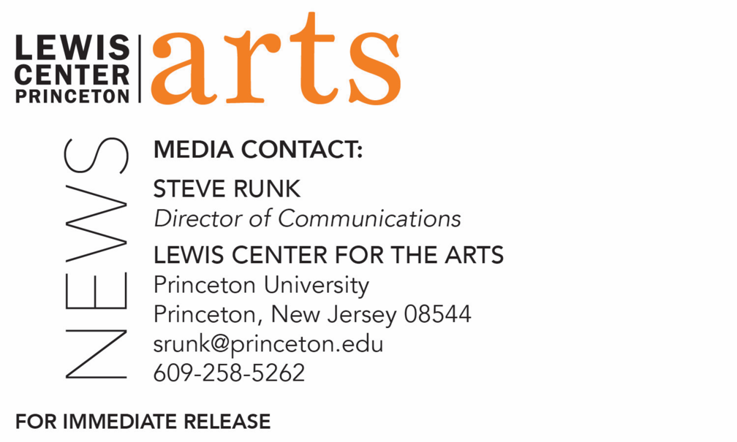

January 26, 2021

Fund for Irish Studies at Princeton University presents
“Irish Hobo, Buddhist Monk, Anti-colonial Celebrity: The Strange Story of U Dhammaloka/Laurence Carroll”
A lecture by sociologist Dr. Laurence Cox next in the series

Photo caption: Dr. Laurence Cox, Associate Professor of Sociology at the National University of Ireland Maynooth and associate researcher at the Collège d’Etudes Mondiales, Paris
Photo credit: Wendy Cox

What/Who: “Irish Hobo, Buddhist Monk, Anti-colonial Celebrity: The Strange Story of U Dhammaloka/Laurence Carroll,” a lecture by Dr. Laurence Cox, Associate Professor of Sociology at the National University of Ireland Maynooth and associate researcher at the Collège d’Etudes Mondiales, Paris. The lecture is based on his recent book, The Irish Buddhist: the Forgotten Monk who Faced Down the British Empire, co-authored with Alicia Turner and Brian Bocking, presented by Princeton’s Fund for Irish Studies
When: Friday, February 5 at 4:30 p.m.
Where: Virtual via Zoom Webinar
Admission: Free and open to the public
Accessibility: This event will be live captioned. Viewers in need of other access accommodations are invited to contact the Lewis Center at least 2 weeks in advance at LewisCenter@princeton.edu
For more information and the Zoom link: https://arts.princeton.edu/events/fund-for-irish-studies-lecture-by-laurence-cox/

(Princeton, NJ) Princeton University’s Fund for Irish Studies presents “Irish Hobo, Buddhist Monk, Anti-colonial Celebrity: The Strange Story of U Dhammaloka/Laurence Carroll,” a lecture by Dr. Laurence Cox, associate professor of sociology at the National University of Ireland Maynooth and associate researcher at the Collège d’Etudes Mondiales, Paris. The lecture will be held on February 5 at 4:30 p.m. (EST) online via Zoom Webinar. The lecture is free and open to the public.

The lecture is based on Cox’s recent book, The Irish Buddhist: the Forgotten Monk who Faced Down the British Empire, co-authored with Alicia Turner and Brian Bocking. Born in Dublin in 1856, Laurence Carroll worked his way across the Atlantic, hoboed across the United States and sailed the Pacific before winding up as a dock worker in Burma where he was ordained as U Dhammaloka, a Buddhist monk, and was an anti-colonial celebrity active from Sri Lanka to Japan. In this lecture, Cox looks at some of the most dramatic moments in Dhammaloka’s extraordinary life and explores how he brought his Irish and American experiences to bear on religion, race and the challenge to Empire in Asia

Cox is one of Europe’s leading specialists on social movements. His work on U Dhammaloka and other early western Buddhists in Asia is well-known as part of the transnational scholarly rethinking of how Buddhism became a global religion in the late nineteenth and early twentieth centuries. He has published over 160 scholarly works. His ten books include Buddhism and Ireland: From the Celts to the Count-culture and Beyond; A Buddhist Crossroads: Pioneer Western Buddhists and Asian Networks 1860 – 1960; Ireland’s New Religious Movements; and Why Social Movements Matter. With Brian Bocking and Yoshinaga Shin’ichi, he also rediscovered the first Buddhist mission to Europe, led by the Irishman Charles Pfoundes in 1889-92. Cox has been an invited speaker at Kyoto University, CUNY Graduate Center, the European University Institute, and Ruskin College Oxford, among many other places. He is founding editor of the global social movement research journal Interface and has twice guest-edited Contemporary Buddhism. In the spirit of Dhammaloka, he has also been a street musician and hitchhiked across Europe, trains activists in the Catalan Pyrenees, and runs hot tubs on Dartmoor for Buddhist meditation retreats.

The Fund for Irish Studies affords all Princeton students, and the community at large, a wider and deeper sense of the languages, literatures, drama, visual arts, history, politics, and economics not only of Ireland but of “Ireland in the world.” The series is co-produced by the Lewis Center for the Arts and organized by Paul Muldoon, Princeton’s Howard G.B. Clark ’21 University Professor in the Humanities, Founding Chair of the Lewis Center, Director of the Princeton Atelier, and Chair of the Fund for Irish Studies.

Information about the Fund for Irish Studies series virtual events can be found at fis.princeton.edu. Other upcoming events in the current series include:
- Fintan O’Toole presents the Robert Fagles Memorial Lecture on “1921 and 2021: The Partition of Ireland, Then and Now” — February 26
- Streaming of The Wild Project’s production of Samuel Beckett’s modernist masterpiece Happy Days in recognition of the play’s 60th anniversary — March 5
- Tara Guissin-Stubbs (Oxford University) on “Symbols from within, and symbols from without: The Celtic Revival and the Harlem Renaissance” — March 19
- Alan Hayden (University College, Dublin) on “Irish Archaeology Now” — April 16

The lecture will be live captioned. Viewers in need of other access accommodations are invited to contact the Lewis Center at least two weeks in advance at LewisCenter@princeton.edu.

The Fund for Irish Studies is generously sponsored by the Durkin Family Trust and the James J. Kerrigan, Jr. ’45 and Margaret M. Kerrigan Fund for Irish Studies.

To learn more about the more than 100 public performances, exhibitions, readings, screenings, concerts, lectures and special events, most of them free, presented each year by the Lewis Center for the Arts, visit arts.princeton.edu.

###

