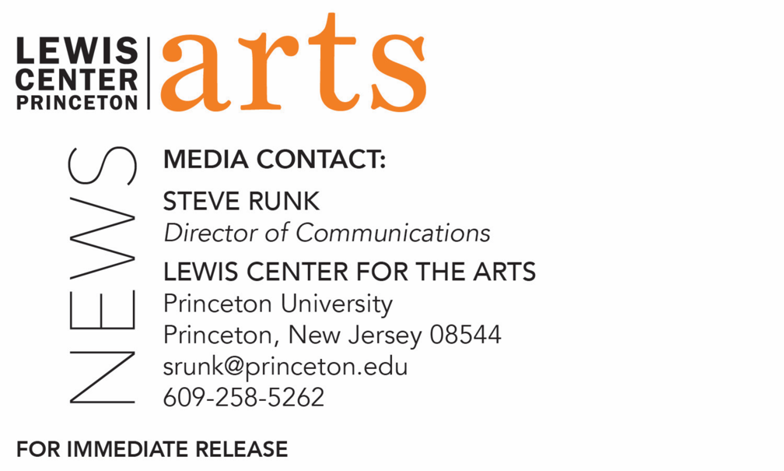

February 4, 2021

C.K. Williams Reading by Ottessa Moshfegh and
Princeton Creative Writing seniors on February 24

Photo caption: Bestselling, award-winning novelist and screenwriter Ottessa Moshfegh
Photo credit: Jake Belcher

What/Who: A reading by bestselling, award-winning novelist and screenwriter Ottessa Moshfegh, and Program in Creative Writing seniors Janie Kim, Sophia Marusic, Shira Moolten, Naomi Park, and Jillian Quigley, next in the 2020-21 season of the C.K. Williams Reading Series, presented virtually this year by the Lewis Center for the Arts’ Program in Creative Writing at Princeton University
When: February 24, 2021 at 6:00 p.m. (EST)
Where: Virtually via Zoom Webinar
Admission: Free and open to the public
Accessibility: Viewers in need of access accommodations are invited to contact the Lewis Center at least 2 weeks in advance at LewisCenter@princeton.edu
For more information and Zoom link: https://arts.princeton.edu/events/c-k-williams-reading-by-ottessa-moshfegh/

(Princeton, NJ) The Lewis Center for the Arts’ Program in Creative Writing at Princeton University presents a reading by bestselling, award-winning novelist and screenwriter Ottessa Moshfegh along with Janie Kim, Sophia Marusic, Shira Moolten, Naomi Park, and Jillian Quigley – five seniors in Princeton’s Program in Creative Writing. The reading is on February 24 at 6:00 p.m. (EST) and continues the 2020-21 C.K. Williams Reading Series showcasing senior thesis students of the Program alongside established writers as special guests. The series is named after the late Pulitzer Prize and National Book Award-winning poet C.K. Williams, who also served on Princeton’s faculty for 20 years. The reading will be presented via Zoom and is free and open to the public.

Ottessa Moshfegh’s books include the PEN/Hemingway Award-winning debut novel, Eileen, named a book of the year by The Washington Post and The San Francisco Chronicle, nominated for a National Book Critics Circle Award, and short-listed for the Man Booker Prize; and the New York Times bestseller, My Year of Rest and Relaxation, named a best book of the year by The Washington Post, Time, NPR, Amazon, Vice, Bustle, The Guardian, Kirkus Reviews, and Entertainment Weekly, among other outlets. She is also the author of a novella, McGlue, winner of the inaugural Fence Modern Prize for Prose, and the Believer Book Award, and optioned for film by Vice with a screenplay adaptation written by Moshfegh. Her short story collection Homesick for Another World received numerous accolades, including being named a New York Times Book Review Notable Book of 2017 and a finalist for the prestigious Story Prize. Her essays and short fiction are occasionally published in The New Yorker, Granta, and The Paris Review. Her latest novel, Death in Her Hands, came out in June and was a New York Times bestseller and named a best book of the year by Elle, Bustle, and the New York Public Library. She has received the Pushcart Prize, the O. Henry Award, and a Plimpton Prize from The Paris Review for her short fiction, as well as a creative writing fellowship from the National Endowment for the Arts. She is originally from Massachusetts and now lives in southern California.

The five seniors, who are pursuing certificates in creative writing in addition to their major areas of study, will read from their senior thesis projects. They are among 24 Princeton seniors who are pursuing certificates in creative writing in addition to their major areas of study. Each is currently working on a novel, a screenplay, translations, or a collection of poems or short stories as part of a creative thesis for the certificate. Thesis students in the Program in Creative Writing work closely with a member of the faculty, which includes award-winning writers Michael Dickman, Aleksandar Hemon, A.M. Homes, Daphne Kalotay, Christina Lazaridi, Jhumpa Lahiri, Yiyun Li, Paul Muldoon, James Richardson, Tracy K. Smith, Kirstin Valdez Quade, Susan Wheeler, Monica Youn, and a number of distinguished lecturers.

Upcoming guests in the 2020-21 C.K. Williams Series include Nana Kwame Adjei-Brenyah and Franny Choi.

Patrons in need of access accommodations in order to participate in this event, are asked to contact the Lewis Center at LewisCenter@princeton.edu at least two weeks in advance of the event date.

To learn more about the reading series, the Program in Creative Writing, and the more than 100 public performances, exhibitions, readings, screenings, concerts and lectures presented each year by the Lewis Center for the Arts, most of them free, visit arts.princeton.edu.

###

