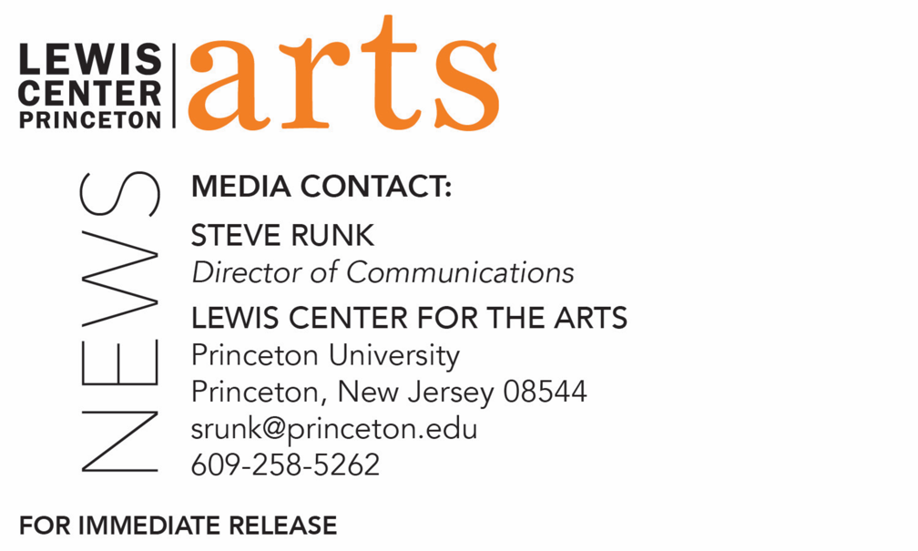

February 25, 2021

Fund for Irish Studies at Princeton University presents
Filmed production of Samuel Beckett’s Happy Days
Produced by NYC’s The Wild Project for the 60th anniversary of this modernist masterpiece in association with the Fund for Irish Studies, featuring alumni Tessa Albertson and
Jake Austin Robertson, directed by alumnus Nico Krell

Photo caption: Princeton alumni Tessa Albertson, Class of 2020 (foreground), and Jake Austin Robertson, Class of 2015, are featured in The Wild Project’s production of Samuel Beckett’s Happy Days, produced in association with Princeton University’s Fund for Irish Studies.
Photo credit: Courtesy of The Wild Project

What/Who: A filmed production of Samuel Beckett’s Happy Days (“One of the most unforgettable plays in the modern canon.” –The New York Times), produced by The Wild Project of New York’s East Village in association with Princeton University’s Fund for Irish Studies in recognition of this modernist masterpiece’s 60th anniversary. In the ultimate emblem of perseverance, Beckett’s Winnie, a tour de force of charm and grit helplessly buried up to her waist in the ground, endures the wearisome humdrum of endless, interchangeable days. And now, speaking to an audience who has faced a year of quarantine, the play endures as well. Featuring Princeton alumni Tessa Albertson and Jake Austin Robertson and directed by alumnus Nico Krell.
When: Friday, March 5 at 4:30 p.m.
Where: Virtual via Zoom Webinar
Admission: Free and open to the public; advance registration required
Accessibility: Live introduction will be captioned and the filmed production will be closed captioned. Viewers in need of other access accommodations are invited to contact the Lewis Center at least 2 weeks in advance at LewisCenter@princeton.edu
For more information and the Zoom registration link: arts.princeton.edu/happy-days

(Princeton, NJ) Princeton University’s Fund for Irish Studies presents The Wild Project’s filmed theatrical production of Happy Days by Samuel Beckett, commemorating this modernist masterpiece’s 60th anniversary. This special preview showing will screen on Friday, March 5 at 4:30 p.m. (EST) via Zoom Webinar with a live introduction by Fund for Irish Studies Chair Paul Muldoon. The event is free and open to the public with advance Zoom registration required. The film will be closed captioned and the introduction will be live captioned.

Happy Days has been hailed by The New York Times as, “One of the most unforgettable plays in the modern canon.” The Wild Project notes the play is the ultimate emblem of perseverance. In the iconic playwright’s lifelong pursuit to illuminate consciousness on stage, Beckett devised Winnie, a tour de force of charm and grit, helplessly buried up to her waist in the ground. She endures the wearisome humdrum of endless, interchangeable days. Now, she speaks to an audience who has endured a year of quarantine.

To commemorate the play’s 60th anniversary, The Wild Project, based in New York City’s East Village, and director Nico Krell are revitalizing this mammoth, mysterious work. In a rare exception allowed only during the global pandemic, the performance has been recorded and will be broadcast online, carefully translated to the screen by a team of artists working on the cutting edge of digital theater. The Wild Project will present six more showings of the film March 5 through 13 with a recommended donation of $25.

Krell is a Princeton alumnus, Class of 2018, and the production features alumni Tessa Albertson, Class of 2020, as Winnie, and Jake Austin Robertson, Class of 2015, as her husband Willie. Alumni Jules Peiperl is costume designer and Stanley Mathabane is sound designer, both members of the Class of 2017.

The Wild Project, a nonprofit theater company and venue, was founded in 2007 to support the diverse independent theater, film, music, visual arts and spoken-word artists of New York City. The organization has presented and produced theater that seeks to enrich, educate, and unify its East Village community in an environmentally responsible green space, devoting specific initiatives to supporting LGBTQ+ artists and projects and those of people of color.

Beckett (1906 –1989) was an Irish novelist, playwright, short story writer, theater director, poet, and literary translator. His idiosyncratic work offers a bleak, tragi-comic outlook on existence and experience, often coupled with dark comedy. Beckett is considered one of the last modernist writers and one of the key figures of the “theater of the absurd.” He is perhaps best-known for his 1953 play, Waiting for Godot. In 1969 he received the Nobel Prize for Literature.

The Fund for Irish Studies affords all Princeton students, and the community at large, a wider and deeper sense of the languages, literatures, drama, visual arts, history, politics, and economics not only of Ireland but of “Ireland in the world.” The series is co-produced by the Lewis Center for the Arts and organized by Paul Muldoon, Princeton’s Howard G.B. Clark ’21 University Professor in the Humanities, Founding Chair of the Lewis Center, and Director of the Princeton Atelier, as well as Chair of the Fund for Irish Studies.

Information about the Fund for Irish Studies series virtual events can be found at fis.princeton.edu. Upcoming events in the current series include:
- Tara Guissin-Stubbs (Oxford University) on “Symbols from within, and symbols from without: The Celtic Revival and the Harlem Renaissance” - March 19
- Alan Hayden (University College, Dublin) on “Irish Archaeology Now” - April 16

The film of the play will be closed captioned and the introduction will be live captioned. Viewers in need of other access accommodations are invited to contact the Lewis Center at least two weeks in advance at LewisCenter@princeton.edu

The Fund for Irish Studies is generously sponsored by the Durkin Family Trust and the James J. Kerrigan, Jr. ’45 and Margaret M. Kerrigan Fund for Irish Studies.

To learn more about The Wild Project visit thewildproject.com. To learn more about this event and the more than 100 public performances, exhibitions, readings, screenings, concerts, lectures and special events, most of them free, presented each year by the Lewis Center for the Arts, visit arts.princeton.edu.

###

