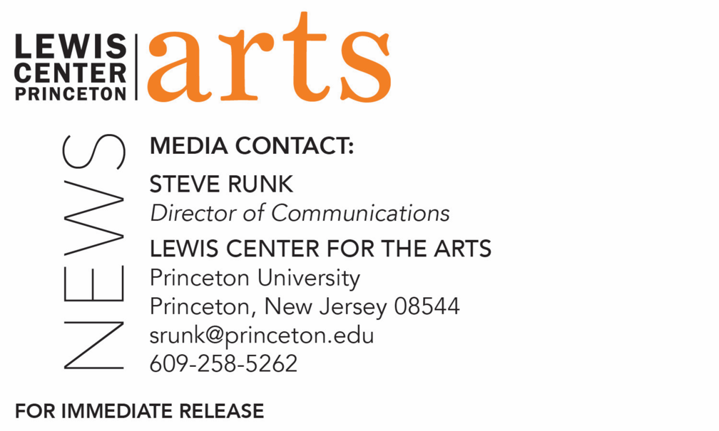

February 3, 2021

Reading in Translation: New Student Work, on February 17
Reading reflects the growing attention to the art of literary translation in Princeton’s
Program in Creative Writing

What/Who: Reading in Translation: New Student Work, a reading by six Princeton students studying literary translation, hosted by faculty member Larissa Kyzer and presented by the Lewis Center for the Arts’ Program in Creative Writing at Princeton University.
When: February 17, 2021 at 5:30 p.m. (EST)
Where: Virtually via Zoom
Admission: Free and open to the public
Accessibility: Viewers in need of access accommodations are invited to contact the Lewis Center at least 2 weeks in advance at LewisCenter@princeton.edu
For more information and Zoom link: https://arts.princeton.edu/events/reading-in-translation-new-student-work/

(Princeton, NJ) The Lewis Center for the Arts’ Program in Creative Writing at Princeton University presents Reading in Translation: New Student Work on February 17 at 5:30 p.m. (EST) via Zoom. This virtual reading by six Princeton students is hosted by faculty member Larissa Kyzer and reflects the growing interest in and attention to literary translation at Princeton. The event is free and open to the public.

The Program in Creative Writing offers courses in introductory and advanced literary translation taught by members of the Program’s faculty Jhumpa Lahiri and Paul Muldoon and recent guest faculty, such as Kyzer, Jenny McPhee, and Idra Novey. Enrollment in these courses has been growing and additional students have studied literary translation through extracurricular activities.

In the fall 2019 semester, Kyzer offered Brú, which means ‘bridge’ in Icelandic, as an informal, non-language specific workshop designed to help students bridge the perceived gap between creative writing and literary translation. Workshop exercises played with language, helped students identify elements of their own personal writing style—with an eye to better utilizing and employing these in their translations—and stressed collaboration and experimentation.

A series of “Translate Alongs” were held during the fall 2020 semester as a way to help student translators build community and get feedback on their works-in-progress. Each hour-long session allowed participants to join via Zoom, mute their mics, and translate “with” one another. Students who encountered challenges in their texts were invited to send a private chat to Kyzer so that they could work through knotty passages or head-scratching phrases together or, when necessary, step into a breakout room to discuss in more detail.

"It's hard to study with Larissa Kyzer and not get excited about translation,” said senior Jillian Quigley, one of the readers on the program. “I decided to attend her workshop last fall semester on a whim, with no real motivation other than pure curiosity. When I was choosing my thesis topic for the French and Italian Department, which is a literary translation, my experiences in the workshop informed my decision. I'm so happy to have found translation. It is something that I otherwise wouldn't have thought so seriously about."
Adds junior Allie Mangel, a comparative literature major who will also read, "I loved taking Literary Translation with Larissa Kyzer this past fall! I learned so much about the nuances of language and how to bring out different tones and colors in translation. Class discussions were extremely rich, as my classmates spoke a variety of languages and provided diverse opinions and interpretations of one another’s texts. Her ‘Translate Alongs’ were especially helpful during this virtual semester! They provided a uniquely supportive online space in which to work individually and seek guidance alongside other students and even other professors."
Other students on the program include juniors Meigan Clark and Jacquelyn Davila, sophomore Luca Morante, and first-year student Valeria Zuluaga-Sanchez.

In addition to teaching in the Program in Creative Writing, Kyzer is a past Princeton Translator-in-Residence and a writer and Icelandic literary translator. Her translation of Kristín Eiríksdóttir’s A Fist or a Heart was awarded the American Scandinavian Foundation’s 2019 translation prize. She is a member of Ós, an Iceland-based international literary collective, as well as the American Literary Translators Association. She is co-chair of PEN America’s Translation Committee and the founder of Jill! a bi-monthly, NYC-based Women+ in Translation reading series.

Patrons in need of access accommodations in order to participate in this event, are asked to contact the Lewis Center at LewisCenter@princeton.edu at least two weeks in advance of the event date.

To learn more about the reading series, the Program in Creative Writing, and the more than 100 public performances, exhibitions, readings, screenings, concerts and lectures presented each year by the Lewis Center for the Arts, most of them free, visit arts.princeton.edu.

###

