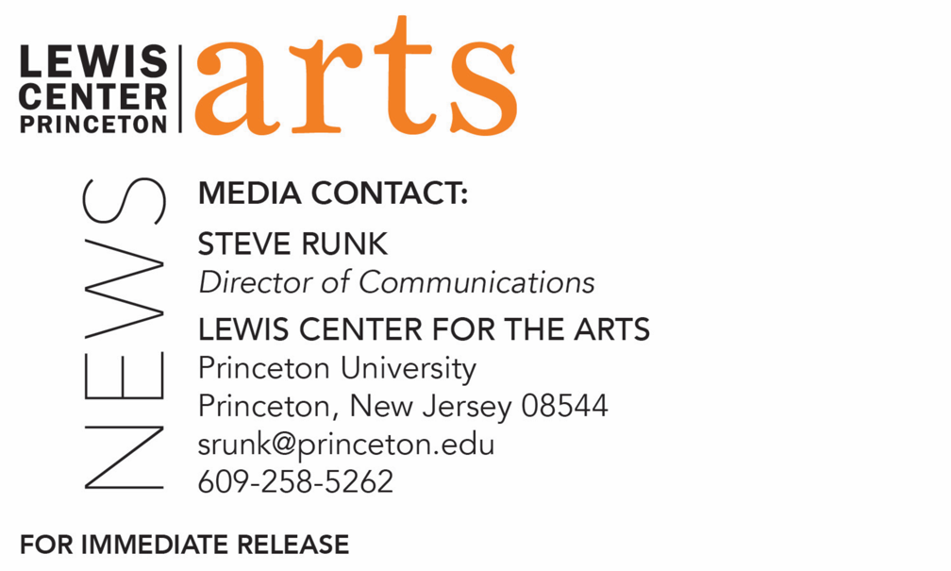

March 17, 2021

C.K. Williams Reading by Nana Kwame Adjei-Brenyah and
Princeton Creative Writing seniors on March 24

Photo caption: New York Times bestselling author Nana Kwame Adjei-Brenyah
Photo credit: Courtesy of Limitless Imprint Entertainment

What/Who: A reading by New York Times bestselling, award-winning writer Nana Kwame Adjei-Brenyah, and Program in Creative Writing seniors Katie DiFrancesco, Alex Kim, Nancy Kim, Leah Linfield and Julia Walton, next in the 2020-21 season of the C.K. Williams Reading Series, presented virtually this year by the Lewis Center for the Arts’ Program in Creative Writing at Princeton University
When: March 24, 2021 at 6:00 p.m. (EDT)
Where: Virtually via Zoom
Admission: Free and open to the public
Accessibility: Viewers in need of access accommodations are invited to contact the Lewis Center at least 2 weeks in advance at LewisCenter@princeton.edu
For more information and Zoom link: https://arts.princeton.edu/events/c-k-williams-reading-by-nana-kwame-adjei-brenyah/

(Princeton, NJ) The Lewis Center for the Arts’ Program in Creative Writing at Princeton University presents a reading by bestselling, award-winning writer Nana Kwame Adjei-Brenyah along with Katie DiFrancesco, Alex Kim, Nancy Kim, Leah Linfield and Julia Walton – five seniors in Princeton’s Program in Creative Writing. The reading is on March 24 at 6:00 p.m. (EDT) and continues the 2020-21 C.K. Williams Reading Series showcasing senior thesis students of the Program alongside established writers as special guests. The series is named after the late Pulitzer Prize and National Book Award-winning poet C.K. Williams, who also served on Princeton’s faculty for 20 years. The reading will be presented via Zoom and is free and open to the public.

Nana Kwame Adjei-Brenyah is a New York Times bestselling author of the story collection Friday Black. Originally from Spring Valley, New York, he graduated from State University of New York at Albany and went on to receive his M.F.A. from Syracuse University. His work has appeared or is forthcoming from numerous publications, including The New York Times Book Review, Esquire, Literary Hub, The Paris Review, Guernica, The Chronicles of Now, and Longreads. He was selected by Colson Whitehead as one of the National Book Foundation’s “5 Under 35” honorees, is the winner of the PEN/Jean Stein Book Award, and a finalist for the National Book Critics Circle’s John Leonard Award for Best First Book and the Aspen Words Literary Prize.

The five seniors, who are pursuing certificates in creative writing in addition to their major areas of study, will read from their senior thesis projects. They are among 24 Princeton seniors who are pursuing certificates in creative writing in addition to their major areas of study. Each is currently working on a novel, a screenplay, translations, or a collection of poems or short stories as part of a creative thesis for the certificate. Thesis students in the Program in Creative Writing work closely with a member of the faculty, which includes award-winning writers Michael Dickman, Aleksandar Hemon, A.M. Homes, Daphne Kalotay, Christina Lazaridi, Jhumpa Lahiri, Yiyun Li, Paul Muldoon, James Richardson, Tracy K. Smith, Kirstin Valdez Quade, Susan Wheeler, Monica Youn, and a number of distinguished lecturers.

The 2020-21 C.K. Williams Series will conclude on April 7 with a reading by poet and writer Franny Choi with five more seniors. All the seniors in the Program will read from their final thesis work on April 28 and 29, and select students in spring writing workshops will read their recent work on April 20.

Patrons in need of access accommodations in order to participate in this event, are asked to contact the Lewis Center at LewisCenter@princeton.edu at least two weeks in advance of the event date.

To learn more about the reading series, the Program in Creative Writing, and the more than 100 public performances, exhibitions, readings, screenings, concerts and lectures presented each year by the Lewis Center for the Arts, most of them free, visit arts.princeton.edu.

###

