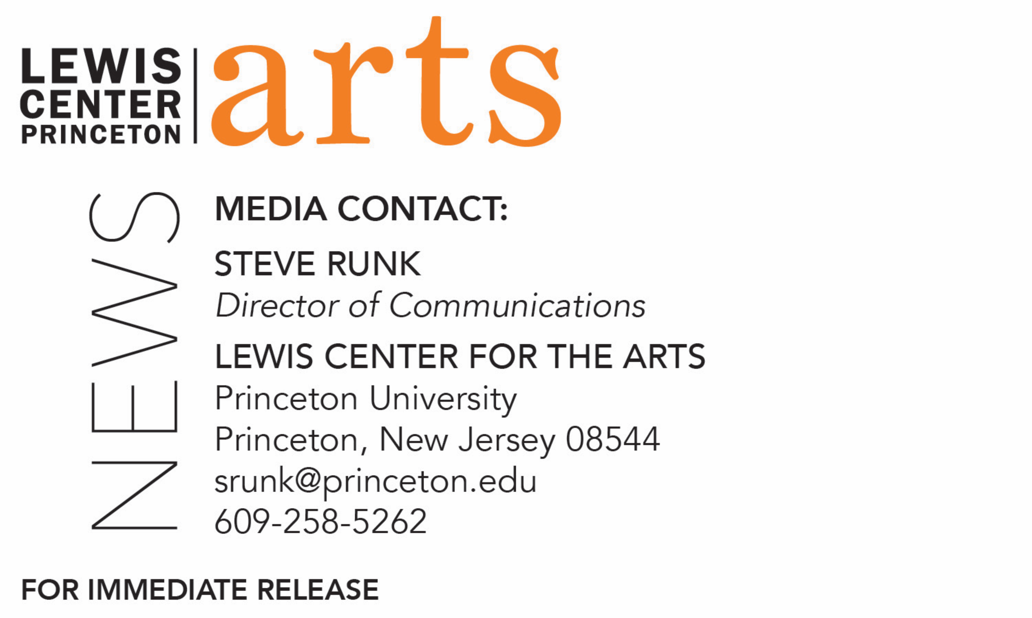

April 19, 2020

Lewis Center for the Arts presents a virtual concert of original songs by students in the spring course, “How to Write a Song,” co-taught by
Paul Muldoon and Bridget Kearney

What/Who: Students perform a virtual concert of original songs with music and lyrics written over the past semester as part of the spring Princeton Atelier course “How to Write a Song,” co-taught by Pulitzer Prize-winning poet Paul Muldoon and Bridget Kearney, founding member of the band Lake Street Dive, with visits by singer/songwriter guest artists and music critics, which this past year included a surprise virtual visit to class by Sir Paul McCartney. Presented by the Lewis Center for the Arts.
When: April 27 at 4:30 p.m. (EDT)
Where: Virtual via Zoom Webinar
Admission: Free and open to the public, advance Zoom registration required
Accessibility: Viewers in need of access accommodations are invited to contact the Lewis Center at least 2 weeks in advance at LewisCenter@princeton.edu
For more information and Zoom registration link: https://arts.princeton.edu/events/how-to-write-a-song-concert-of-new-songs-sp-21/

(Princeton, NJ) Students in Princeton University’s spring course “How to Write a Song,” offered by the Princeton Atelier in the Lewis Center for the Arts, will present original songs at a virtual concert on April 27 at 4:30 p.m. (EDT) via Zoom Webinar. The students will perform selected new work written over the past semester. The concert is free and open to the public and will be live captioned.

Co-taught this semester by Pulitzer Prize-winning poet Paul Muldoon and Bridget Kearney, a founding member of the band Lake Street Dive, this enormously popular course required students to write new songs throughout the semester inspired by a broad range of varying emotions. Each week the students, all with varying levels of literary and musical backgrounds, split into different groupings of two to four participants and wrote lyrics and composed tunes on an assigned emotional topic such as joy, despair, defiance, or desire. At each class, the students performed their pieces for Muldoon, Kearney and their classmates, who then provided critiques. Guest critics and singer-songwriters joined the class to share their experience and to listen to and provide feedback to the student songwriters, including a surprise virtual visit in February by Sir Paul McCartney.

Former Beatle and international music icon McCartney Zoomed with the class for two hours on February 16, listening to and critiquing the work created that week by the class’s teams, offering advice, sharing anecdotes, and leading the discussion.

Other guest visitors to the class this semester included music critic Jon Pareles of The New York Times, music producer Cautious Clay, and singer-songwriter Maggie Rogers.

“This semester was truly unforgettable, said Kearney. “I was astounded week after week by how much beauty and how much truth came blaring through my Zoom audio. Circumstance prevented us from meeting in person, but everyone really rose to the occasion and learned a lot of music production skills in addition to honing their songwriting craft. The silver lining is that at the end of the semester we now have archived recordings of many albums worth of incredible songs! The concert will be an opportunity to share some of our class favorite songs with a wider audience for the first, but certainly not the last, time.”

The Princeton Atelier is directed by Muldoon and was founded in 1994 by Nobel laureate and former faculty member Toni Morrison. It brings professional artists to the University for intensive collaborative work with students through semester-long courses. Participating Atelier artists often select a project they want to explore and experiment within the context of a class with Princeton students before developing it for the professional art world.

Muldoon is the Howard G.B. Clark ’21 University Professor in the Humanities, Professor of Creative Writing, and founding chair of the Lewis Center for the Arts, in addition to directing the Princeton Atelier. He has been described by The Times Literary Supplement as “the most significant English-language poet born since the Second World War.” His fourteenth volume of poems, Howdie-Skelp, will be published later this year by Farrar Straus & Giroux. A selection of songs written for his rock band, Rogue Oliphant, has been published by Eyewear under the title Sadie and the Sadists, itself the title of a double LP available locally at the Princeton Record Exchange and on many streaming platforms.

Muldoon has been working with Paul McCartney over the last five years on McCartney’s two-volume autobiography The Lyrics: 1956 to the Present, due out in November. The book, described as a “self-portrait in 154 songs,” is based on conversations McCartney had with Muldoon, who also penned the introduction, recounting his life and art from all stages of his career.

Kearney is a songwriter, multi-instrumentalist, and producer. A founding member of the band Lake Street Dive, she has performed at Radio City Music Hall, The Hollywood Bowl, Red Rocks Amphitheater, and The White House South Lawn, as well as appeared on The Late Show with David Letterman, The Late Show with Stephen Colbert, The Colbert Report, Ellen, and Conan. Her solo debut, "Won't Let You Down," came out in 2017 on Signature Sounds and in 2020 she released a collaborative album written and recorded in Accra, Ghana, called "Still Flying" on Verve Forecast. Kearney holds a Bachelors in Music from the New England Conservatory in Jazz Studies (bass) and Bachelor of Arts from Tufts University in English.

For more information on this event, the Princeton Atelier, or any of the more than 100 performances, exhibitions, readings, screenings, concerts, and lectures presented each year by the Lewis Center for the Arts, most of them free, visit arts.princeton.edu.

###

