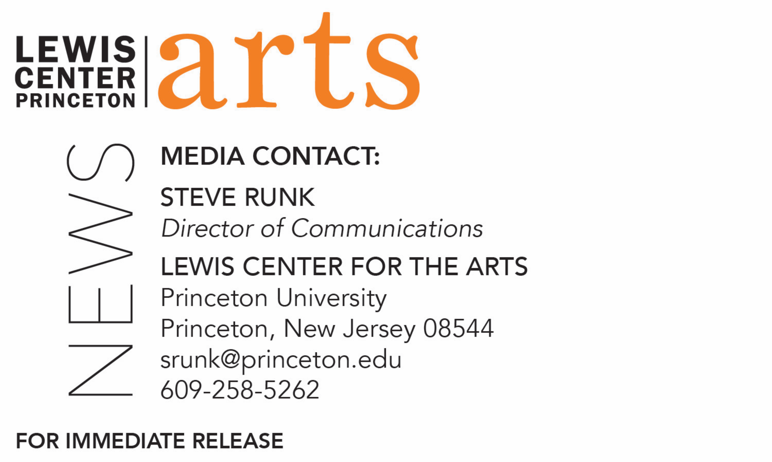

April 23, 2021

Lewis Center for the Arts’ Program in Dance presents
Spring Dance Festival - April
Premiere of three new works choreographed for film by Princeton seniors
Sophie Blue, Liam Lynch and Enver Ramadani

Photo caption 1: Members of the cast of Sophie Blue’s “əˈfem(ə)rəl” perform for the camera in a field near Princeton University
Photo credit 1: Courtesy of Sophie Blue
Photo caption 2: Members of the cast perform in Liam Lynch’s filmed dance work “Empty Your Head” staged in an attic space.
Photo credit 2: Courtesy of Liam Lynch
Photo caption 3: A member of the cast of Enver Ramadani’s new work choreographed for film performs “i.me.”
Photo credit 3: Courtesy of Enver Ramadani

What/Who: Spring Dance Festival – April features the premiere of new works choreographed for film by Princeton dance seniors Sophie Blue, Liam Lynch and Enver Ramadini. Blue’s piece explores the intimacy and strength of the female moving body, as captured by the simultaneous choreography of the camera. Seeking to offer the audience a new lens into the dance, the highly prescribed usage of videography works against “objectifying” or “feminizing” the bodies and moving of the full female-identifying cast. Lynch’s piece is a reflection on his relationship with his grandfather, who has dementia, and the questions of memory, identity and subjectivity that his condition gives rise to. The piece tracks the transformation from a structured reality to a world in which context slips away. In Ramadani’s piece, several dancers in solo vignettes perform experiences of navigating emotion and loss set to a soundtrack drawn from interviews with the cast. The work explores the volatility of being: how the pull into intimate, internal headspace challenges and complicates awareness of the physical, pedestrian self. Hosted by dance faculty member Miguel Gutierrez and presented by the Lewis Center for the Arts’ Program in Dance at Princeton University.
When: April 30 at 8:00 p.m. (EDT)
Where: Virtual online via Zoom Webinar
Admission: Free and open to the public; registration required
Accessibility: This event will be open captioned. Viewers in need of other access accommodations are invited to contact the Lewis Center at least 2 weeks in advance at LewisCenter@princeton.edu
For information and Zoom registration link: https://arts.princeton.edu/events/spring-dance-festival-sp-21/

(Princeton, NJ) The Lewis Center for the Arts’ Program in Dance at Princeton University presents Spring Dance Festival - April, premiering new works choreographed for film by three seniors in the Program: Sophie Blue, Liam Lynch and Enver Ramadini. The presentation via Zoom Webinar will be presented April 30 at 8:00 p.m., is free and open to the public, and will be open captioned.

The presentation represents the three seniors’ independent thesis work in the Program in Dance. Each conceived and choreographed the works specifically for presentation via video in a virtual environment, exploring the translation of movement specifically for the camera.

“əˈfem(ə)rəl” by Blue explores the intimacy and strength of the female moving body, as captured by the simultaneous choreography of the camera. Seeking to offer the audience a new lens into the dance, the highly prescribed usage of videography works against “objectifying” or “feminizing” the bodies and moving of the full female-identifying cast. Developed during the COVID-19 pandemic, this piece served as a centralizing site of movement production amidst social isolation, embodying the here and now of our times. Blue’s cast includes Princeton students Naomi Benenson ’23, Leah Emanuel ’23, Sam Grayson ’21, Margaret King ’22, Natalia Lalin ’24 and Emma Wang ’23.

Blue is an anthropology major pursuing certificates in cognitive science and gender studies, as well as dance. While at Princeton, she has worked to develop herself as an artist and a leader within the arts community on campus. She has been deeply involved in the Program in Dance, diSiac Dance Company, and Princeton University Ballet, two of Princeton’s student dance groups. In 2019 she founded Trenton Youth Dancers as a fellow of the Trenton Arts Program, working to expand the accessibility of dance to children in Trenton. Her dedication to arts outreach and enrichment at Princeton and beyond has fueled her passion for serving in leadership positions such as president of diSiac Dance Company and president of Princeton’s Performing Arts Council. Over the summers she has interned in the Dance Division of the 92nd Street Y in New York City and for artists Sidra Bell and Rashaun Mitchell + Silas Riener.

Filmed in an off-campus attic space, Lynch’s piece, “Empty Your Head,” is a reflection on his relationship with his grandfather, who has dementia, and the questions of memory, identity and subjectivity that his condition gives rise to. The piece tracks the transformation from a structured reality to a world in which context slips away. Students Nina He ’21 and Zi Liu ’24 join Lynch in the cast.

Lynch is a senior in the Department of Philosophy, pursuing certificates in the Program in Dance and in German language. Though most of his movement practice is based in the techniques of hip hop and other street forms, he has also been inspired by the wide range of contemporary styles he has studied in Princeton’s dance program. In his work, he attempts to weave together his disparate influences into a unique, individual mode of physical expression. He credits the importance of the campus dance community in his development, which he notes has supported him and fueled his growth over the years.

In Ramadani’s piece, “i.me,” several dancers in solo vignettes perform experiences of navigating emotion and loss set to a soundtrack drawn from interviews with the cast. The work explores the volatility of being: how the pull into intimate, internal headspace challenges and complicates awareness of the physical, pedestrian self. Ramadani’s cast includes students Yolore Airewele ’21, Molly Gibbons ’22, Sam Grayson ’21, Ive Jones ’24, Samantha Liu ’22, Zi Liu ’24 and Julie Shin ’22.

Ramadani is a senior in the School of Public and International Affairs studying counterterrorism policy and strategy, as well as pursuing a certificate in dance. During his time at Princeton, he has been in several dance productions, including the thesis works of other seniors and other Program in Dance performances. He is also involved in the student dance group community on campus and is the current artistic director of BodyHype Dance Company.

“These three choreographers have demonstrated astounding resilience and resourcefulness this past year. In order to realize their projects, the students not only shifted their dance conceptions from stage to camera, but also navigated and adapted to ever-changing pandemic health restrictions,” said Susan Marshall, Director of the Program in Dance. “I’m deeply impressed by these seniors' ingenuity and ability to make penetrating choreographic work, even within the most unexpected limitations.”

The evening will be hosted by Miguel Gutierrez, Princeton’s current Hearst Choreographer-in-Residence and this academic year a member of the Program in Dance faculty. Gutierrez is a choreographer, composer, performer, singer, writer, educator, and advocate. His work has been presented in more than 60 cities around the world, in venues such as the Centre national de la danse, Centre Pompidou, Festival Universitario, ImPulsTanz, Fringe Arts, Walker Art Center, TBA/PICA, MCA Chicago, Live Arts Bard, American Realness, and the 2014 Whitney Biennial. Gutierrez is the recipient of numerous grants and fellowships, including support from MAP Fund, New England Foundation for the Arts’ National Dance Project, NPN, John Simon Guggenheim Memorial Foundation, and United States Artists. In 2016 Gutierrez received a Franky Award from the PRELUDE festival and has received four New York Dance and Performance “Bessie” Awards. He is a 2016 Doris Duke Artist.

Members of the professional production team for Spring Dance Festival – April include Mary Jo Mecca as costume consultant, Vince di Mura as music director, Daniel Madoff as film production manager, Tina Fehlandt as faculty production advisor, and Mary-Susan Gregson as event stage manager.

The event will be open captioned. Viewers in need of other access accommodations are invited to contact the Lewis Center at least two weeks in advance at LewisCenter@princeton.edu.

Spring Dance Festival – May will be presented May 13 and 14 at 8:00 p.m. via Zoom Webinar. In this virtual concert 13 Princeton dance seniors will perform a series of new solos, duets and ensemble works choreographed for them by professional guest choreographers Adam Barruch, Rena Butler, Christine He, Loni Landon, Martha Nichols, Christopher Ralph and Jermaine Spivey, and by Elisa Clark, based on the movement language of Robert Battle.

For Zoom registration link and to learn more about this event, the Program in Dance, and the more than 100 performances, exhibitions, readings, screenings, concerts and lectures presented each year by the Lewis Center for the Arts visit: arts.princeton.edu.

###

