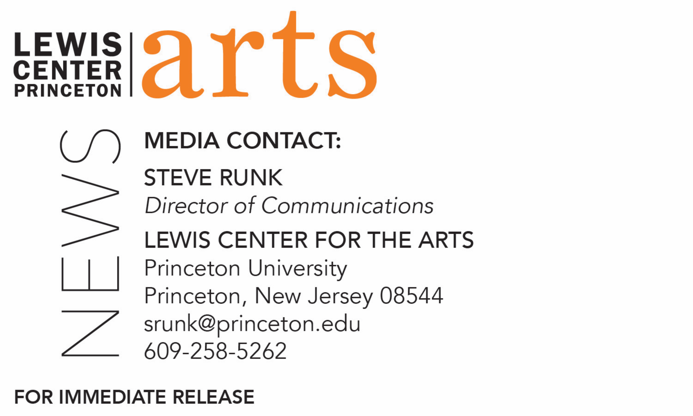

April 30, 2021

Lewis Center for the Arts’ Program in Dance presents
Spring Dance Festival - May
Thirteen Princeton dance seniors perform new solo and duet works by professional choreographers Adam Barruch, Rena Butler, Christine He, Loni Landon, Martha Nichols, Christopher Ralph, and Jermaine Spivey and an ensemble piece by Elisa Clark based on the movement language of Robert Battle

Photo caption: Princeton dance seniors perform a new dance work for film choreographed by Elisa Clark based on the movement language of Robert Battle, recorded outside on the Princeton campus
Photo credit: Daniel Madoff

What/Who: Spring Dance Festival – May features performances by 13 Princeton seniors of new solo and duet works choreographed for and with them by professional choreographers Adam Barruch, Rena Butler, Christine He, Loni Landon, Martha Nichols, Christopher Ralph, and Jermaine Spivey and an ensemble piece by Elisa Clark based on the movement language of Robert Battle. Each evening will feature different solo and duet works with the ensemble piece presented on both nights. Presented by the Lewis Center for the Arts’ Program in Dance at Princeton University.
When: May 13 & 14 at 8:00 p.m. (EDT)
Where: Virtual online via Zoom Webinar
Admission: Free and open to the public; registration required
Accessibility: This event will be open captioned. Viewers in need of other access accommodations are invited to contact the Lewis Center at least 2 weeks in advance at LewisCenter@princeton.edu
For information and Zoom registration link: https://arts.princeton.edu/events/spring-dance-festival-sp-21-may/2021-05-13/

(Princeton, NJ) The Lewis Center for the Arts’ Program in Dance at Princeton University presents Spring Dance Festival - May featuring 13 Princeton seniors performing new solo and duet works choreographed for and with them by professional choreographers Adam Barruch, Rena Butler, Christine He, Loni Landon, Martha Nichols, Christopher Ralph, and Jermaine Spivey, and an ensemble piece by Elisa Clark based on the movement language of Robert Battle. Presented on May 13 and 14 at 8:00 p.m. (EDT), each evening will feature different solo and duet works with the ensemble piece presented on both nights. The presentation via Zoom Webinar is free and open to the public, and will be open captioned. Registration is required.

The presentation represents the seniors’ independent thesis work in the Program in Dance. Each was matched with a guest choreographer to create a new work specifically for presentation via video in a virtual environment, exploring the translation of movement specifically for the camera.

Senior Jane Brown, majoring in chemical and biological engineering, will dance a solo choreographed by Adam Barruch titled “Element,” which features a movement vocabulary based on the dynamic processes of nature that manifest and balance all that exists. The new work, with an original score by Roarke Menzies, explores the connection between the elements of the natural world and the inner alchemy of the human body. It proposes that by connecting our intention and movement with nature, transformation of the self and the outer world can occur.

Runako Campbell, an African American studies major who is finishing her senior year from Cleveland as a member of the professional dance company GroundWorks DanceTheater, performs “Here, There” choreographed by Rena Butler. This new solo work explores the constant momentum of shifting landscapes and how it molds the sense of the ever-evolving self, asking: What propels us to shift scenarios in order to locate ourselves in process, thus giving us agency to imagine and explore?

Natalie Lu, an architecture major based this year in Hong Kong, performs a new solo work by Christine He. Titled “rise,” the creative team invites audiences into the piece: “come with me on a journey, from the bottom of my dreams, through the heritage of my city, into the limitlessness of my mind.”

In “Thea,” psychology major Thea Zalabak performs a solo created for her by Loni Landon. Zalabak notes, “The state of isolation and mindless repetition for the past year has driven so many of us insane, and I feel like this piece has become a way of communicating some of that experience. Working with Loni to embody these feelings of boredom, exhaustion, anxiety, fear, and mania in a dance film has given me an opportunity to be more honest with myself and the way I interact with the world around me. Finding creativity in chaos has shifted the way I view dance performance and find deeper intent in my movement.”

The duet on the program, “Here, Now, This Way,” is choreographed by Martha Nichols and performed by Yolore Airewele, a psychology major, and Sydney Maple, an African American studies major. This duet is a combination of set choreographic material and movement generated from various tasks and improvisational practices. The piece explores aspects of identity, intimacy, and personal narrative, centering the many multi-dimensional displays of one’s Blackness in stillness, in movement, and in everyday life.

Auset Taylor, who is majoring in ecology and evolutionary biology, performs “Lock in Let go,” a new solo work by Christopher Ralph that explores enclosure. The team notes that we have all felt trapped at one point whether that be emotionally or physically, and this piece focuses on feelings that arise when entrapped or enclosed. The work asks the viewer to look at and deal with the boundaries of one’s self-built cage, and how to break or embrace them.

At the heart of “As it Happens,” a solo work by Jermaine Spivey performed by Sam Grayson, a psychology major, is shaping a path to reconnect and to move forward, involving reminiscence and bearing. It is also about taking a moment to celebrate the vibe between the soul of a dancer moved by music and a performative space.

Thirteen seniors - Yolore Airewele, Ysabel Ayala (anthropology major), Sophie Blue (anthropology), Jane Brown, Runako Campbell, Sam Grayson, Sydney Maple, Natalie Lu, Enver Ramadani (School of Public and International Affairs major), Auset Taylor, Leila Ullmann (African American studies), Phoebe Warren (art and archaeology major), and Thea Zalaback – will perform “in time,” an original dance film conceived and directed by Elisa Clark that uses movement vocabulary from a dozen of Robert Battle’s choreographic works. Staying present to internal and external tensions, both while in isolation and within a community, we are reminded that we are never really alone, and encouraged by the need to come together. Clark was a founding member of Robert Battle’s Battleworks Dance Company, where she also served as Company Manager.

“These outstanding dance certificate students of the Class of 2021 have demonstrated astounding resilience and resourcefulness this past year,” said Susan Marshall, Director of the Program in Dance. "Whether here on the Princeton campus under ever-changing pandemic health restrictions or in other parts of the world facing their own local challenges, they’ve found the wherewithal to dance with curiosity and conviction. These seniors and the star-studded group of guest choreographers who collaborated with them have created dance works of lasting significance. This dance festival performance will provide us and our audiences an uplifting and triumphant conclusion to this extremely difficult year."

Members of the professional production team for Spring Dance Festival – May include Mary Jo Mecca as costume designer, Aaron Copp as lighting designer, Vince di Mura as music director, Daniel Madoff as film production manager, Tina Fehlandt as faculty production advisor, and Mary-Susan Gregson as event stage manager.

The event will be open captioned. Viewers in need of other access accommodations are invited to contact the Lewis Center at least two weeks in advance at LewisCenter@princeton.edu.

For Zoom registration link and to learn more about this event, the Program in Dance, and the more than 100 performances, exhibitions, readings, screenings, concerts and lectures presented each year by the Lewis Center for the Arts visit: arts.princeton.edu.

###

