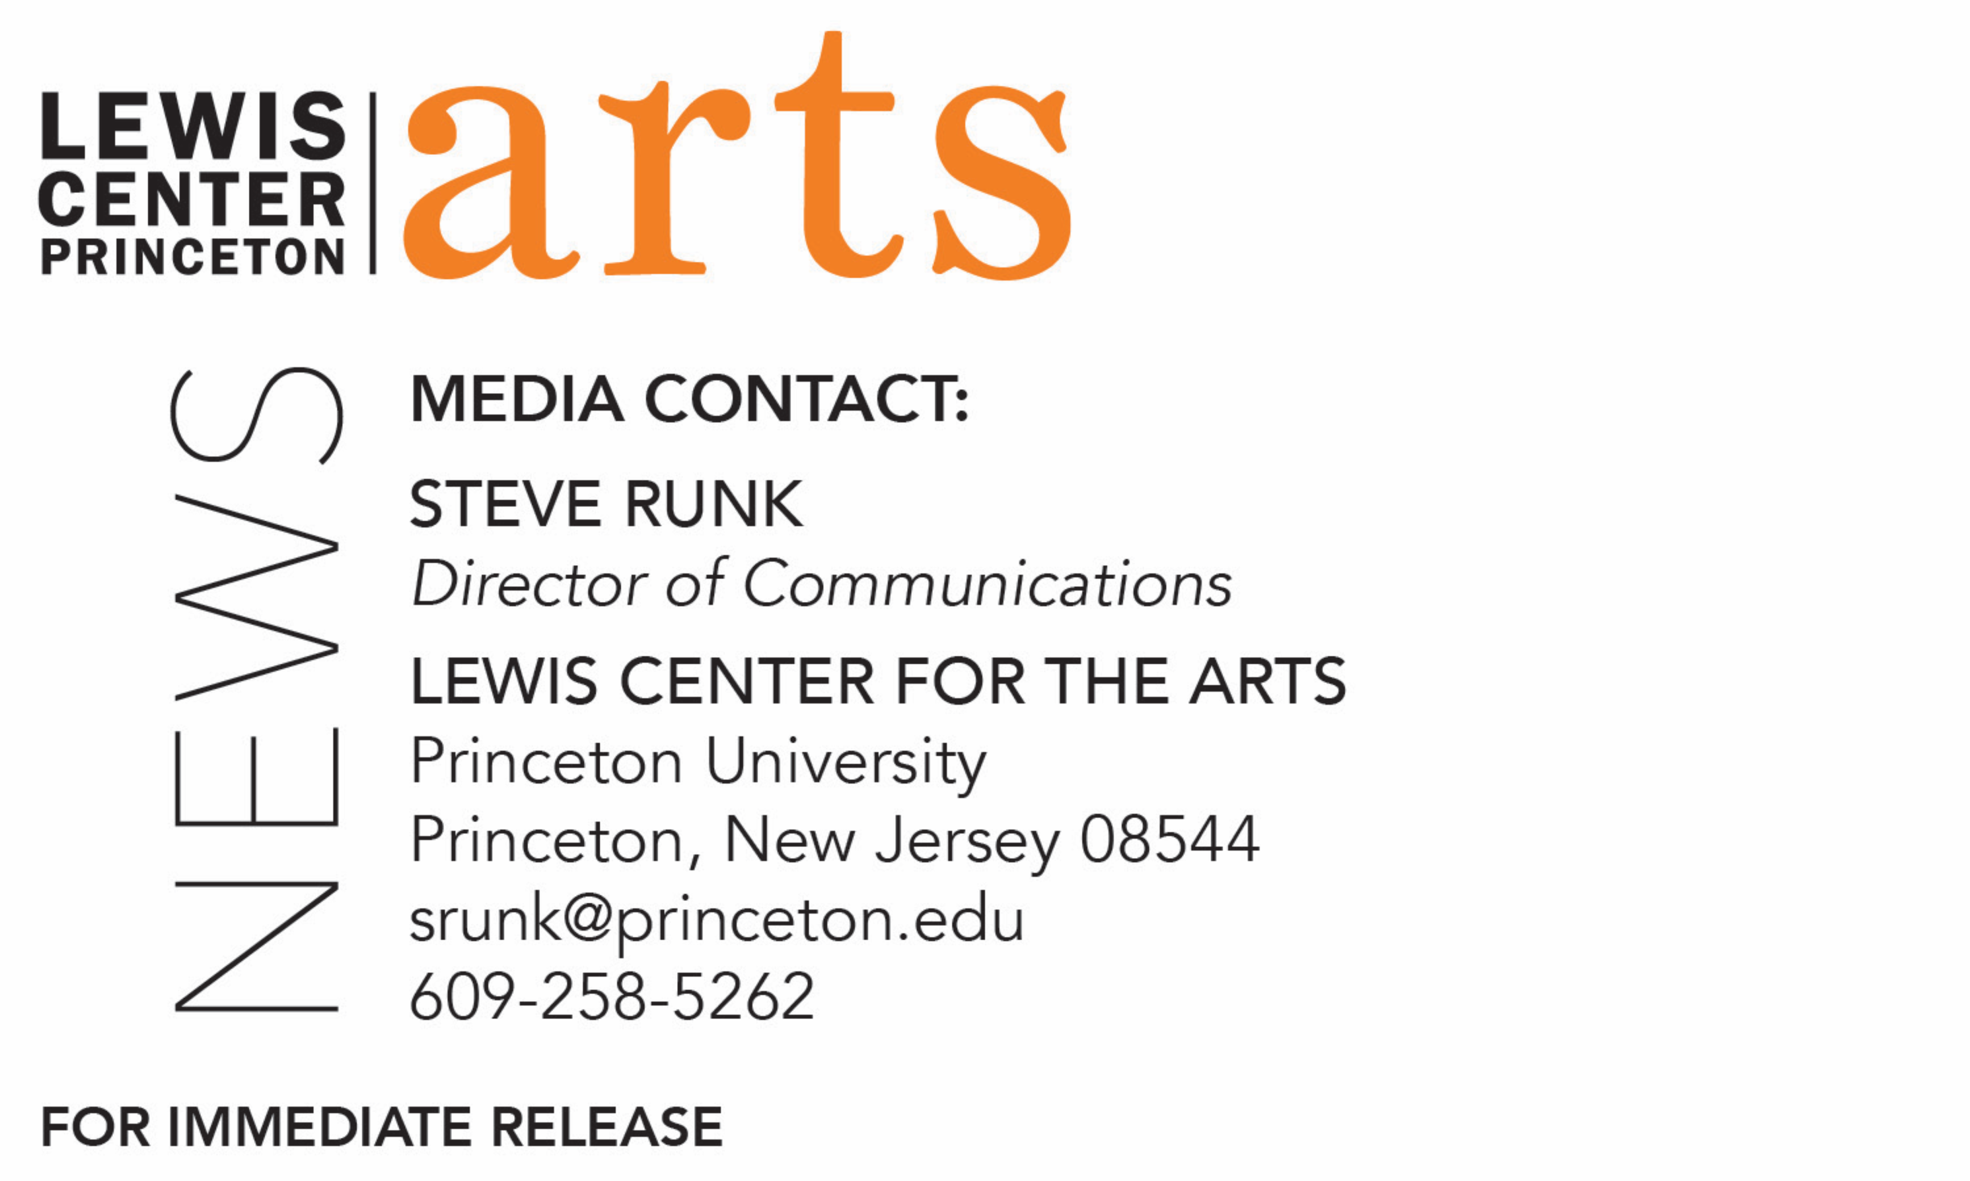

May 20, 2021

Lewis Center for the Arts awards over $129,000
for summer projects in the arts to 56 Princeton students

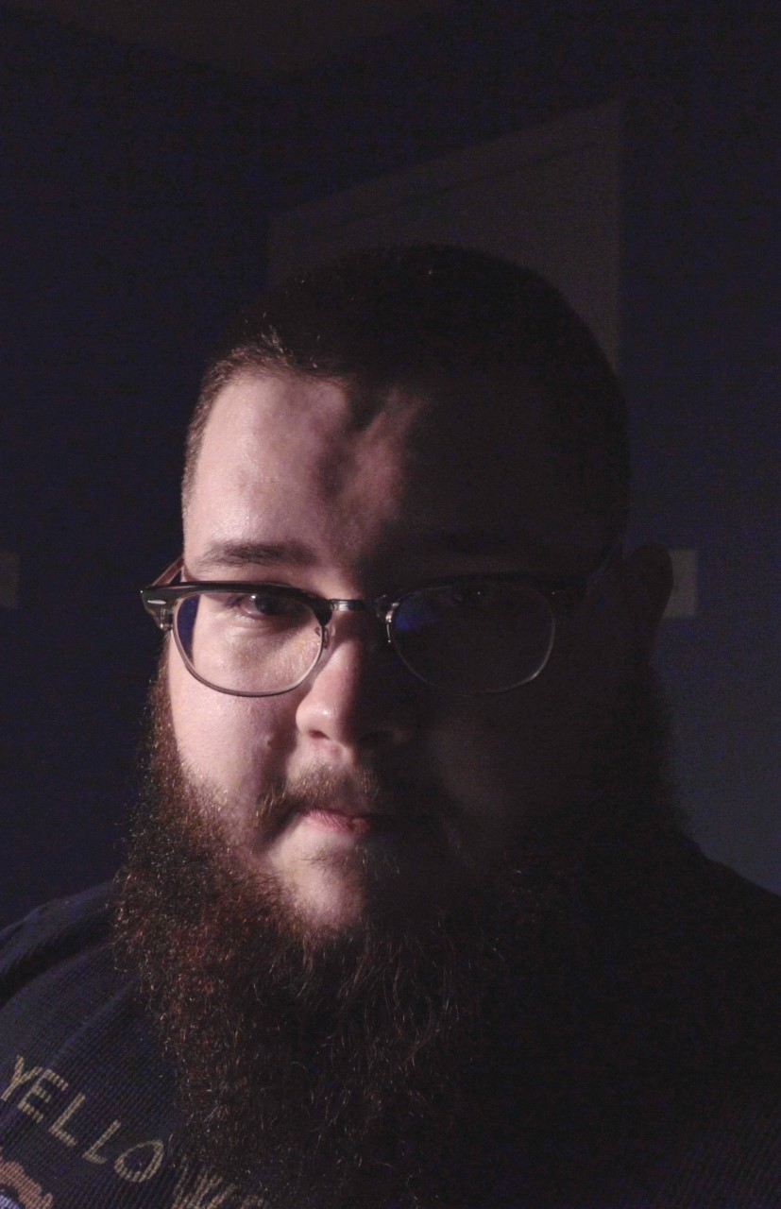
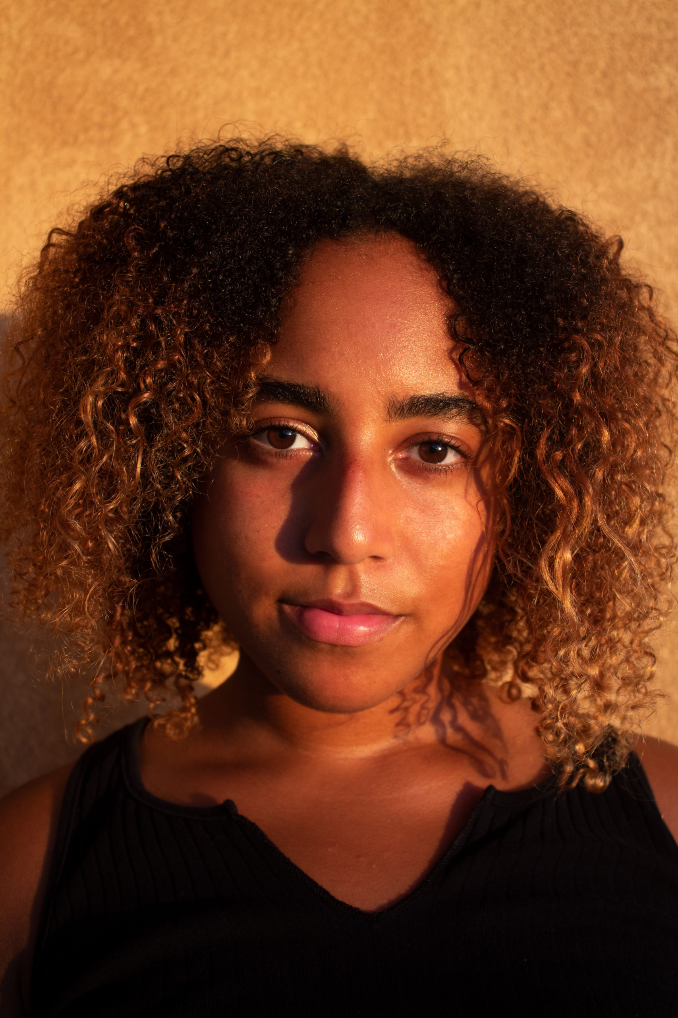

Photo caption: Princeton students (left to right) Silma Berrada, Dylan Fox, and Amanda Kural (photo not provided) are recipients of funding through the Lewis Center for the Arts’ Alex Adam ’07 Award for 2021.
Photo credits: Courtesy of the students
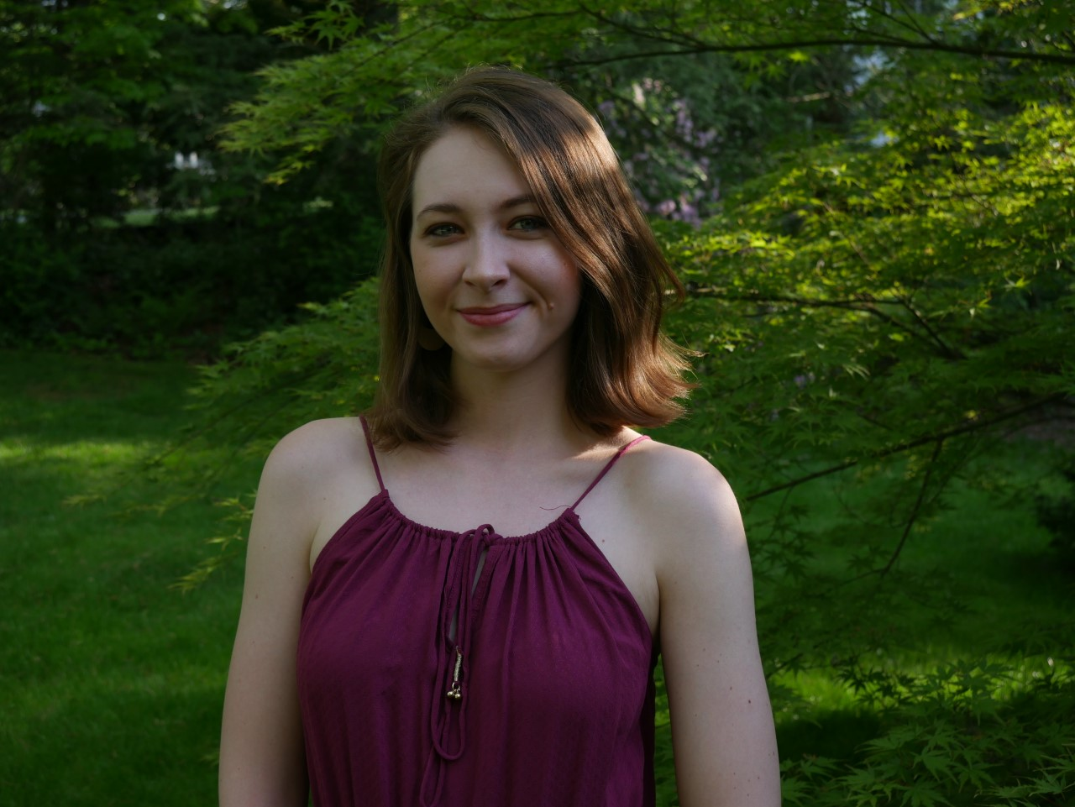
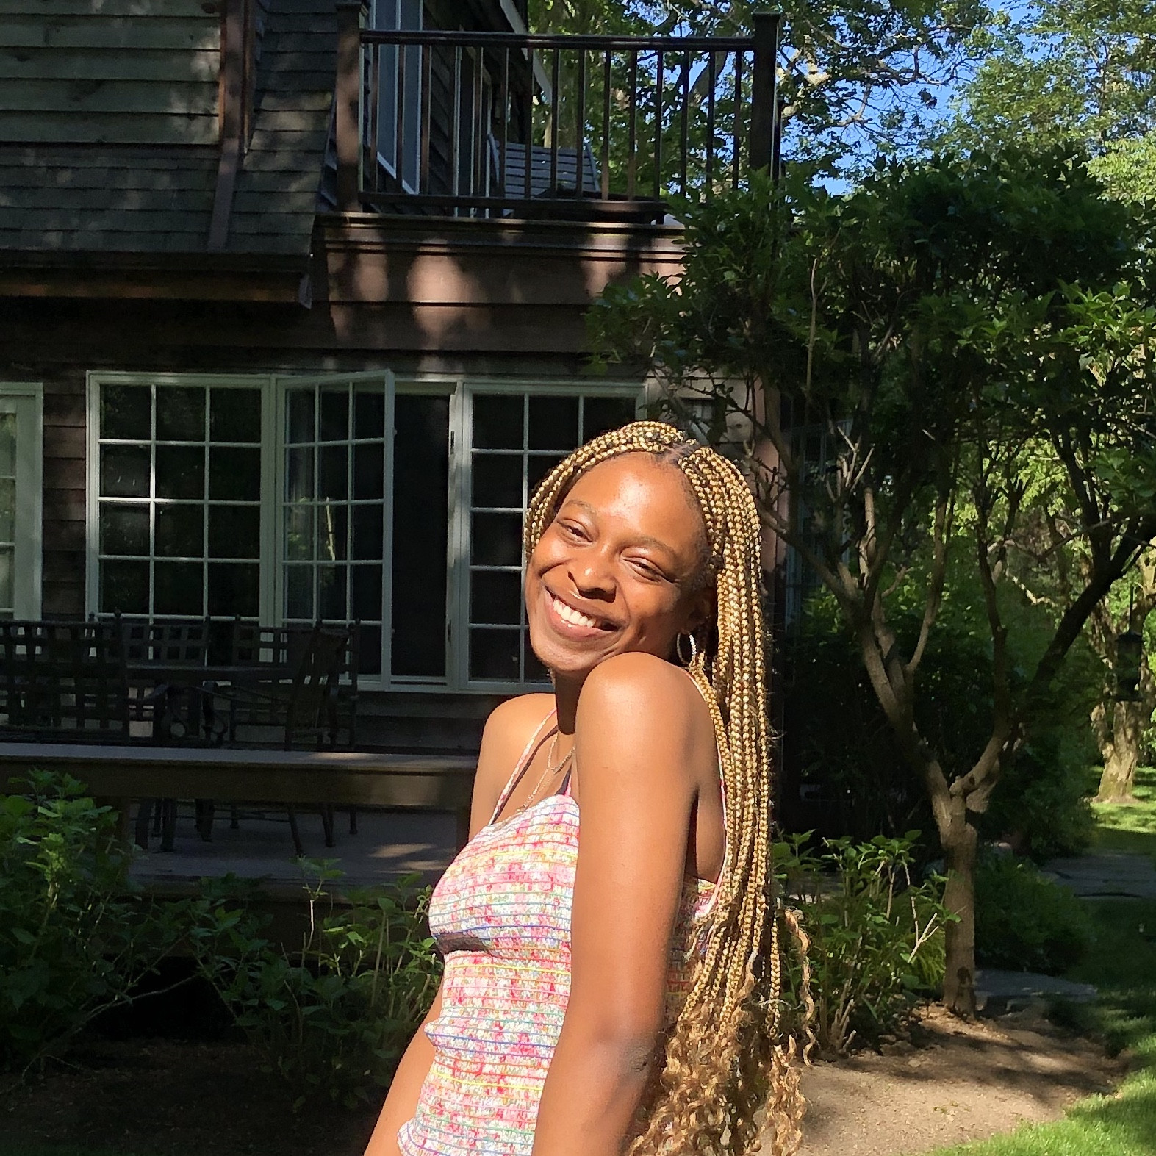

Photo caption: Princeton students (left to right) Tobi Ajayi and Jacqueline Pothier are recipients of funding through the Lewis Center’s Mallach Senior Thesis Fund.
Photo credits: Courtesy of the students

(Princeton, NJ) The Lewis Center for the Arts at Princeton University announces more than $129,000 in awards to support the summer projects and research of 56 Princeton undergraduates. Although all first, second, and third-year student-artists are eligible to apply, for many of the award recipients the funding provides vital resources to conduct research, undertake training, and pursue other opportunities critical to achieving their senior thesis project goals in the arts. The grants range from $160 to $7,500.

Each year, many student proposals typically include traveling domestically or internationally and learning in-person with professional artists or through intensive group workshops. Beginning last spring at the onset of the COVID-19 pandemic and continuing this year, students have had to revise their plans in response to various restrictions. Many student proposals incorporate several alternate plans for meeting their objectives, including a variety of options depending upon public health policies and guidelines this summer.

Three students — Silma Berrada, Dylan Fox, and Amanda Kural — have been selected for the Alex Adam ’07 Award. Established in memory of Alexander Jay Adam ’07 and made possible by a generous gift from his family, the award provides $7,500 in support to each of three Princeton undergraduates who will spend a summer pursuing a project that will result in the creation of new artistic work. While a student at Princeton, Alex Adam pursued artistic interests in creative writing and theater. Joyce Carol Oates, his creative writing professor, praised his work as “sharp-edged, unexpectedly corrosive and very funny.” He was also an actor and performed with the Princeton Shakespeare Company, Theatre Intime, and the Program in Theater.

"The Alex Adam ’07 Award was created to honor the memory of a talented young writer and theater maker,” said Tracy K. Smith, Chair of the Lewis Center. “Through the generosity of the Adam family, current students are afforded the opportunity to spend a summer in pursuit of artistic dream projects. Over the years, this award has deepened the creative practice of a great many developing artists."

Rising senior Silma Berrada is an English major earning certificates in the Programs in Creative Writing, Theater and Visual Arts in the Lewis Center, along with a certificate in the Department of African American Studies. The Alex Adam Award funding will enable her to conduct archival research and digital and in-person fieldwork within Black communities to gather information on laws, policies, customs, and personal narratives from the past 400 years. Berrada's project goal is to “(re)essay a love story about Black beings, pointing the spotlight on enduring love among Black folk in the face of daunting odds.” Her final work may employ poetry, prose, playwriting, visual arts and/or music to examine the complex lineage of white supremacy's systemic opposition of Black companionship. "I want the work to hold onto our hearts' strength and celebrate everything it is to love and be loved as a Black being in America,” Berrada states in her proposal.

Dylan Fox, a rising senior majoring in the Practice of Art Track through the Department of Art and Archaeology, has taken several filmmaking and screenwriting courses in the Lewis Center. Using the funds from his Alex Adam Award, Fox will work on completing two current works-in-progress: a draft screenplay for a full-length feature film and an hour-long experimental film. Set in rural Appalachia in 2017 near the height of the opioid crisis, Fox's screenplay is a fictionalized account delving into issues of drug trafficking and those profiting from the epidemic. He will continue research on the opioid crisis in his hometown in Jefferson County, Tennessee, a place hard hit by the opioid epidemic. To wrap up his experimental film that focuses on the history of his town and family, Fox plans to research land ownership, birth certificates, and other records in local archives and conduct interviews with local historians and members of his family. With threads of family interwoven through both projects, Fox shares that "the history of my family has always been a source of mystery.” Both projects will represent his culminating senior thesis work at Princeton as a filmmaker and screenwriter.

Amanda Kural, a rising junior pursuing a certificate in the Program in Creative Writing, notes a fascination with American folk art and the people who create it. Born and raised almost entirely in the Midwest, she plans to spend her summer exploring the different geographies, languages, and cultures in every corner of America — through virtual research or actual travel — to better enable her to write modern folk tales. In her proposal, Kural defines a folk tale as a story that has a purpose, is meant for everyone, is passed down through generations, and is beautifully imperfect. Her goal is to craft 48 folk tales, one for each contiguous state of America, that will make up a book loosely titled Tales for the Possible Tail-End of America. Kural says that having the ability to explore and write this summer through the gift of the Alex Adam Award “will give me space to grow: not only in my art, but also in my scholarship.”

Rising seniors Tobi Ajayi and Jacqueline Pothier have been selected for funding through the Mallach Senior Thesis Fund. This award, established by Douglas J. Mallach ’91, supports the realization of one or two proposed senior thesis projects that incorporate historical research and create an alternative path to learning history.

Tobi Ajayi, a rising senior in the Department of Architecture and pursuing a certificate in the Program in Visual Arts, will use her funding award to create "Mapping from the Margins," a body of work that will serve as research for her senior thesis. Her project aims to illuminate the ways that Black women survive, thrive, and make space for themselves amidst systems that seek to diminish these acts. To produce her body of work, she will collect narratives from a network of seven Black women, refine her printmaking skills and artistic practice by working with New York City-based printmakers Stephanie Santana and Lane Sell, and produce a series of prints and written texts. The project, circular in nature, will allow Ajayi "to make a space for their stories as well as for myself as an artist.”

Rising senior Jacqueline Pothier, a politics major pursuing certificates in creative writing and vocal performance, possesses a deep love for stories, Irish history and folklore. For her senior thesis project in screenwriting, she plans to write the television pilot for a limited series focused on three generations of women in Ireland and the literal and figurative ghosts they face. Inspired by historian and author Dorothy Macardle, Pothier will research the role of women during the Irish revolutionary movement, modern politics in Ireland, Irish folklore, and gothic stories in order to better craft her own new drama centered on motherhood, revolution, and ghosts. A portion of her project is also supported through the E. Ennalls Berl 1912 and Charles Waggaman Berl 1917 Senior Thesis Award in Visual Arts.

Rising seniors Cameron Lee and Megan Pai have been awarded grants from the Mary Quaintance ’84 Fund for the Creative Arts established in her memory to foster talents similar to those Quaintance developed in writing, film studies, and literature in the creative arts programs at Princeton. A portion of Lee’s project is also supported by the Lucas Summer Fellowship.

Rising senior Miles Wilson has received a grant from the E. Ennalls Berl 1912 and Charles Waggaman Berl 1917 Senior Thesis Award in Visual Arts, which was established in 1999 by Marie Broadhead to provide support for research, travel or other expenses of current juniors undertaking senior thesis work in the Program in Visual Arts.

Leila Abou-Jaoude, Anna Allport, Jared Harbour, Maya Keren, Ethan Luk and Noel Peng received funding through the Sam Hutton Fund for the Arts instituted by Thomas C. Hutton ’72 to support undergraduate summer study, travel and thesis research in the Lewis Center.

Rising seniors Nicolas Gregory and Michael Osei-Wusu are recipients of the Lucas Summer Fellowship, which is presented annually to one or more visual arts concentrators for summer thesis work in any media.

Camryn Stafford has received support from the Mellor Fund for Undergraduate Research, which underwrites course, travel, and/or research costs related to studies in the creative and performing arts.

Rising seniors Ameena Faruki, Isabella Hilditch and Olivia Kusio are beneficiaries of the Lawrence P. Wolfen ’87 Senior Thesis Award established for travel or research costs, materials, equipment or other expenses of current juniors for thesis work in the creative arts, especially the visual arts or graphic arts.

The Hartman Feldman Fund for the Arts supports undergraduate study or research in the Department of Music or the Lewis Center’s Program in Dance. Rising junior Halle Mitchell is the recipient of this award.

Twenty-six students have received support through the Peter B. Lewis Summer Fund, with grants ranging from $160 to $2,000.

In addition to funding, the Lewis Center has also established paid internships and research assistant positions for Princeton students for this summer to assist faculty and guest artists with a number of projects and initiatives.

To learn more about the Lewis Center for the Arts, the funding available to Princeton students, and the more than 100 other performances, exhibitions, readings, screenings, concerts, and lectures presented by the Lewis Center, most of them free, visit arts.princeton.edu.

###

