May 20, 2020

Deana Lawson Named the Inaugural Dorothy Krauklis ’78 Professor of Visual Arts at Princeton University
Renowned photographer is first to be named to this endowed professorship in the Lewis Center for the Arts’ Program in Visual Arts

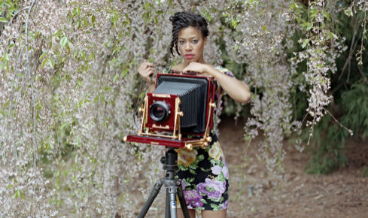

Photo caption: Deana Lawson, recently named the inaugural Dorothy Krauklis ’78 Professor of Visual Arts at Princeton University
Photo credit: Courtesy of Deana Lawson

(Princeton, NJ) Award-winning photographer Deana Lawson has recently been named the inaugural Dorothy Krauklis ’78 Professor of Visual Arts in Princeton University’s Lewis Center for the Arts. A member of Princeton’s Program in Visual Arts faculty since 2012, Lawson’s appointment begins July 1.

“Deana Lawson, one of the preeminent artists of our time, has fashioned a visual vocabulary for Black lives and Black selfhood that is indispensable in a climate where daily threats and convoluted debate have hamstrung our national dialog about race and redress,” said Lewis Center Chair Tracy K. Smith. “Poignant, painterly, provocative, her images hurt a little bit, even when the inner wish they capture is rapturous. It's fitting that she be honored with an endowed professorship.”

Lawson was the recipient of the 2020 Hugo Boss Prize awarded by the Solomon R. Guggenheim Foundation by a jury of international critics and curators, the first photographer to win this prestigious biennial award. She received an honorarium of $100,000 and a solo exhibition at the Guggenheim Museum, which opened May 7 and runs through October 11. Lawson was also the subject by a recent New York Times Magazine cover story that dives deeply into Lawson’s life, artistic process, her aesthetic, the cultural importance of her work, and her latest projects. Staff writer Jenna Wortham noted, “Deana Lawson’s regal, loving, unburdened photographs imagine a world in which Black people are free from the distortions of history.”

“I’m thrilled that Deana has been appointed the inaugural Dorothy Krauklis ’78 Professor of Visual Arts,” said Martha Friedman, Director of the Program in Visual Arts. “Deana has been a singularly consequential professor for scores of students at Princeton and is a daring and remarkable artist. Her photographs offer an object lesson in intimacy, majesty and defiance, holding one rapt from the moment they are glimpsed. Deana crystallizes everything that is best about the arts at Princeton.”

Lawson’s work was included in the 2017 Whitney Biennial, New Photography 2011 at the Museum of Modern Art, New York, and she had a solo exhibition at The Art Institute of Chicago in 2015. Her first museum survey will open later this year at the ICA Boston. She has participated in group exhibitions at The Studio Museum, Harlem; MoMA P.S.1 Contemporary Art Center; Artists Space, New York; and the Spelman College Museum of Fine Art, Atlanta. Gallery shows include Rhona Hoffman Gallery, Chicago; Yancey Richardson Gallery, New York; Helene Bailly Gallery, Paris; and Light Work Gallery, Syracuse, New York. Her work has been published in The New Yorker, TIME Magazine, BOMB, The Collector’s Guide to New Art Photography, Photo District News, Time Out New York, Contact Sheet #154, and PQ Journal for Contemporary Photography. In addition to the Hugo Boss Prize, Lawson is the recipient of a Guggenheim Fellowship, the John Gutmann Photography Fellowship, a Rema Hort Mann Foundation Grant, an Aaron Siskind Fellowship Grant, and a New York Foundation for the Arts Grant. She has participated in the Workspace residency at the Lower Manhattan Cultural Council, the Light Work residency in Syracuse, and the Visual Studies Workshop residency in Rochester, New York.

At Princeton she has taught introductory and advanced level courses in both digital and analog photography.

“I am most honored to be appointed the Dorothy Krauklis ’78 Professorship of Visual Arts in Princeton University’s Lewis Center for the Arts,” said Lawson. “I look forward to serving our students, and supporting creative possibilities around photography and visual art.”

The endowed professorship is named for Dorothy Krauklis Hintze, a Princeton Class of 1978 alumna.”

To learn more about the Lewis Center for the Arts and the Program in Visual Arts visit arts.princeton.edu.

###

