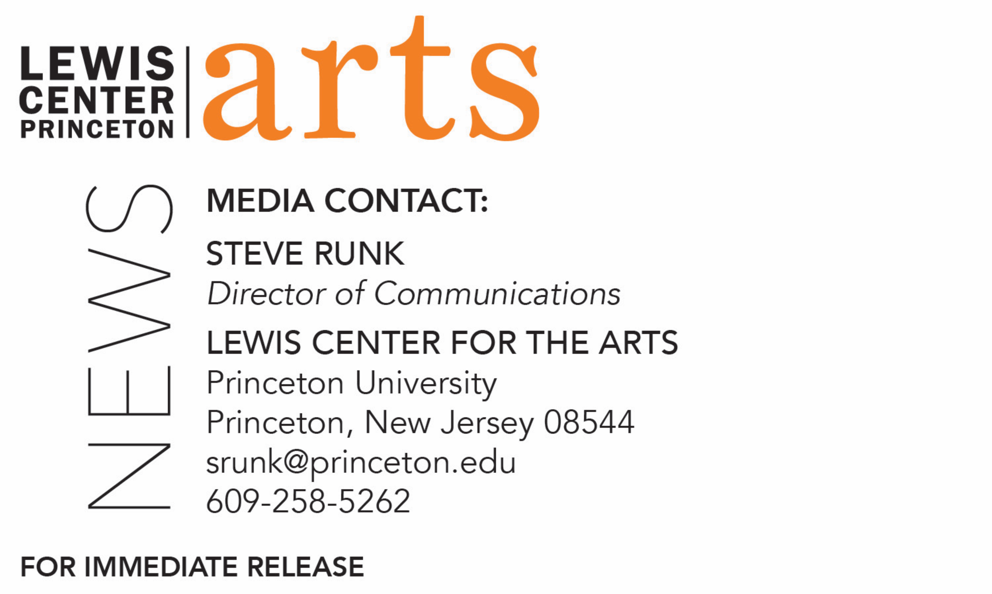

August 11, 2021

Lewis Center for the Arts’ Program in Music Theater presents
REACTIVATING MEMORY
Shuffle Along and the Tulsa Race Massacre:
A Centennial Symposium
Princeton Humanities Council Magic Project examines the 2021 anniversary of these two seemingly disparate and neglected but pivotal events in U.S. history, the landmark musical Shuffle Along and one of the nation’s worst incidents of racial violence.

Photo caption 1: Photograph of the Oklahoma National Guard in front of Police Station during the Tulsa Race Massacre
Photo credit 1: Courtesy of the National Museum of African American History and Culture, Smithsonian
Photo caption 2: Archival photograph of the “Bandana Days” number from the
hit 1921 Broadway musical Shuffle Along
Photo credit 2: Courtesy of the Eubie Blake Collection of the Maryland Historical Society

What: REACTIVATING MEMORY Shuffle Along and the Tulsa Race Massacre: A Centennial Symposium, features a day-long virtual symposium of panels, a keynote and performances examining the 2021 anniversary of these two seemingly disparate and neglected but pivotal events in U.S. history: the landmark hit Broadway musical Shuffle Along, which was created by an all-Black artistic team, and one of the nation’s worst incidents of racial violence: the murder of hundreds of Black residents and the burning of the vibrant Black neighborhood of Greenwood in Tulsa, Oklahoma. The evening prior, a panel discusses the 2016 Broadway production of Shuffle Along, or, The Making of the Musical Sensation of 1921 and All That Followed, which documented the original musical’s struggles and triumph. This event is a Princeton Humanities Council Magic Project.
Who: Keynote by award-winning cultural critic and journalist Soraya Nadia McDonald; panelists DeNeen L. Brown, Jayna Brown, Crystal Z. Campbell, Meta G. Carstarphen, Nathan Alan Davis, Caseen Gaines, Eric M. Glover, Amber Iman, Hannibal B. Johnson, Quraysh Ali Lansana, Koritha Mitchell, Tina Post, Daryl Waters and Isaiah M. Wooden; and featured artists Masi Asare, Lisa LaTouche, Michael J. Love, and Alicia Hall Moran, and Sonia Sanchez. Organized by CLASSIX members Brittany Bradford, A.J. Muhammad, Dominique Rider, Arminda Thomas, and Awoye Timpo; Director of Music Theater at Princeton Stacy Wolf; Lecturer in the Princeton Writing Program Catherine M. Young; and 2021-23 Princeton Arts Fellow Michael J. Love.
When: Thursday, September 9 at 7:30 p.m.-9:00 pm and Friday, September 10 at 9:30 a.m.-6:30 p.m. (ET)
Where: Online via Zoom Webinar
Admission: Free and open to the public; advanced registration required
Accessibility: Both events will be live captioned. Viewers in need of other access accommodations are invited to contact the Lewis Center at least 2 weeks in advance at LewisCenter@princeton.edu
For more information including the registration link: arts.princeton.edu/reactivating-memory

(Princeton, NJ) The Lewis Center for the Arts’ Program in Music Theater at Princeton University will present REACTIVATING MEMORY Shuffle Along and the Tulsa Race Massacre: A Centennial Symposium, featuring a day-long symposium of panels, a keynote, and performances on September 10 examining these two seemingly disparate and neglected but pivotal events in U.S. history on their 100th anniversary: the 1921 landmark hit Broadway musical Shuffle Along, which was created by an all-Black artistic team, and one of the nation’s worst incidents of racial violence: the murder of hundreds of Black residents and the burning of the vibrant Black neighborhood of Greenwood in Tulsa, Oklahoma in 1921. On the evening of September 9, a panel reuniting members of the 2016 Broadway production team of Shuffle Along, or, The Making of the Musical Sensation of 1921 and All That Followed will discuss both productions. These online events are free and open to the public with advance registration required at arts.princeton.edu/reactivating-memory . Both events will be live captioned. This event is a Princeton Humanities Council Magic Project, a deliberate intervention designed to create new collaborations and to be an intentional shaping force in the landscape of the humanities at Princeton.

The symposium and reunion event are organized by a committee including Stacy Wolf, Professor of Theater and American Studies and Director of the Program in Music Theater at Princeton; Catherine M. Young, Lecturer in Princeton’s Writing Program; Michael J. Love, tap dance artist and 2021-23 Princeton Arts Fellow; and members of CLASSIX, a New York-based collective of artists and scholars dedicated to expanding the classical theater canon through an exploration of dramatic works by Black writers, including actor, director and producer Brittany Bradford, dramaturg and researcher A.J. Muhammad, director and dramaturg Dominique Rider, dramaturg and archivist Arminda Thomas, and director Awoye Timpo. Both events continue a partnership between CLASSIX and the Lewis Center for the Arts’ Program in Theater that launched last spring with readings and performances in A Past Becomes a Heritage: The Negro Units of the Federal Theatre Project.

“CLASSIX is thrilled to be partnering with Princeton for this symposium,” said CLASSIX founder Timpo. “Our work revolves around exploring the stories behind theatrical masterpieces, engaging the historical and political context in which the work was made and the societal change it provoked. The work to reactivate memory continues - we explore our past as we dream and build toward the future.”

The original Shuffle Along—created by an all-Black artistic team including Noble Sisle and Eubie Blake—was a hit that ushered in the Jazz Age and transformed the popular stage as it introduced a syncopated jazz score and tapping chorus girls for the first time on Broadway. The musical opened on May 23, 1921, at the 63rd Street Music Hall launching the careers of Josephine Baker, Adelaide Hall, Florence Mills, and Paul Robeson. Despite its fame at the time, the impact of Shuffle Along on contemporary musical theater has been largely forgotten beyond musical theater and Harlem renaissance scholars.

A week later and halfway across the country, the Tulsa Race Massacre occurred over 18 hours from May 31 to June 1, 1921, when a white mob attacked residents, homes, and businesses in the predominantly Black Greenwood neighborhood of Tulsa, Oklahoma. The event remains one of the worst incidents of racial violence in U.S. history, and, for a period, remained one of the least known: news reports were largely squelched, despite the fact that hundreds of people were killed, and thousands left homeless. The Tulsa Race Massacre centennial events have included national and local documentaries, a Congressional hearing featuring survivor testimony, Tulsa-based visual and performing arts exhibits, literary publications, a grave site excavation, anti-police brutality activism, a new lawsuit against the city of Tulsa, special university and high school curricula development, and a backlash against such curricula. REACTIVATING MEMORY offers the opportunity to evaluate spring 2021’s complex network of historical, political, and artistic interventions.

Nearly a century later in 2016, the production of Shuffle Along, or, The Making of the Musical Sensation of 1921 and All That Followed, which documented the original musical’s struggles and triumph, debuted on the Broadway. The musical was written and directed by Tony Award-winner George C. Wolfe, choreographed by Savion Glover, boasted a cast of African American musical theater luminaries, and played to full houses, and yet, closed barely three months into its run.

Looking back at these seemingly disparate events, the symposium examines what can be learned about Black success, racial capitalism, and white violence, what can be learned about how journalists and historians document, neglect, or erase certain events, and how the past can be redressed by “reactivating memory.”

“This work stems from several years of research on anti-Black violence during the Jim Crow era, racial capitalism, and white responses to Black success,” said Young. “By gathering journalists, artists, and scholars for a full day of conversation and community, we hope to think through the possibilities and limits of redressing the past, and the many ways to forge forward.”

As a prelude to REACTIVATING MEMORY, on September 9 at 7:30 p.m – 9:00 p.m. (ET) members of the cast and creative team of the 2016 Broadway metamusical Shuffle Along, or, The Making of the Musical Sensation of 1921 and All That Followed, will reunite for a virtual event. Moderated by tap dance artist and Princeton Arts Fellow Michael J. Love, the panel will discuss the choreography, song selection, singing style, and the personal impact and political implications of the show and its abrupt closing. Reunion panelists include performer Amber Iman, assistant director on the 2016 production Awoye Timpo, and music orchestrator, arranger and supervisor Daryl Waters.

On September 10, the day-long symposium will begin at 9:30 a.m. (ET) with a welcome by CLASSIX founder Timpo and a performance by composer, lyricist, playwright, and Assistant Professor of Theatre and Performance Studies at Northwestern University Masi Asare. Following, a panel titled “Reactivating Memories of Shuffle Along” will include Professor in the Graduate Program in Media Studies at Pratt Institute Jayna Brown; author, director, educator, and popular culture historian Caseen Gaines; Assistant Professor of Dramaturgy and Dramatic Criticism at Yale University Eric M. Glover; Associate Professor of English and African American Studies at Princeton Kinohi Nishikawa; and Assistant Professor of English and Theater and Performance at University of Chicago Tina Post. After performances by Broadway performer Lisa LaTouche and Broadway musical artist Alicia Hall Moran, the next panel, “Reactivating Memories of Greenwood and the Tulsa Race Massacre,” features visual artist Crystal Z. Campbell; Professor at Gaylord College of Journalism and Mass Communication at University of Oklahoma Meta Carstarphen; author and playwright Hannibal B. Johnson; and Director of the Center for Truth, Racial Healing & Transformation at Oklahoma State University Tulsa Quraysh Ali Lansana. The afternoon will include performances by poet, activist and scholar Sonia Sanchez along with the panel “Reactivating Memory Now: Artistry, Journalism, Scholarship” with Washington Post writer and Associate Professor at the Philip Merrill College of Journalism at the University of Maryland DeNeen Brown; playwright and Princeton Lecturer in Theater Nathan Alan Davis; Professor of English at Ohio State University Koritha Mitchell; Assistant Professor of English and African American Studies at Princeton Autumn Womack; and Assistant Professor of Theater Arts at Brandeis University Isaiah M. Wooden. The keynote address will be given by Soraya Nadia McDonald, who writes about film, television and the arts and is the award-winning cultural critic for The Undefeated, ESPN’s platform covering race, sports, and culture, the 2020 winner of the George Jean Nathan Prize for dramatic criticism, a 2020 finalist for the Pulitzer Prize in criticism, and the runner-up for the 2019 Vernon Jarrett Medal for outstanding reporting on Black life. The day will conclude with tap dance artist and Princeton Arts Fellow Love presenting original work developed for REACTIVATING MEMORY.

“Contributing to the Symposium planning has been such a wonderful way to begin my time as an Arts Fellow at Princeton—and what an honor to be able to share my work,” said Love. “I look forward to hosting the Shuffle Along reunion and being in community with the panelists, artists, and special guests who will be joining us."

“We’re so appreciative for the generous financial support from the Humanities Council Magic Project,” added Wolf, “and for the superb production team at the Lewis Center for the Arts, which are enabling this unique artistic and scholarly event.”

The reunion panel and symposium will be live captioned. Attendees in need of other access accommodations are invited to contact the Lewis Center at least two weeks in advance at LewisCenter@princeton.edu.

To learn more about the Program in Music Theater and the more than 100 performances, exhibitions, readings, screenings, concerts, and lectures presented each year at the Lewis Center, most of them free, visit arts.princeton.edu.

###

