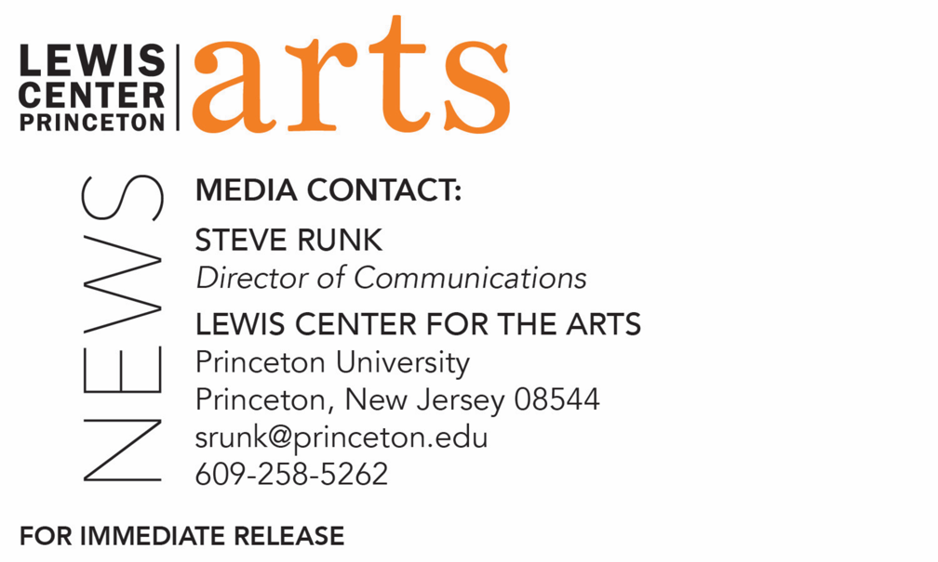

September 21, 2021

Lewis Center for the Arts’ Program in Creative Writing presents a reading by
Sherwin Bitsui and Maaza Mengiste
Award-winning writers open the Althea Ward Clark W’21 Reading Series at Princeton, returning in-person for the 2021-22 season

Photo caption 1: Sherwin Bitsui
Photos credit 1: Courtesy of Blue Flower Arts
Photo caption 2: Maaza Mengiste
Photos credit 2: Nina Subin

What/Who: The Althea Ward Clark W’21 Reading Series returns in-person for the 2021-22 season with a reading by American Book Award-winning Navajo poet Sherwin Bitsui and multiple award-winning novelist/essayist Maaza Mengiste, presented by the Lewis Center for the Arts’ Program in Creative Writing at Princeton University
When: October 5 at 7:30 p.m.
Where: Hearst Dance Theater at Lewis Arts complex on the Princeton University campus
Admission: Free and open to the public – all guests are required to be fully vaccinated against COVID-19 and to wear a mask when indoors; registration required through University Ticketing at tickets.princeton.edu.
Accessibility: Guests in need of access accommodations are invited to contact the Lewis Center at least 2 weeks in advance at LewisCenter@princeton.edu
For more information: https://arts.princeton.edu/events/reading-by-sherwin-bitsui-and-maaza-mengiste/

(Princeton, N.J.) The Althea Ward Clark W’21 Reading Series, presented by the Lewis Center for the Arts’ Program in Creative Writing at Princeton University, returns for the 2021-22 season in-person with a reading by American Book Award-winning Navajo poet Sherwin Bitsui and multiple award-winning novelist/essayist Maaza Mengiste. The reading begins at 7:30 p.m. in the Hearst Dance Theater in the Lewis Arts complex on the Princeton University campus. The reading is free and open to the public, however registration is required and all guests must be fully vaccinated against COVID-19 and wear a mask when indoors. Reservations can be made through University Ticketing at tickets.princeton.edu. Guests in need of access accommodations are invited to contact the Lewis Center at least 2 weeks in advance at LewisCenter@princeton.edu.

Originally from White Cone, Arizona, on the Navajo Reservation, Sherwin Bitsui is the author of three collections of poetry, Dissolve (Copper Canyon), Flood Song (Copper Canyon), and Shapeshift (University of Arizona Press). He is Diné of the Todích’ii’nii (Bitter Water Clan), born for the Tlizílaaní (Many Goats Clan) and holds an A.F.A. from the Institute of American Indian Arts Creative Writing Program and a B.A. from University of Arizona in Tucson. In addition to an American Book Award, his honors include a 2011 Lannan Foundation Literary Fellowship and a 2011 Native Arts & Culture Foundation Arts Fellowship. He is also the recipient of a 2010 PEN Open Book Award and a Whiting Writers Award. Bitsui’s poems have been published in Narrative, Black Renaissance Noir, American Poet, The Iowa Review, LIT, and elsewhere. Steeped in Native American culture, mythology, and history, Bitsui’s poems are noted to reveal the tensions in the intersection of Native American and contemporary urban culture. As an ecopoet, his work has been recognized as imagistic, surreal, and rich with details of the landscape of the Southwest.

Maaza Mengiste is a novelist and essayist whose work examines the individual lives at stake during migration, war and exile, and considers the intersections of art and violence. A Pushcart Prize nominee who was named a “New Literary Idol” by New York Magazine, she was born in Addis Ababa, Ethiopia. Her critically acclaimed debut novel, Beneath the Lion’s Gaze, was selected by The Guardian as one of the 10 Best Contemporary African Books and was a Runner-Up for the 2011 Dayton Literary Peace Prize. Mengiste’s newest book, The Shadow King, called a “lyrical, remarkable new novel” by The New York Times, revolves around a group of ordinary women who join the front lines during Mussolini’s fascist invasion of Ethiopia in what many consider the first conflict of World War II. “One of the most beautiful novels of the year” (NPR), the book was a finalist for The Los Angeles Times Book Prize for Fiction and the Man Booker Prize and was a New York Times Notable Book of 2019. A film adaptation is in the works to be directed by Kasi Lemmons (Eve's Bayou, Harriet). Mengiste’s fiction and nonfiction have appeared in The New Yorker, Granta, The Guardian, The New York Times, BBC Radio, and Lettre International, among others. Winner of the 2020 Literature Award from the American Academy of Arts and Letters, Mengiste's honors include the Creative Capital Award, a Fulbright Scholarship, and fellowships from the National Endowment for the Arts, the New York Public Library Cullman Center, and Puterbaugh Festival of International Literature & Culture. She was also a writer on the documentary film Girl Rising, part of a global action campaign for girls’ education and empowerment. Mengiste is at work on A Brief Portrait of Small Deaths, a novel set in Berlin during the interwar years. She has previously taught in Princeton’s Program in Creative Writing.
The Lewis Center’s Program in Creative Writing annually presents the Althea Ward Clark W’21 Reading Series, which provides an opportunity for students, as well as all in the greater Princeton region, to hear and meet the best contemporary writers. The series is organized by Lecturer in Creative Writing and award-winning poet Michael Dickman. All readings are at 7:30 p.m. in venues in the Lewis Arts complex and are free and open to the public. The 2021-22 series continues on November 16 with a reading by fiction writer Peter Ho Davies and filmmaker Jenni Olson, followed by readings by fiction writer Gish Jen and poet Garrett Hongo on February 22 and fiction writer Brontez Purnell and poet Marilyn Nelson on March 29.
To learn more about this event, the Program in Creative Writing, and the more than 100 other performances, exhibitions, readings, screenings, concerts, and lectures presented each year by the Lewis Center, most of them free, visit arts.princeton.edu.
###

