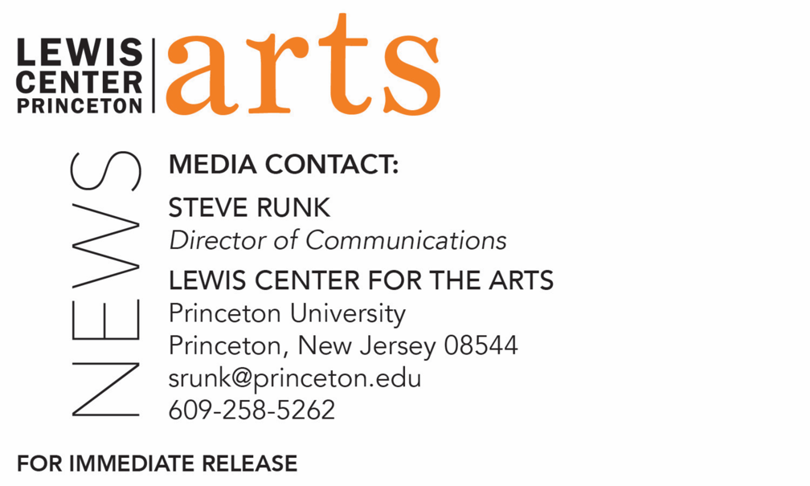

September 27, 2021

Fund for Irish Studies Series at Princeton University presents
“A History of Ireland in 100 (and More) Words,”
Authors Máire ní Mhaonaigh and Sharon Arbuthnot, discuss their book on the history of Ireland through 100 key words from the Royal Irish Academy’s Dictionary of the Irish Language, next in the 2021-2022 series

Photo caption: Máire Ní Mhaonaigh
Photo credit: Courtesy of Máire Ní Mhaonaigh
Photo caption: Sharon Arbuthnot
Photo credit: Trudy Tweedy

What/Who: “A History of Ireland in 100 (and More) Words,” a lecture by two of the three authors of A History of Ireland in 100 Words, Máire ní Mhaonaigh and Sharon Arbuthnot, on their book, which tells the history of Ireland through the examination of 100 key words from the Royal Irish Academy’s Dictionary of the Irish Language, the most comprehensive dictionary of Irish in existence. Introduced by Fund for Irish Studies Chair and Princeton’s Howard G.B. Clark University Professor of the Humanities Paul Muldoon. Event is next in the 2021-22 Fund for Irish Studies Series, which will remain virtual for the fall.
When: Friday, October 1, 2021 at 4:30 p.m.
Where: Online via Zoom
Admission: Free and open to the public; registration required
Accessibility: This event will be live captioned. Guests in need of other access accommodations are asked to contact the Lewis Center at LewisCenter@princeton.edu at least 2 weeks in advance of the event date.
For more information and the Zoom link: https://arts.princeton.edu/events/fund-for-irish-studies-maire-ni-mhaonaigh-sharon-arbuthnot/

(Princeton, NJ) Princeton University’s Fund for Irish Studies presents “A History of Ireland in 100 (and More) Words,” a lecture by Máire ní Mhaonaigh and Sharon Arbuthnot, two of the three authors of A History of Ireland in 100 Words. The book tells the history of Ireland through the examination of 100 key words from the Royal Irish Academy’s Dictionary of the Irish Language, the most comprehensive dictionary of Irish in existence. This virtual lecture on Friday, October 1 at 4:30 p.m. via Zoom will be introduced by Princeton’s Howard G.B Clark University Professor of the Humanities Paul Muldoon, co-chair of the series. The 2021-22 series, which will be virtual for the fall, is free and open to the public; registration is required.

Sharon Arbuthnot specializes in medieval Irish language and literature. She has lectured and researched at a number of universities in the United Kingdom and Ireland, predominantly at Queen’s University, Belfast, and at the University of Cambridge. In the decade up to 2019, she was the main editor and researcher behind the electronic Dictionary of the Irish Language (eDIL), and she is currently involved with Faclair na Gàidhlig, the historical dictionary of Scottish Gaelic. She has published widely, particularly on early Irish glossaries and encyclopedic texts, on scribal practice and on rare and obscure words. Recent and upcoming articles and chapters focus on vocabulary associated with the supernatural, technology, medieval medicine and the natural world, and a co-edited volume The Gaelic Finn Tradition II with Síle Ní Mhurchu and Geraldine Parsons will be published shortly through Four Courts Press, exploring the oral and written literature centered around the figure of Finn mac Cumaill. She is the core contributor to a public-engagement project, entitled Spreading the Words, based at the University of Cambridge, outputs of which include a range of heritage activities, educational resources, and a series for the digital radio station of the Museum of Literature Ireland.

Máire Ní Mhaonaigh is Professor of Celtic and Medieval Studies at the University of Cambridge and a Fellow of St. John’s College. She works at the intersection of history and literature, her research focusing on medieval constructions of the past. She has published widely on medieval Irish literature and history and on Ireland’s place in the wider world. She has contributed chapters to the Cambridge History of Irish Literature and to the recent multi-volume Cambridge History of Ireland. Among other recent publications are a co-authored volume, Norse-Gaelic Contacts in a Viking World with Colmán Etchingham, Jón Vidar Sigurðsson and Elizabeth Ashman Rowe exploring the cultural and political connections between Norse and Gaelic speakers in the high Middle Ages. She co-led a project on the electronic Dictionary of the Irish Language which resulted in a revised and augmented version of that resource, eDIL 2019. She is currently directing research on the landscape history of medieval Ireland, Mapping the Medieval Mind: Ireland’s Literary Landscapes in a Global Space, illuminating medieval dinnshenchas, a literature of place. She chairs the board of the School of Celtic Studies of the Dublin Institute for Advanced Studies and serves on many other bodies, including the editorial board of Interfaces: A Journal of Medieval European Literatures and the advisory board of the Centre for the Study of Manuscript Cultures based in Hamburg, Germany.

Ní Mhaonaigh’s and Arbuthnot’s co-author of A History of Ireland in 100 Words is Gregory Toner.

In addition to holding an endowed University professorship, Muldoon is director of the Princeton Atelier, a professor of creative writing, and founding chair of the Lewis Center for the Arts. He has been described by The Times Literary Supplement as “the most significant English-language poet born since the Second World War.” His fourteenth volume of poems, Howdie-Skelp, will be published later this year by Farrar Straus & Giroux. A selection of songs written for his rock band, Rogue Oliphant, has been published by Eyewear under the title Sadie and the Sadists, itself the title of a double LP available locally at the Princeton Record Exchange and on many streaming platforms.

The Fund for Irish Studies affords all Princeton students, and the community at large, a wider and deeper sense of the languages, literatures, drama, visual arts, history, politics, and economics not only of Ireland but of “Ireland in the world.” The series, co-curated this year by Muldoon and Fintan O’Toole, is co-produced by the Lewis Center for the Arts.

Information about the Fund for Irish Studies series events can be found at fis.princeton.edu. Other upcoming events in the current series, which is hoped to resume in-person in the spring, include:
- “Seamus Heaney's Late Poems” with Nicholas Allen on October 29
- “Irish Futures” with Brendan O’Leary on November 5
- “The Coffin Ship: Life and Death at Sea during the Great Famine” with Cian McMahon on December 3

The lecture will be live captioned. Viewers in need of other access accommodations are invited to contact the Lewis Center at least two weeks in advance at LewisCenter@princeton.edu.

The Fund for Irish Studies is generously sponsored by the Durkin Family Trust and the James J. Kerrigan, Jr. ’45 and Margaret M. Kerrigan Fund for Irish Studies.

To learn more about the more than 100 public performances, exhibitions, readings, screenings, concerts, lectures and special events, most of them free, presented each year by the Lewis Center for the Arts, visit arts.princeton.edu.

###

