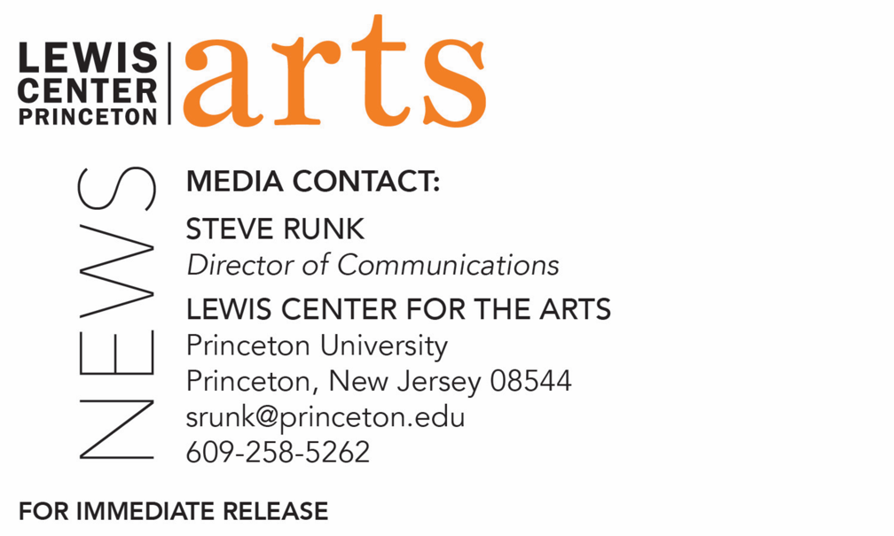

September 10, 2020

Fund for Irish Studies Series at Princeton University presents
A Conversation with Novelist Roddy Doyle
Fintan O’Toole leads a discussion with the award-winning writer,
opening the 2021-2022 series

Photo caption: Award-winning novelist Roddy Doyle
Photo credit: Courtesy of Roddy Doyle

What/Who: Scholar and critic Fintan O’Toole in conversation with award-winning novelist Roddy Doyle, introduced by Fund for Irish Studies Chair and Princeton’s Howard G.B. Clark University Professor of the Humanities Paul Muldoon. Event opens the 2021-22 Fund for Irish Studies Series, which will remain virtual for the fall.
When: Friday, September 17, 2021 at 4:30 p.m.
Where: Online via Zoom
Admission: Free and open to the public
For more information and the Zoom link: https://arts.princeton.edu/events/fund-for-irish-studies-conversation-roddy-doyle-fintan-o-toole/

(Princeton, NJ) Princeton University’s Fund for Irish Studies presents a conversation with award winning novelist, dramatist and screenwriter Roddy Doyle led by scholar and critic Fintan O’Toole, co-chair of the series, on Friday, September 17 at 4:30 p.m. via Zoom. Princeton’s Howard G.B Clark University Professor of the Humanities Paul Muldoon, co-chair of the series, will provide a welcome and introduction. The event opens the 2021-22 series, which will be virtual for the fall. The event is free and open to the public.

Doyle has written 12 novels, including The Commitments, Paddy Clarke Ha Ha Ha, for which he won the Booker Prize in 1993, The Woman Who Walked Into Doors, and, most recently, Love. His latest book, a story collection called Life Without Children, will be published in the U.S. in spring of 2022. Doyle has written eight books for children. He has also written for screen and stage. He is the co-founder of Fighting Words, which aims to help Irish children and young people to discover and harness the power of their own imaginations and creative writing skills. He lives in Dublin.

O’Toole’s books on politics include the best sellers Ship of Fools and Enough is Enough. His books on theater include works on William Shakespeare, Richard Brinsley Sheridan, and Thomas Murphy. He regularly contributes to The New York Review of Books, The New Yorker, Granta, The Guardian, The Observer, and other international publications. In 2011, The Observer named O’Toole one of “Britain’s top 300 intellectuals.” He has received the A.T. Cross Award for Supreme Contribution to Irish Journalism, the Millennium Social Inclusion Award, Journalist of the Year in 2010, the Orwell Prize, and the European Press Prize. O’Toole’s History of Ireland in 100 Objects, which covers 100 highly charged artifacts from the last 10,000 years, is currently the basis for Ireland’s postage stamps. His most recent book is Judging Shaw: The Radicalism of GBS, published by the Royal Irish Academy. He has recently been appointed official biographer of Nobel Prize-winning poet Seamus Heaney.

In addition to holding an endowed University professorship, Muldoon is director of the Princeton Atelier, a professor of creative writing, and founding chair of the Lewis Center for the Arts. He has been described by The Times Literary Supplement as “the most significant English-language poet born since the Second World War.” His fourteenth volume of poems, Howdie-Skelp, will be published later this year by Farrar Straus & Giroux. A selection of songs written for his rock band, Rogue Oliphant, has been published by Eyewear under the title Sadie and the Sadists, itself the title of a double LP available locally at the Princeton Record Exchange and on many streaming platforms.

The Fund for Irish Studies affords all Princeton students, and the community at large, a wider and deeper sense of the languages, literatures, drama, visual arts, history, politics, and economics not only of Ireland but of “Ireland in the world.” The series is co-produced by the Lewis Center for the Arts.

Information about the Fund for Irish Studies series virtual events can be found at fis.princeton.edu. Other upcoming events in the current series, which is hoped to resume in-person in the spring, include:
- “A History of Ireland in 100 (and More) Words” with Máire ní Mhaonaigh and Sharon Arbuthnot on October 1
- “Seamus Heaney's Late Poems” with Nicholas Allen on October 29
- “Irish Futures” with Brendan O’Leary on November 5
- “The Coffin Ship: Life and Death at Sea during the Great Famine” with Cian McMahon on December 3

The lecture will be live captioned. Viewers in need of other access accommodations are invited to contact the Lewis Center at least two weeks in advance at LewisCenter@princeton.edu.

The Fund for Irish Studies is generously sponsored by the Durkin Family Trust and the James J. Kerrigan, Jr. ’45 and Margaret M. Kerrigan Fund for Irish Studies.

To learn more about the more than 100 public performances, exhibitions, readings, screenings, concerts, lectures and special events, most of them free, presented each year by the Lewis Center for the Arts, visit arts.princeton.edu.

###

