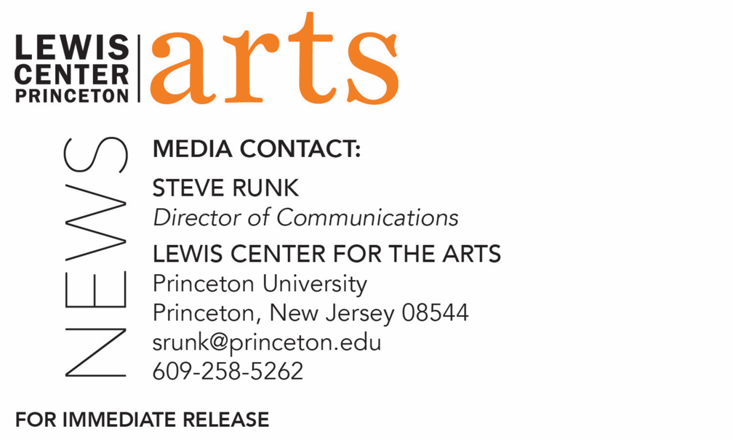

September 16, 2021

Princeton University’s Lewis Center for the Arts announces Tyehimba Jess as
Holmes National Poetry Prize Winner and
several visiting professorships for the 2021-22 academic year

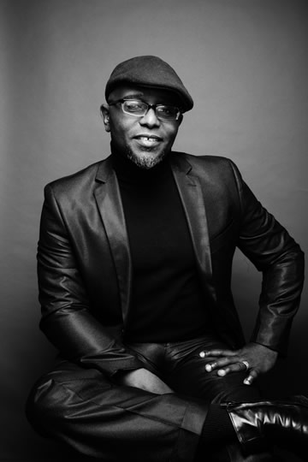
Photo caption: Pulitzer Prize-winning poet Tyehimba Jess, recipient of the Holmes National Poetry Prize from Princeton University’s Program in Creative Writing
Photo credit: John Midgley

(Princeton, NJ) Pulitzer Prize-winning poet Tyehimba Jess has been selected as the latest recipient of the Theodore H. Holmes ’51 and Bernice Holmes National Poetry Prize awarded by the Lewis Center for the Arts’ Program in Creative Writing at Princeton University. Jess is one of several artists joining the Lewis Center faculty in guest visiting professorships for the 2021-22 academic year.

The Holmes National Poetry Prize was established in memory of Princeton 1951 alumnus Theodore H. Holmes and is presented each year to a poet of special merit as selected by the faculty of the Creative Writing Program, which includes writers Michael Dickman, Aleksandar Hemon, A.M. Homes, Daphne Kalotay, Christina Lazaridi, Jhumpa Lahiri, Yiyun Li, Paul Muldoon, Kirstin Valdez Quade, Susan Wheeler, and a number of distinguished lecturers. The award currently carries a prize of $5,000 and was first made to Mark Doty in 2011 and has since also been awarded to Franny Choi, Eduardo Corral, Natalie Diaz, Claudia Rankine, Matt Rasmussen, Solmaz Sharif, Evie Shockley, and Jenny Xie. The Holmes poet delivers the annual Holmes Lecture each spring.

Tyehimba Jess is the author of two books of poetry, Leadbelly and Olio. Olio won the 2017 Pulitzer Prize, the Anisfield-Wolf Book Award, The Midland Society Author’s Award in Poetry, and it received an Outstanding Contribution to Publishing Citation from the Black Caucus of the American Library Association. It was also nominated for the National Book Critics Circle Award, the PEN Jean Stein Book Award, and the Kingsley Tufts Poetry Award. Leadbelly was a winner of the 2004 National Poetry Series. The Library Journal and Black Issues Book Review both named it one of the “Best Poetry Books of 2005.” Jess' fiction and poetry have appeared in many journals, as well as anthologies such as Angles of Ascent: A Norton Anthology of Contemporary African American Poetry, Beyond The Frontier: African American Poetry for the Twenty-First Century, Role Call: A Generational Anthology of Social and Political Black Literature and Art, Bum Rush the Page: A Def Poetry Jam, Power Lines: Ten Years of Poetry from Chicago's Guild Complex, and Slam: The Art of Performance Poetry. Jess, an alumnus of Cave Canem and New York University, received a 2004 Literature Fellowship from the National Endowment for the Arts and was a 2004–2005 Winter Fellow at the Provincetown Fine Arts Work Center. Jess is also a veteran of the 2000 and 2001 Green Mill Poetry Slam Team, and he won a 2000–2001 Illinois Arts Council Fellowship in Poetry, the 2001 Chicago Sun-Times Poetry Award, and a 2006 Whiting Fellowship. He presented his poetry at the 2011 TedX Nashville Conference and won a 2016 Lannan Literary Award in Poetry. He received a Guggenheim fellowship in 2018. Jess is a professor of English at College of Staten Island.

“I have been eager to call Tyehimba Jess a colleague ever since I discovered his bold and brilliant poetry,” said Jhumpa Lahiri, Director of the Program in Creative Writing. “The Program is honored by his presence, and our students are fortunate indeed to work with such an innovative, talented writer.”

Jess is teaching an introductory poetry course this semester and will teach an advanced poetry course in the spring, along with presenting the Holmes Lecture.

Also joining the Lewis Center faculty for the current academic year are dance scholar Jasmine E. Johnson as a full-time visiting assistant professor in the Program in Dance, who will teach the fall course, “Black Dance: History, Theory, Practice” this fall and another course in the spring; visual artist and filmmaker RaMell Ross as a Princeton Stanley Kelley Jr. Visiting Professor for Distinguished Teaching, who will teach in the Program in Visual Arts in the spring; Black feminist theorist of visual culture and contemporary art Tina Campt, who will be jointly appointed in the Program in Visual Arts and the Department of Art and Archaeology and will teach a course cross-listed between those two units this spring; and three visiting professors in the Program in Creative Writing: Yousef Komunyakaa teaching two courses in the spring, Rowan Ricardo Phillips teaching two courses each in the fall and spring, and Patricia Smith teaching a course each semester.

To learn more about the Lewis Center for the Arts, visit arts.princeton.edu.

###

