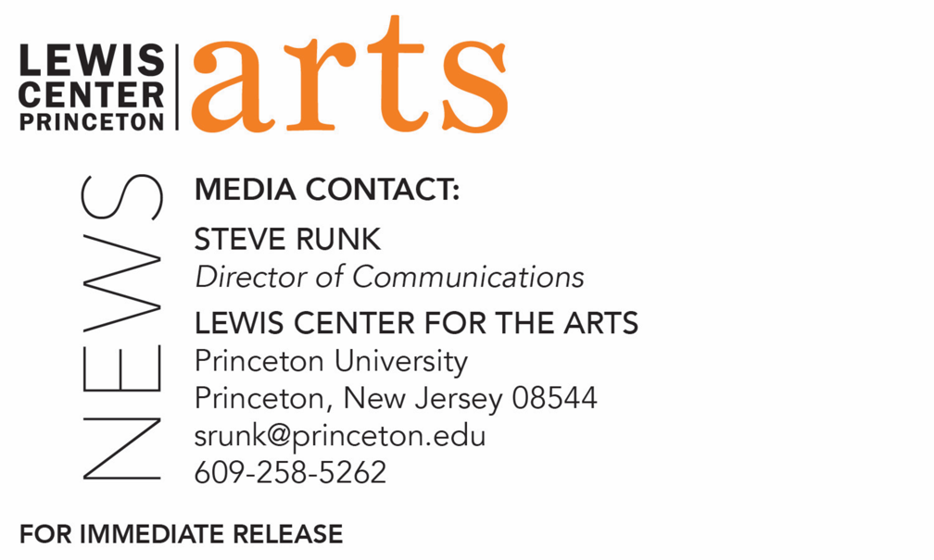

October 5, 2021

Reading by poet Raena Shirali and
Princeton Creative Writing seniors on October 12
Opening the 2021-22 C.K. Williams Reading Series organized by
Princeton’s Creative Writing students

Photo caption: Award-winning poet Raena Shirali
Photo credit: Hannah Yoon

What/Who: A reading by poet Raena Shirali, winner of the 2018 Milt Kessler Poetry Book Award and the 2021 Hudson Prize, and Program in Creative Writing seniors Lauren Howard, AG McGee, Sydney Peng, and Emily Weiss, opens the 2021-22 season of the C.K. Williams Reading Series, presented in-person by the Lewis Center for the Arts’ Program in Creative Writing at Princeton University
When: October 12, 2021 at 5:00 p.m.
Where: Drapkin Studio at Lewis Arts complex on the Princeton University campus
Admission: Free and open to the public; all guests are required to be fully vaccinated against COVID-19 and to wear a mask when indoors; registration required through University Ticketing at tickets.princeton.edu.
Accessibility: Guests in need of access accommodations are invited to contact the Lewis Center at least 2 weeks in advance at LewisCenter@princeton.edu
For more information: https://arts.princeton.edu/events/c-k-williams-reading-by-poet-raena-shirali/

(Princeton, NJ) Award-winning poet Raena Shirali will read from her work at 5:00 p.m. on Wednesday, October 12, in-person in the Drapkin Studio in the Lewis Arts complex on the Princeton University campus. Joining her will be Lauren Howard, AG McGee, Sydney Peng, and Emily Weiss – four seniors in Princeton’s Program in Creative Writing who will also be reading from their recent work. Creative writing senior Noel Peng will host the evening. This event opens the 2021-22 C.K. Williams Reading Series, named after the late Pulitzer Prize and National Book Award-winning poet C.K. Williams, who also served on Princeton’s faculty for 20 years. This event, presented by the Lewis Center for the Arts, is free and open to the public, however all guests are required to be fully vaccinated against COVID-19 and to wear a mask when indoors. Tickets are available through University Ticketing at tickets.princeton.edu.

The series showcases senior thesis students of the Program in Creative Writing alongside established writers as special guests.

Raena Shirali is a poet, editor, and educator from Charleston, South Carolina. Her first book, GILT (YesYes Books, 2017), won the 2018 Milt Kessler Poetry Book Award, and her forthcoming collection, summonings, won the 2021 Black Lawrence Press Hudson Prize. Winner of a Pushcart Prize and a former Philip Roth Resident at Bucknell University, Shirali is also the recipient of prizes and honors from VIDA, Gulf Coast, Boston Review, and Cosmonauts Avenue. Her work has appeared in American Poetry Review, Academy of American Poets’ Poem-A Day, The Nation, The Rumpus, and elsewhere. She holds an M.F.A. in Poetry from The Ohio State University and is an Assistant Professor of English at Holy Family University, where she serves as Faculty Advisor for Folio, HFU’s literary magazine dedicated to publishing works by undergraduate students at the national level. She is also co-editor-in-chief of Muzzle Magazine and lives in Philadelphia.

The four seniors, who are pursuing certificates in creative writing in addition to their major areas of study, will read from their senior thesis projects. They are among 31 Princeton seniors who are pursuing certificates in creative writing in addition to their major areas of study. Each is currently working on a novel, a screenplay, translations, or a collection of poems or short stories as part of a creative thesis for the certificate. Thesis students in the Program in Creative Writing work closely with a member of the faculty, which includes award-winning writers Michael Dickman, Aleksandar Hemon, A.M. Homes, Daphne Kalotay, Christina Lazaridi, Jhumpa Lahiri, Yiyun Li, Paul Muldoon, Kirstin Valdez Quade, and Susan Wheeler, and a number of distinguished lecturers and visiting professors

Additional guests in the series will be announced soon.

Patrons in need of access accommodations in order to participate in this event, are asked to contact the Lewis Center at LewisCenter@princeton.edu at least two weeks in advance of the event date.

To learn more about the reading series, the Program in Creative Writing, and the more than 100 public performances, exhibitions, readings, screenings, concerts and lectures presented each year by the Lewis Center for the Arts, most of them free, visit arts.princeton.edu.

###

