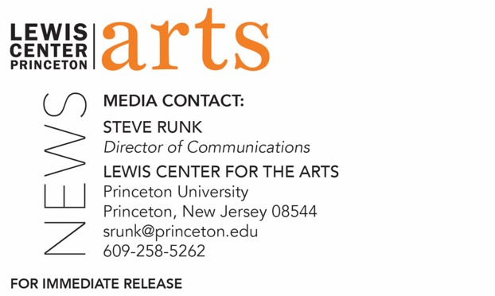

October 29, 2021

Reading by poet Chen Chen and
Princeton Creative Writing Seniors on November 9
Part of the C.K. Williams Reading Series organized by
Princeton’s Creative Writing students

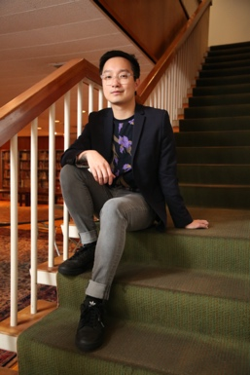

Photo Caption: Poet Chen Chen
Photo Credit: Mike Lovett

What/Who: A reading by poet Chen Chen, winner of a 2019 National Endowment for the Arts Fellowship and 2015 winner of the Kundiman Prize, and Program in Creative Writing seniors Thomas Dayzie, Marc Schorin, Malcolm Slutzky, Peter Taylor, and Ellen Whiteside as part of the 2021-2022 season of the C.K. Williams reading Series, presented in-person by the Lewis Center for the Arts’ Program in Creative Writing at Princeton University.
When: November 9, 2021 at 5:00 p.m.
Where: Drapkin Studio at Lewis Arts complex on the Princeton University campus.
Admission: Free and open to the public; all guests are required to be fully vaccinated against COVID-19 and to wear a mask when indoors.
Tickets required: Reserve tickets through University Ticketing
Accessibility: Guests in need of access accommodations are invited to contact the Lewis Center at least 1 week in advance at LewisCenter@princeton.edu.
For more information: https://arts.princeton.edu/events/c-k-williams-reading-by-poet-chen-chen/

PRINCETON, NJ — Award-winning poet Chen Chen will read from his work at 5:00 p.m. on Tuesday, November 9, 2021, in-person in the Drapkin Studio in the Lewis Arts complex on the Princeton University campus. Joining him will be Thomas Dayzie, Mark Schorin, Malcolm Slutzky, Peter Taylor, and Ellen Whiteside, five seniors in Princeton’s Program in Creative Writing, who will also be reading from their recent work; Taylor will host the evening. This event is part of the 2021-2022 C.K. Williams Reading Series, named after the late Pulitzer Prize and National Book Award-winning poet C.K. Williams, who served on Princeton’s faculty for 20 years. This series showcases senior thesis students of the Program in Creative Writing alongside established writers as special guests.

This event, presented by the Lewis Center for the Arts, is free and open to the public, however all guests are required to be fully vaccinated against COVID-19 and to wear a mask when indoors. Tickets are required and available through University Ticketing.

Chen Chen is the author of When I Grow Up I Want to Be a List of Further Possibilities (BOA Editions, 2017), which was longlisted for the National Book Award and won the Thom Gunn Award for Gay Poetry, the A. Poulin Jr. Poetry Prize, and the GLCA New Writers Award. His forthcoming poetry collection, Your Emergency Contact Has Experienced an Emergency (BOA Editions, 2022), was a finalist for the Lambda Literary Award for Gay Poetry and was named one of the best books by The Brooklyn Rail, Entropy, Library Journal, and others. In an interview with NPR, Chen explained, “I felt like I couldn’t be Chinese and American and gay all at the same time. I felt like the world I was in was telling me that these had to be very separate things.” As someone who was struggling with his sexuality and thinking about identity—with immigrant parents and wondering how to come out, “Poems were a way for those different experiences to come together, for them to be in the same room.” Chen’s work appears or is forthcoming in many publications, including Poetry and three editions of The Best American Poetry (2015, 2019, and 2021). Recently, Chen’s work has been translated into French, Greek, Spanish, and Russian, and Poets & Writers Magazine featured him in their Inspiration Issue as one of “Ten Poets Who Will Change the World.” Chen has received a Pushcart Prize and fellowships from Kundiman and the National Endowment for the Arts. He edits the literary journal Underblong. He has taught at Brandeis University as the 2018-2020 Jacob Ziskind Poet-in-Residence.

The five seniors, who are pursuing certificates in creative writing in addition to their major areas of study, will read from their senior thesis projects. They are among 31 Princeton seniors who are pursuing certificates in creative writing in addition to their major areas of study. Each is currently working on a novel, a screenplay, translations, or a collection of poems or short stories as part of a creative thesis for the certificate. Thesis students in the Program in Creative Writing work closely with a member of the faculty, which includes award-winning writers Michael Dickman, Aleksander Hemon, A.M. Homes, Daphne Kalotay, Christina Lazaridi, Jhumpa Lahiri, Yiyun Li, Paul Muldoon, Kirstin Valdez Quade, Susan Wheeler, and a number of distinguished lecturers and visiting professors.

Patrons in need of access accommodations in order to participate in this event are asked to contact the Lewis Center at LewisCenter@princeton.edu at least one week in advance of the event date.

To learn more about the reading series, the Program in Creative Writing, and the more than 100 public performances, exhibitions, readings, screenings, concerts, and lectures presented each year by the Lewis Center for the Arts, most of them free, visit arts.princeton.edu.

