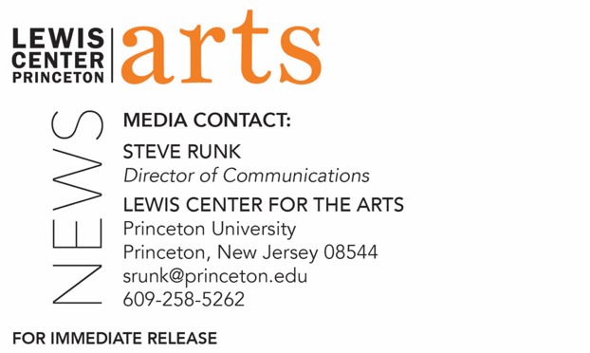

October 29, 2021

Fund for Irish Studies at Princeton University presents
“Irish Reunification: Prospects & Feasible Models”
Lecture by Brendan O’Leary continues the 2021-2022 series

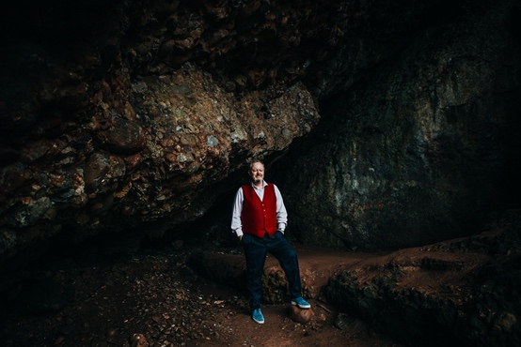
Photo Caption: Brendan O’Leary in Cave at Cushendun, Lauder Professor of Political Science at the University of Pennsylvania
Photo Credit: Courtesy of Brendan O’Leary

Who/What: Brendan O’Leary, Lauder Professor of Political Science at the University of Pennsylvania, presents “Irish Reunification: Prospects & Feasible Models,” a lecture drawn from his book-in-progress on questions and issues surrounding the idea of a unification of the island of Ireland. Introduced by Princeton’s Visiting Leonard L. Milberg ’53 Professor in Irish Letters, Fintan O’Toole. Part of the 2021-2022 Fund for Irish Studies Lecture Series at Princeton University, which will remain virtual for the fall.
When: Friday, November 5, 2021, at 4:30 p.m.
Where: Online via Zoom Webinar
Admission: Free and open to the public (Zoom registration required)
Admission: Event will be live captioned. Viewers in need of other access accommodations are invited to contact the Lewis Center at least one week in advance at LewisCenter@princeton.edu
For more information and the Zoom link: https://arts.princeton.edu/events/fund-for-irish-studies-brendan-o-leary/

PRINCETON, NJ – Princeton University’s Fund for Irish Studies presents “Irish Reunification: Prospects & Feasible Models,” a lecture by Brendan O’Leary, Lauder Professor of Political Science at the University of Pennsylvania, on Friday, November 5, 2021 at 4:30 p.m. via Zoom Webinar. Princeton’s Visiting Leonard L. Milberg ’53 Professor in Irish Letters, Fintan O’Toole, will provide a welcome and introduction. The event is part of the 2021-2022 lecture series, which is virtual for the fall. The lecture is free and open to the public.

O’Leary will discuss the questions and issues surrounding possible Irish reunification, where Northern Ireland, currently part of the United Kingdom, and the Republic of Ireland become one sovereign state. This is the topic of O’Leary’s upcoming book and was the focus of a working group study of which O’Leary was a member. The study was conducted at the Constitution Unit at University College London and was funded by the British Academy. The study’s culminating report presented two models for possible Irish reunification: in the first “integrated model,” the country of Northern Ireland would be dissolved and merged entirely with the Republic of Ireland’s government; and in the second, Northern Ireland would be a parliamentary entity within the Republic of Ireland’s government, much as it is within the United Kingdom currently. Though a new referendum for Irish reunification has yet to be presented to the Irish people, both models require plans for merging the two countries’ social services, such as education and health services; transferring financial assets from the United Kingdom to the new Republic of Ireland; and defining territorial expanses, such as coastal waters and fishing zones.

O’Leary is recognized as one of the foremost scholars of political science on the island of Ireland. His three-volume magnum opus, A Treatise on Northern Ireland, published by the Oxford University Press in 2019, won the 2020 James S. Donnelly Sr. Prize of the American Conference of Irish Studies for the best book in History and Social Science.

O’Leary, a U.S., Irish and European Union citizen who grew up in Nigeria, Sudan, and Northern Ireland, has been a member on the U.S. Council on Foreign Relations and an Honorary Member of the Royal Irish Academy. He is a founding member of ARINS (Analyzing and Researching Ireland, North and South), a project sponsored by the Royal Irish Academy and the University of Notre Dame focusing on authoritative, independent and non-partisan analysis and research on constitutional, institutional and policy options for Ireland, north and south, in a post-Brexit context. In 2014, O’Leary was the inaugural winner of the Juan Linz Prize of the International Political Science Association for the study of multinational societies, federalism, and democratization.

O’Toole’s books on Irish politics include the best sellers Ship of Fools (2009) and Enough is Enough (2010). His books on Irish and English theater include works on Richard Brinsley Sheridan, Thomas Murphy, and William Shakespeare. He regularly contributes to The New York Review of Books, The New Yorker, Granta, The Guardian, The Observer, and other international publications. In 2011, The Observer named O’Toole one of “Britain’s top 300 intellectuals.” He has received the A.T. Cross Award for Supreme Contribution to Irish Journalism, the Millennium Social Inclusion Award, Journalist of the Year in 2010, the Orwell Prize, and the European Press Prize. O’Toole’s History of Ireland in 100 Objects covers 100 culturally significant artifacts from the last 10,000 years, and is currently the basis for Ireland’s postage stamps. His most recent book is Judging Shaw: The Radicalism of GBS, published in 2017 by the Royal Irish Academy.

This year, O’Toole co-chairs The Fund for Irish Studies, along with Paul Muldoon, Princeton’s Howard G.B. Clark University Professor of the Humanities. The Fund for Irish Studies affords all Princeton students, and the community at large, a wider and deeper sense of the languages, literatures, drama, visual arts, history, politics, and economics not only of Ireland but of “Ireland in the world.” The lecture series is co-produced by the Lewis Center for the Arts.

Information about the Fund for Irish Studies lecture series’ virtual events can be found at fis.princeton.edu. The final scheduled event for this fall is “The Coffin Ship: Life and Death at Sea during the Great Famine” with Cian McMahon on December 3. The series plans to resume in-person events in the spring. Additional events in the works will feature poet James Longenbach; Helen Phelan, Professor of Arts Practice at the Irish World Academy of Music and Dance, University of Limerick; Fintan O’Toole presenting the Robert Fagles Memorial Lecture; acclaimed writer Colm Tóibín presented in collaboration with Labyrinth Books; journalist Susan McKay; and novelist Danielle McLaughlin.

The Fund for Irish Studies is generously sponsored by the Durkin Family Trust and the James J. Kerrigan, Jr. ’45 and Margaret M. Kerrigan Fund for Irish Studies.

The lecture will be live captioned. Viewers in need of other access accommodations are invited to contact the Lewis Center at least one week in advance at LewisCenter@princeton.edu.

To learn more about the more than 100 public performances, exhibitions, readings, screenings, concerts, lectures and special events, most of them free, presented each year by the Lewis Center for the Arts, visit arts.princeton.edu.

