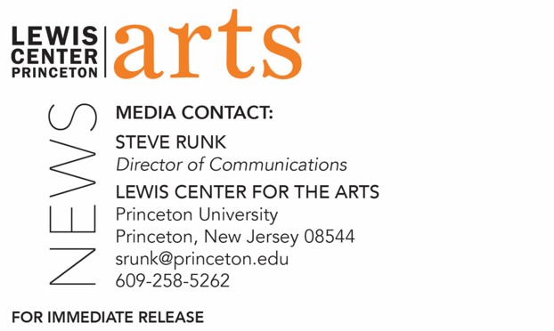

November 30, 2021

Lewis Center for the Arts’ Program in Creative Writing presents the
Fall 2021 Student Reading
Part of the Althea Ward Clark W’21 Reading Series at Princeton

What/Who: Selected students from fall courses in Creative Writing will read from their work in fiction, poetry, screenwriting and literary translation as part of the Althea Ward Clark W’21 Reading Series presented by the Program in Creative Writing at Princeton University.
When: Tuesday, December 7, 2021 at 5:00 p.m.
Where: Chancellor Green Rotunda on the Princeton University campus
Admission: Free and open to the public; all guests are required to be fully vaccinated against COVID-19 and to wear a mask when indoors.
Tickets Required: Tickets can be purchased through University Ticketing at tickets.princeton.edu
Accessibility: Guests in need of access accommodations are asked to contact the Lewis Center at LewisCenter@princeton.edu at least one week prior to the event date.
For more information: https://arts.princeton.edu/events/fall-2021-student-reading/

PRINCETON, NJ – Students enrolled in fall creative writing courses in the Lewis Center for the Arts’ renowned Program in Creative Writing at Princeton University will read from their new works of fiction, poetry, screenwriting, and literary translation on Tuesday, December 7 at 5:00 p.m. in the Chancellor Green Rotunda on the Princeton campus as part of the Program’s Althea Ward Clark W’21 Reading Series. The reading is the culmination of students’ work in the Program in Creative Writing’s fall creative writing workshops.

Through the Program in Creative Writing, Princeton students can take courses or earn a certificate in creative writing in addition to pursuing their undergraduate degree in a major. The small workshop courses offered by the Program are limited in enrollment to ten students to ensure the benefits of working closely with faculty. Each workshop focuses on one genre of writing (poetry, fiction, nonfiction, screenwriting, or translation) and meets for up to three hours weekly, devoting time primarily to the discussion of students’ work. Each year, 20 to 30 seniors also work individually with a member of the faculty of practicing, award-winning authors on a creative thesis, such as a novel, a screenplay, or a collection of short stories, poems, or translations. The faculty currently includes Michael Dickman, Aleksandar Hemon, A.M. Homes, Christina Lazaridi, Jhumpa Lahiri, Yiyun Li, Paul Muldoon, Kirstin Valdez Quade, Susan Wheeler, and a number of distinguished lecturers and visiting professors.

Alumni of the Program include such well-known writers as Jonathan Ames ’87, Jonathan Safran Foer ’99, Jane Hirshfield ’73, and Monica Youn ’93.

The Althea Ward Clark W’21 Reading Series annually brings a number of distinguished writers to campus to read and discuss their work. Writers reading in the coming months include Gish Jen and Garrett Hongo on February 22, 2022, and Brontez Purnell and Marilyn Nelson on March 29, 2022.

All Althea Ward Clark W’21 readings are free and open to the public. However, registration is required and all guests must be fully vaccinated against COVID-19 and wear a mask when indoors. Reservations can be made through University Ticketing at tickets.princeton.edu. Guests in need of access accommodations are invited to contact the Lewis Center at least one week prior to the event at LewisCenter@princeton.edu.

To learn more about this reading series, the Program in Creative Writing, and the more than 100 public performances, exhibitions, readings, screenings, concerts and lectures presented each year by the Lewis Center for the Arts, most of them free, visit arts.princeton.edu.

###

