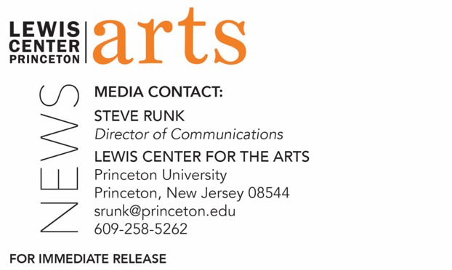

November 10, 2021

Lewis Center for the Arts’ Program in Creative Writing presents a reading by
Peter Ho Davies and Jenni Olson
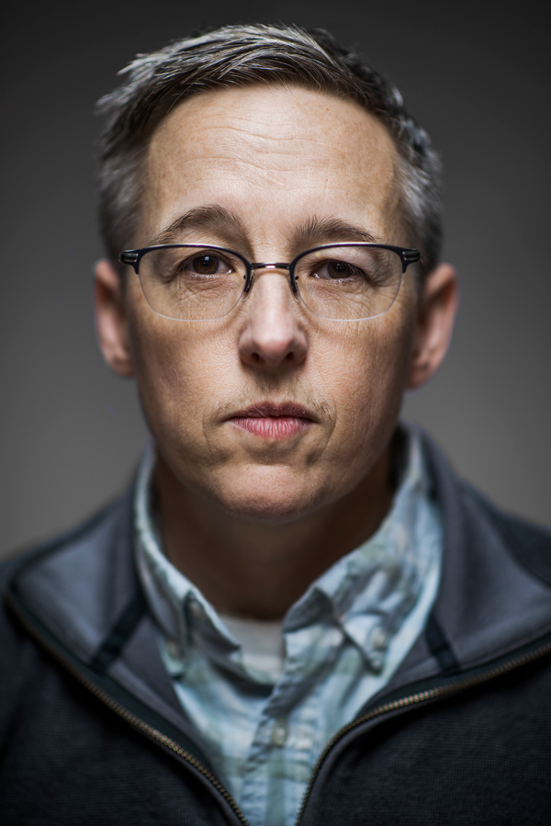
Award-winning writers continue the Althea Ward Clark W’21 Reading Series at Princeton

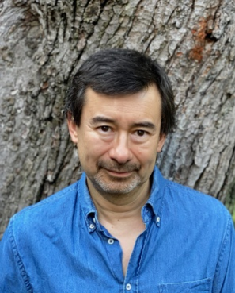
Photo Caption: Peter Ho Davies Photo Caption: Jenni Olson
Photo Credit: Lynn Raughley Photo Credit: Scott McDermott

What/Who: The Althea Ward Clark W’21 Reading Series returns in-person for the 2021-22 season with a reading by Anisfield-Wolf Award-winning novelist Peter Ho Davies and Jenni Olson, writer/filmmaker and former co-director of the San Francisco International LGBTQ Film Festival, presented by the Lewis Center for the Arts’ Program in Creative Writing at Princeton University.
When: Tuesday, November 16 at 7:30 p.m.
Where: Hearst Dance Theater at the Lewis Arts complex on the Princeton University campus.
Admission: Free and open to the public. All guests are required to be fully vaccinated against COVID-19 and to wear a mask when indoors; registration required through University Ticketing at tickets.princeton.edu
Accessibility: Guests in need of access accommodations are asked to contact the Lewis Center at least one week in advance at LewisCenter@princeton.edu.
For more information: https://arts.princeton.edu/events/reading-by-peter-ho-davies-and-jenni-olson/

PRINCETON, NJ – The Althea Ward Clark W’21 Reading Series, presented by the Lewis Center for the Arts’ Program in Creative Writing at Princeton University, returns for the 2021-2022 season in-person with a reading by Anisfield-Wolf Award-winning novelist Peter Ho Davies and Jenni Olson, writer/ filmmaker and former co-director of the San Francisco International LGBTQ Film Festival. The reading will take place on Tuesday, November 16 at 7:30 p.m. in the Hearst Dance Theater in the Lewis Arts complex on the Princeton University campus. The reading is free and open to the public. However, registration is required, and all guests must be fully vaccinated against COVID-19 and wear a mask when indoors. Reservations can be made through University Ticketing at tickets.princeton.edu. Guests in need of access accommodations are invited to contact the Lewis Center at least one week in advance at LewisCenter@princeton.edu.

Peter Ho Davies’ most recent novel is A Lie Someone Told You About Yourself and his first work of non-fiction, The Art of Revision: The Last Word, is forthcoming. His other books include The Fortunes, winner of the Anisfield-Wolf Award and a New York Times Notable Book of the Year, which National Public Radio (NPR) described as “a stunning look at what it means to be Chinese, what it means to be American, and what it means to be a person navigating the strands of identity”; and The Welsh Girl, long-listed for the Man Booker Prize and a London Times bestseller. His two critically acclaimed collections of short stories are The Ugliest House in the World, which won the John Llewelyn Rhys Prize and the Oregon Book Award; and Equal Love, a New York Times Notable Book, and a finalist for the Los Angeles Times Book Prize. His work has appeared in Harpers, The Atlantic, The Paris Review, and Granta and has been anthologized in Prize Stories: The O. Henry Awards and Best American Short Stories. In 2003, Granta magazine named him among its “Best of Young British Novelists.” Davies is a recipient of fellowships from the Guggenheim Foundation and the National Endowment for the Arts and a winner of the PEN/Malamud and PEN/Macmillan Awards. Born in Britain to Welsh and Chinese parents, he now teaches in the M.F.A. program at the University of Michigan.

Jenni Olson is a writer and non-fiction filmmaker based in Berkeley, California. A 2018 MacDowell Fellow, Olson is currently in development on her third feature-length essay film, The Quiet World, as well as an essayistic memoir of the same name. Her two earlier feature-length essay films, The Joy of Life (2005) and The Royal Road (2015), premiered at the Sundance Film Festival and have screened internationally to awards and acclaim. In 2020, the Criterion Channel launched a retrospective on Olson and her work. Also in 2020, the Harvard Film Archive established the Jenni Olson Queer Film Collection, a repository for Olson’s work as a filmmaker and film historian/archivist. Her work as a film historian and critic includes the Lambda Award-nominated The Queer Movie Poster Book (2005) and decades of writing for publications such as Filmmaker Magazine and The Advocate. Her reflection on the last 30 years of LGBT film history, The Oxford Handbook of Queer Cinema, is forthcoming from Oxford Press in 2021. Olson co-founded the pioneering LGBT online platform, PlanetOut.com and is a film columnist for Logo TV’s NewNowNext. She has been widely recognized for her creative writing and innovative non-fiction storytelling and has essays forthcoming in 2021 in TSQ: Transgender Studies Quarterly and the New Orleans Review.

The Lewis Center’s Program in Creative Writing annually presents the Althea Ward Clark W’21 Reading Series, which provides an opportunity for students, as well as all in the greater Princeton region, to hear and meet the best contemporary writers. The series is organized by Lecturer in Creative Writing and award-winning poet Michael Dickman. All readings are at 7:30 p.m. in venues in the Lewis Arts complex and are free and open to the public. The 2021-22 series continues on February 22 with a reading by fiction writer Gish Jen and poet Garrett Hongo, and finishes with a reading by fiction writer Brontez Purnell and poet Marilyn Nelson on March 29.

To learn more about this event, the Program in Creative Writing, and the more than 100 other performances, exhibitions, readings, screenings, concerts, and lectures presented each year by the Lewis Center, most of them free, visit arts.princeton.edu.

###

