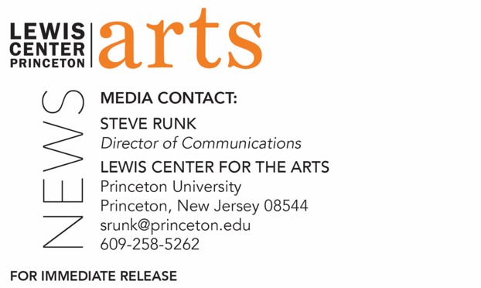

November 23, 2021

Lewis Center for the Arts’ Program in Theater presents
Jersey Jokers
An evening of stand-up with 9 comics, 1 fabulous host, and unlimited hilarity!

Photo caption: Maysoon Zayid, actress, comedian, writer, and disability advocate
Photo credit: Michelle Kinney

What/Who: Come to Jersey Jokers and laugh with (or at) Maysoon Zayid's Art of Standup students as they take their final exam live! 9 comics, 1 fabulous host, and unlimited hilarity! Featuring Princeton students Harshini Abbaraju, Mohamed Alghondakly, Jeremy Bernius, Daniel Drake, Benjamin Graham, Jenni Lawson, Asher Muldoon, Rosemary Paulson, and Fernanda Romo Herrera Ibarrola. Maysoon Zayid is an actress, comedian, writer, and disability advocate and a 2021-23 Princeton Arts Fellow.
When: December 6, 2021 at 7:00 pm
Where: Wallace Theater at Lewis Arts complex
Admission: Free and open to the public; registration required through University Ticketing at tickets.princeton.edu All guests are required to be fully vaccinated against COVID-19 and to wear a mask when indoors. The performers will be unmasked and socially distanced from the audience when performing. Due to language and the sexual nature of some content, this event may not be suitable for children under 16 years of age.
Accessibility: This event will be open-captioned and American Sign Language (ASL) interpreted. The event space is wheelchair accessible. Guests in need of other access accommodations are asked to contact the Lewis Center at LewisCenter@princeton.edu.
For more information: https://arts.princeton.edu/events/jersey-jokers/

PRINCETON, NJ – Comedian and Princeton Arts Fellow Maysoon Zayid will host a night of comedy as students from her fall Princeton University course, “The Art of Standup,” take their final exam in front of a live audience. A night Zayid assures will be filled with unlimited laughs and hilarity will begin at 7:00 p.m. on Monday, December 6, presented in-person in the Wallace Theater at the Lewis Arts complex on the Princeton campus. The nine Princeton students performing are Harshini Abbaraju, Mohamed Alghondakly, Jeremy Bernius, Daniel Drake, Benjamin Graham, Jenni Lawson, Asher Muldoon, Rosemary Paulson, and Fernanda Romo Herrera Ibarrola. All guests are required to be fully vaccinated against COVID-19 and to wear a mask when indoors. The performers will be unmasked and socially distanced from the audience when performing. Due to language and the sexual nature of some content, this event may not be suitable for children under 16 years of age.

Maysoon Zayid is a comedian, actress, writer, and disability advocate. She is a graduate of Arizona State University and a 2021-23 Princeton Arts Fellow. Zayid is the co-founder/co-executive producer of the New York Arab American Comedy Festival and The Muslim Funny Fest. She was a full-time on-air contributor to Countdown with Keith Olbermann and a columnist for The Daily Beast. She has appeared on 60 Minutes, CNN, ABC News, and Oprah Winfrey Networks. Zayid had the most-viewed TED Talk of 2014 and was named One of 100 Women of 2015 by the BBC.

As a professional comedian, Zayid has sold out top New York clubs and has toured extensively in the U.S. and abroad. She was a headliner on the Arabs Gone Wild Comedy Tour and The Together Live Tour. She appeared alongside Adam Sandler in You Don’t Mess with the Zohan and has written for Glamour Magazine. She limped, as she puts it, in New York Fashion Week and is a recurring character on General Hospital. She is the author of the best-selling memoir Find Another Dream and is collaborating with Scholastic Magazines on a comic book series.

The nine students performing are presenting their work from Zayid’s class, “The Art of Standup,” a fall course offered by the Program in Theater in the Lewis Center for the Arts. The Program in Theater offers all Princeton students the opportunity to investigate questions about themselves, others, and the events and systems that affect everyone, through the imaginative and collaborative medium of theater. The program offers courses in writing, performance, directing, design, dramaturgy, performance history, theory, and criticism. Students in the program study with award-winning artists, critics and scholars.

The event will be open-captioned and American Sign Language (ASL) interpreted. The event space is wheelchair accessible. Guests in need of other access accommodations are asked to contact the Lewis Center at LewisCenter@princeton.edu.

To learn more about the Program in Theater, and the more than 100 public performances, exhibitions, readings, screenings, concerts, and lectures presented each year by the Lewis Center for the Arts, most of them free, visit arts.princeton.edu.

