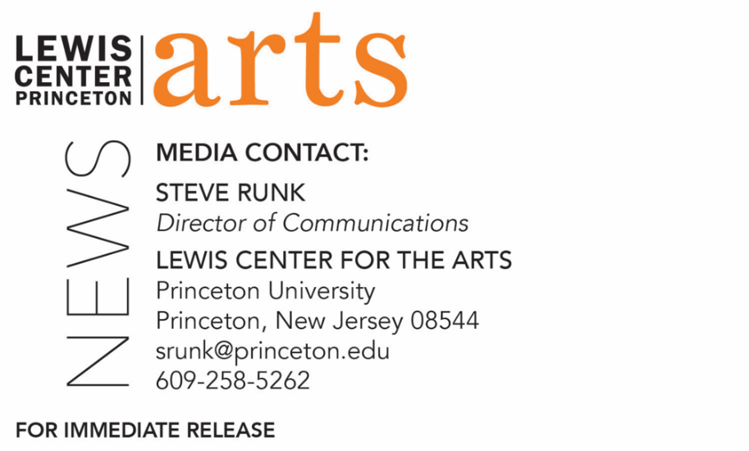
January 25, 2022

Fund for Irish Studies at Princeton University presents
“Open Secrets: Ulysses at 100”
The Robert Fagles Memorial Lecture by Fintan O’Toole
continues the 2021-2022 series

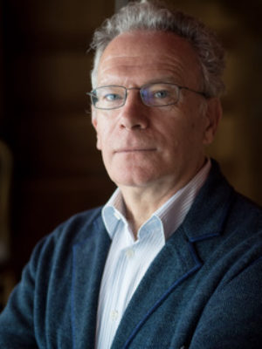
Photo Caption: Princeton’s Visiting Leonard L.Milberg ’53 Professor in Irish Letter Fintan O’Toole
Photo Credit: Courtesy of Fintan O’Toole

Who/What: Fintan O’Toole, Princeton’s Visiting Leonard L. Milberg '53 Professor in Irish Letters, presents “Open Secrets: Ulysses at 100.” James Joyce's revolutionary novel Ulysses was published 100 years ago in February 1922. In the Robert Fagles Memorial Lecture, O’Toole asks why the book still matters today. Introduced by Paul Muldoon, Princeton’s Howard G.B. Clark ’21 University Professor in the Humanities and co-chair of the Fund for Irish Studies. Part of the 2021-2022 Fund for Irish Studies Lecture Series at Princeton University.
When: Friday, February 11, 2022, at 4:30 p.m.
Where: Online via Zoom webinar
Admission: Free and open to the public
Accessibility: Guests in need of access accommodations are invited to contact the Lewis Center at LewisCenter@princeton.edu at least one week in advance of the event date.
For more information and Zoom link: https://arts.princeton.edu/events/fund-for-irish-studies-robert-fagles-lecture-fintan-o-toole/

PRINCETON, NJ – Princeton University’s Fund for Irish Studies presents “Open Secrets: Ulysses at 100,” the Robert Fagles Memorial Lecture by Fintan O’Toole, one of Ireland’s leading public intellectuals, columnist for The Irish Times, and the Visiting Leonard L. Milberg ’53 Professor in Irish Letters at Princeton University. Paul Muldoon, Princeton’s Howard G.B. Clark ’21 University Professor in the Humanities and co-chair of the Fund for Irish Studies, will provide a welcome and introduction. The lecture will be held on Friday, February 11 at 4:30 p.m., online via Zoom webinar. This event is free and open to the public.

James Joyce's revolutionary novel Ulysses was published 100 years ago in February 1922. In its initial review of the book, The New York Times declared Ulysses “the most important contribution that has been made to fictional literature in the twentieth century.” Through a stream of consciousness writing style, Joyce follows Stephen Dedalus, a 22-year-old aspiring poet and teacher, and Leopold Bloom, a 38-year-old Jewish advertising agent, as they go about nineteen hours of daily life in Dublin, Ireland. Both men grapple with themes of religion, philosophy, remorse, and mortality. In his lecture, O’Toole asks why the book still matters today. It is, he suggests, one of the best explorations we have of the way the local is also universal; of the fluidity of identity; of the fusion of body and mind; and of the possibility of living beyond tragedy.

O’Toole’s books on politics include the best sellers Ship of Fools and Enough is Enough. His books on theater include works on William Shakespeare, Richard Brinsley Sheridan, and Thomas Murphy. He regularly contributes to The New York Review of Books, The New Yorker, Granta, The Guardian, The Observer, and other international publications. In 2011, The Observer named O’Toole one of “Britain’s top 300 intellectuals.” He has received the A.T. Cross Award for Supreme Contribution to Irish Journalism, the Millennium Social Inclusion Award, Journalist of the Year in 2010, the Orwell Prize, and the European Press Prize. O’Toole’s History of Ireland in 100 Objects, which covers 100 highly charged artifacts from the last 10,000 years, is currently the basis for Ireland’s postage stamps. His most recent book is Judging Shaw: The Radicalism of GBS, published by the Royal Irish Academy. He has recently been appointed official biographer of Nobel Prize-winning poet Seamus Heaney.

Muldoon is a professor of creative writing at Princeton. As an internationally renowned poet, Muldoon has been described by The Times Literary Supplement as “the most significant English-language poet born since the second World War.” Muldoon won a Pulitzer Prize in 2003 for his ninth collection of poems, Poems 1968-1998 (2001). Additionally, Muldoon has won the T.S. Eliot Prize, the Griffin International Prize for Excellence in Poetry, the Shakespeare Prize, and the European Prize for Poetry, among others. His fourteenth volume of poems, Howdie-Skelp, was released in December 2021. Muldoon is editor of the recently released Paul McCartney boxed, two-volume set, The Lyrics: 1956 to the Present, illuminating the stories behind 154 of McCartney’s song lyrics.

Robert Fagles (1933-2008), for whom the annual Memorial Lecture is named, was an award-winning scholar, writer and member of the Princeton faculty for 42 years, serving as the Arthur Marks ’19 Professor of Comparative Literature at Princeton. He was widely acclaimed for his popular translations of Homer’s “The Iliad” and “The Odyssey,” both of which became best-sellers. He also created English renditions of “The Oresteia” by Aeschylus and “The Three Theban Plays” by Sophocles, as well as “The Aeneid” by the Roman poet Virgil. Starting in 1966, Fagles was director of Princeton’s Program in Comparative Literature, which attained department status in 1975. He served as founding chair of the department from 1975 to 1994. Fagles’ teaching and research specialties were the classical tradition in English and European literature; the theory and practice of translation; interrelationships between the arts; and forms of poetry: lyric, tragedy and epic.

The Fund for Irish Studies is co-chaired this year by O’Toole and Muldoon and affords all Princeton students, and the community at large, a wider and deeper sense of the languages, literatures, drama, visual arts, history, and economics not only of Ireland but of “Ireland in the world.” The lecture series is co-produced by the Lewis Center for the Arts.

Information about the Fund for Irish Studies series’ events can be found at fis.princeton.edu. Upcoming events for this spring include lectures from journalist Susan McKay and novelist Danielle McLaughlin.

The Fund for Irish Studies is generously sponsored by the Durkin Family Trust and the James J. Kerrigan, Jr. ’45 and Margaret M. Kerrigan Fund for Irish Studies.

The lecture will be live captioned. Viewers in need of other access accommodations are invited to contact the Lewis Center at least one week in advance at LewisCenter@princeton.edu.

To learn more about the more than 100 performances, exhibitions, readings, screenings, concerts, lectures and special events, most of them free, presented each year by the Lewis Center for the Arts, visit arts.princeton.edu.
# # #

